**HO CHI MINH CITY PEOPLE'S COMMITTEE**

**SAIGON UNIVERSITY**

**FACULTY OF INFORMATION TECHNOLOGY**



**BUILDING AND TESTING THE ZSTYLE E-COMMERCE SOFTWARE USING AGILE METHODOLOGY AND CI/CD PRACTICES**

Instructor: Dr. Do Nhu Tai

| Full name | Student ID |
| --- | --- |
| Ly Phuc Linh | 3122411111 |
| Nguyen Quoc Hung | 31224111060 |
| Truong Van Hau | 31224111050 |
| Nguyen Cong Tuyen | 31224111239 |

# 

# **INDEX**

**Chapter 1: Introduction to the Topic 5**

1.1 Introduction 5

1.2. Technology Platform 5

**Chapter 2: Business Processes 7**

2.1 Overview 7

2.2 Stakeholders in a Business Context 7

2.3 Business Context 7

2.3.1 Products and Categories 7

2.3.2 Shopping Cart 8

2.3.3 Ordering 8

2.3.4 Orders 8

2.3.5 Access Management 8

2.4 Main Functions 9

2.5 User Story 10

2.5.1 Products and Categories 10

2.5.2 Shopping Cart 10

2.5.3 Ordering and Order Management 10

2.5.4 Access Management 11

2.6 System Design 12

2.6.1 Workflow 12

2.6.2 Conceptual Model 15

2.6.3 Object Model 16

2.6.4 Data Model 17

2.6.5 Business Process 20

2.6.6 Use Case Summary 21

2.6.7 ERD 23

2.6.8 UI/UX design 24

2.7 System Architecture Design 48

2.7.1 System Architecture 48

2.7.2 Conceptual database schema of functions 49

2.7.3 Dictionary data 54

2.7.4 Business rules 56

2.7.5 Block Diagram 59

2.7.6 CI/CD Diagram 60

2.7.7 Decomposite view : C4 60

2.7.8 Communication view 63

2.7.9 Deployment view 64

**Chapter 3: Test Plan 65**

3.1 Testing Objectives 65

3.2. Scope of testing 66

3.2.1 Scope of testing client-side modules 66

3.2.2 Scope of testing for administrator modules (Admin Modules) 66

3.2.3 Data Testing Scope (Data & Database Modules) 67

3.2.4 Scope of testing according to business process (Workflow Modules) 67

3.2.5 Scope of applicable test types by module 67

3.2.6 Scope of Non-Testing 68

3.3 References 68

3.4 Background 68

3.5 Constraints 68

3.6 Risk List 69

3.7 Training Requirements 72

3.7.1 Training on system operations 72

3.7.2 Training on testing methods and techniques 73

3.7.3 Training on testing tools and environments 73

3.7.4 Scope and level of training 73

3.8 Test Requirements 74

3.8.1 Test Items 75

3.8.2 Acceptance Conditions 77

3.9 Testing Strategy 79

3.9.1 Overview of testing strategy 79

3.9.2 Total Testing Approach 79

3.9.3 Testing Strategy by Test Type 80

3.10 Testing Phases 81

3.11 Resources 84

3.11.1 Human Resources 84

3.11.2 Test Management 85

3.12 Testing Environment 86

3.12.1 Hardware 86

3.12.2 Software 87

3.12.3 Test Deployment Environment 87

3.12.4 Test Data 87

3.12.5 Limitations of the testing environment 88

3.13 Test milestones 88

3.14 Test Plan Review Checklist 89

3.14.1 General Information 89

3.14.2 OVERVIEW 89

3.14.3 CONTENT 90

3.14.4 Summary of comments 92

**Chapter 4: DESIGN AND TESTING 92**

4.1 Testing Strategy 92

4.1.1 Applying the Agile/Scrum testing model 92

4.1.2 Integrating testing into the project development lifecycle 93

4.1.3 Scope and focus of testing 95

4.1.4 Choosing a testing method 96

4.1.5 Applying testing strategies to test case design 97

4.2 Testing System and Environment 98

4.2.1 Identifying the test object 98

4.2.2 Test Environment Details 100

4.3 Test Design 101

4.3.1 Test case design approach 101

4.3.2 Traditional Test Case Design Techniques 102

4.3.3 Advanced Test Case Design Techniques 104

4.3.4 Test Case Specification and Test Scenarios 106

4.3.5. Traceability Matrix 131

**Chapter 5: Test Report, Bug Report, Test Summary 134**

5.1 Test Execution Summary 134

5.1.1 Test Execution Overview 134

5.1.2 Scope of Test Execution 134

5.1.3 Test case execution methods 134

5.1.4 Linking with risk management 135

5.1.5 Test Environment 135

5.2 Test Result Summary 135

5.2.1 Overall Test Results 135

5.2.2 Result Analysis 136

5.3 Test Report 136

5.3.1 Test Coverage Evaluation 136

5.3.2 Quality Assessment 136

5.3.3 Deviations and Limitations 137

5.4 Bug / Defect Report 137

5.4.1 Defect Summary 137

5.4.2 Representative Defects 137

5.4.3 Defect Impact Analysis 138

5.5 Test Conclusion and Recommendation 138

5.5.1 Test Conclusion 138

5.5.2 Recommendations 138

5.5.3 Overall Assessment 138

**Chapter 6: CONCLUSION 139**

6.1. Summary of achievements 139

6.2. Limitations of the topic 139

6.3. Lessons Learned 140

6.4. Development direction 140

# 

# 

# **Chapter 1: Introduction to the Topic**

## **1.1 Introduction**

In recent years, along with the rapid development of information technology and the Internet, e-commerce has become an important field, widely applied in online business and shopping. E-commerce websites not only provide product information but also integrate many complex business functions such as user management, product management, shopping cart management, order placement, and order processing.

ZStyle is an e-commerce website designed to facilitate the online sale of fashion products (clothing). The system allows users to access the website to view products, select suitable items, place orders, and track order information. In addition, ZStyle provides an administration area for administrators to manage products, categories, users, and orders.

## **1.2. Technology Platform**

The ZStyle e-commerce website is built on a popular web technology platform, suitable for the scale and goals of the system, while also facilitating the deployment and execution of software testing activities.

Overall, the ZStyle system is developed according to the traditional web application model, in which the interface, business logic processing, and data storage components are relatively clearly separated.

The main technologies used in the system include:

* Server-side programming language: PHP, used to handle business logic, manage user sessions, and interact with the database.
* Database: MySQL, used to store important system data such as user information, fashion products, orders, and other related data.
* Frontend: HTML, CSS, and JavaScript are used to build the visual interface, allowing users to interact with the system through a web browser.
* Source code organization model: The system is organized in a way that separates data processing, business logic processing, and display interface components, making maintenance and testing more convenient.
* Deployment and Development Environment: The system is deployed and runs on a local web server environment using Apache (via XAMPP), suitable for development and testing purposes within the scope of this project.

# **Chapter 2: Business Processes**

## **2.1 Overview**

ZStyle is an e-commerce website selling clothing, where business operations are organized into multiple interconnected processes to facilitate online shopping and system management.

ZStyle's business processes cover the entire lifecycle of a sales transaction, from the moment a customer accesses a product until the order is created, processed, and managed by the system.

## **2.2 Stakeholders in a Business Context**

In the ZStyle system, the main participating entities include:

Customer: This refers to the group of users who use the ZStyle website to conduct online shopping activities.

Administrators (Admin): This is the group of users responsible for managing and operating the ZStyle system. Administrators perform tasks such as managing products, categories, users, and orders, as well as controlling access rights and system operations.

## **2.3 Business Context**

### **2.3.1 Products and Categories**

The product access and selection process describes how customers access fashion products on the ZStyle website. Customers access the website to view the list of clothing products provided by the system. During this process, customers can browse products by category, perform searches, and filter products according to various criteria. When selecting a specific product, the system displays full detailed product information for customers to review before making a purchase decision.

This process is the initial step in online shopping and directly impacts the user experience.

### **2.3.2 Shopping Cart**

After selecting products, customers can perform actions related to their shopping cart. The shopping cart management process allows customers to add selected products to the cart, view the list of products in the cart, update the quantity of products, or remove products they no longer need.

The shopping cart serves as a temporary storage space for customer selections before placing an order. Managing the shopping cart allows customers to control the contents of their planned order and adjust it according to their personal needs.

### **2.3.3 Ordering**

The ordering process begins when a customer decides to purchase the products already in their shopping cart. During this process, the customer places an order and provides the necessary information. The system checks the validity of the information, then creates the order and stores the order data in the system.

After an order is successfully created, the system updates the order's initial status to facilitate subsequent processing steps. This is a crucial business process, directly related to the system's transaction data.

### **2.3.4 Orders**

After an order is created, customers can track their order information and status through the system. This process allows customers to view a list of placed orders, see details of each order, and understand the order processing status.

Simultaneously, administrators perform order management tasks, including viewing the order list, viewing detailed order information, and updating order status as it progresses. This process demonstrates the interaction between customer activity and administrative activities within the system.

### **2.3.5 Access Management**

The access management process describes how the ZStyle system controls access and use of website functions for each user type. This process aims to ensure that each user can only perform actions appropriate to their role and permissions within the system.

In this process, when users access the website, the system determines their access status based on authentication information. For customers, the system allows access to basic shopping functions such as viewing products, shopping cart, and placing orders after a valid login. Functions requiring personal information or related to orders are only performed after the user has been authenticated.

For administrators, the system applies a stricter access control mechanism. Only users with administrator privileges are allowed to access the system administration area and perform data management operations such as managing products, users, and orders. Invalid or unauthorized access will be denied by the system to ensure data security and website operation.

Access management processes play a crucial role in protecting the system from unauthorized access, while also ensuring consistency and security throughout the operation of the ZStyle website.

## **2.4 Main Functions**

**Customer-facing functions**

1. Visit the website to view the list of clothing products.
2. Search and filter products based on various criteria.
3. View detailed information for each product.
4. Add products to your shopping cart.
5. Update your shopping cart.
6. Place your order from the shopping cart.
7. Track the information and status of your placed orders.
8. Manage your personal account information.

**Functions for administrators (Admin)**

1. Log in to the system administration area.
2. Product catalog management.
3. Clothing product management.
4. Manage user information.
5. Manage orders and update order status.
6. Monitoring and controlling system data.

## **2.5 User Story**

### **2.5.1 Products and Categories**

* As a customer, I would like to see a list of clothing products to choose the ones that best suit my needs.  
  As a customer, I want to search and filter products based on criteria to quickly find the product I want.
* As a customer, I want to see detailed product information to make a purchase decision.
* As an administrator, I want to add new products and categories to update the business's inventory.  
  As an administrator, I want to edit or delete products to ensure that the product information on the website is always accurate.

### **2.5.2 Shopping Cart**

* As a customer, I want to add products to my shopping cart to save the items I intend to buy.
* As a customer, I would like to update the quantity or remove products from my shopping cart to adjust my order according to my needs.
* As an administrator, I don't directly manage customers' shopping carts, but I want to indirectly track the results through order data after customers place their orders.

### **2.5.3 Ordering and Order Management**

* As a customer, I want to place an order from my shopping cart to purchase the products I have selected.
* As a customer, I want to see a list and status of my placed orders to track the order processing progress.
* As an administrator, I want to view the list of orders in the system to manage sales activities.
* As an administrator, I want to update the order status to accurately reflect the processing progress.

### **2.5.4 Access Management**

* As a customer, I would like to register an account on the ZStyle website so that I can use the shopping and personal order management functions.
* As a customer, I want to log in and log out of the system to ensure my personal information is kept secure.
* As a customer, I want to update my personal information so that my account details are always accurate.
* As a customer, I want to have access only to functions that are within my rights to ensure the security of my personal information.
* As a customer, I want the system to require authentication when performing important operations to prevent unauthorized access.
* As an administrator, I want to log into the admin area to perform system management tasks.
* As an administrator, I want to view and manage the list of users to control access within the system.
* As an administrator, I want only accounts with administrator privileges to have access to the system administration area to ensure data security.
* As an administrator, I want the system to reject unauthorized access to minimize security risks.

## **2.6 System Design**

### **2.6.1 Workflow**

Product Catalog & Search

Product page

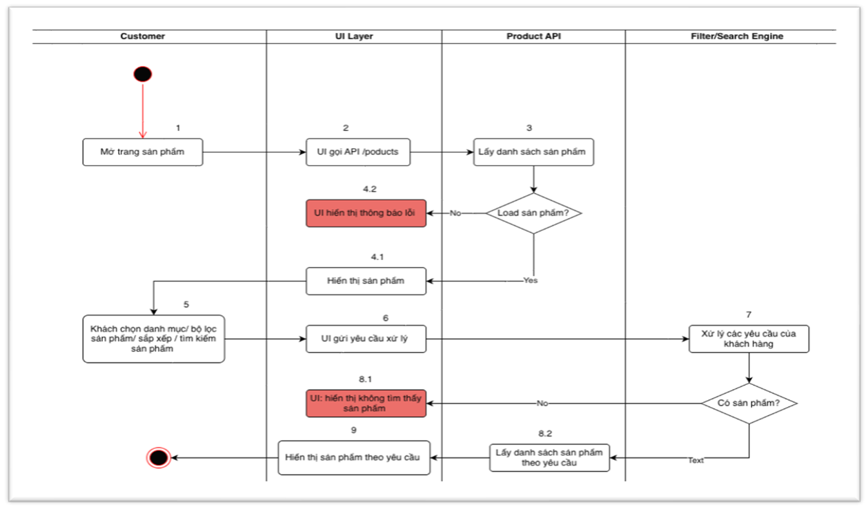

Cart

Add to cart

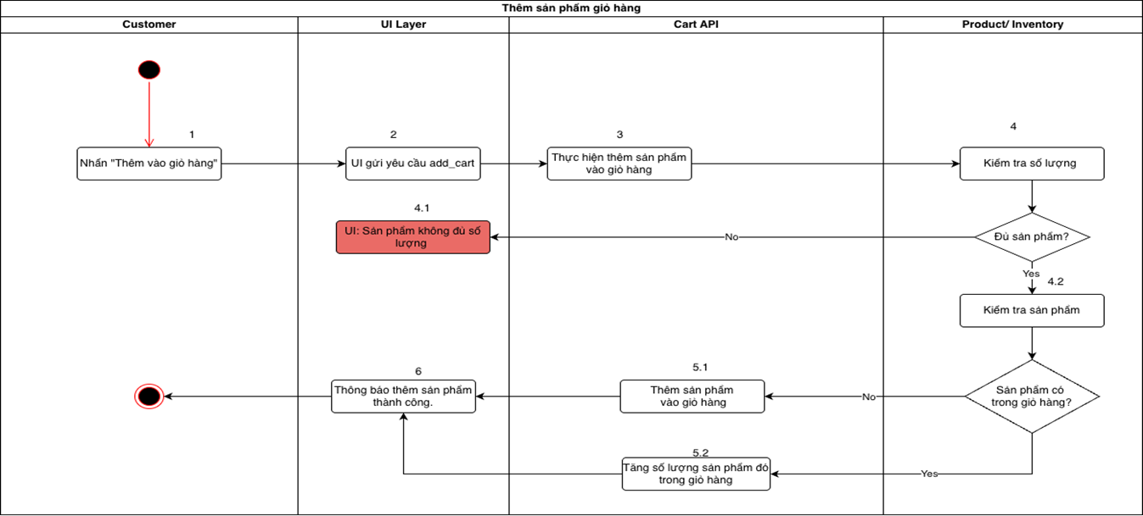

Update shopping cart

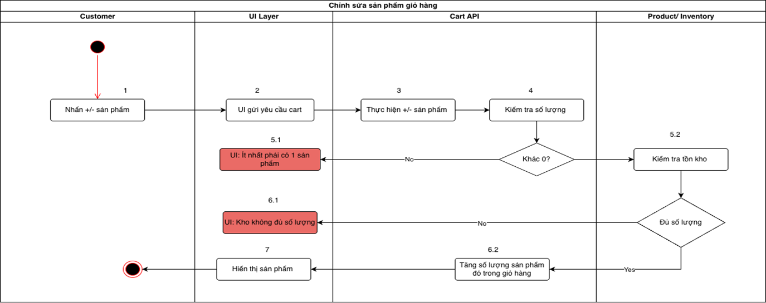

Checkout & Order placement

Pay

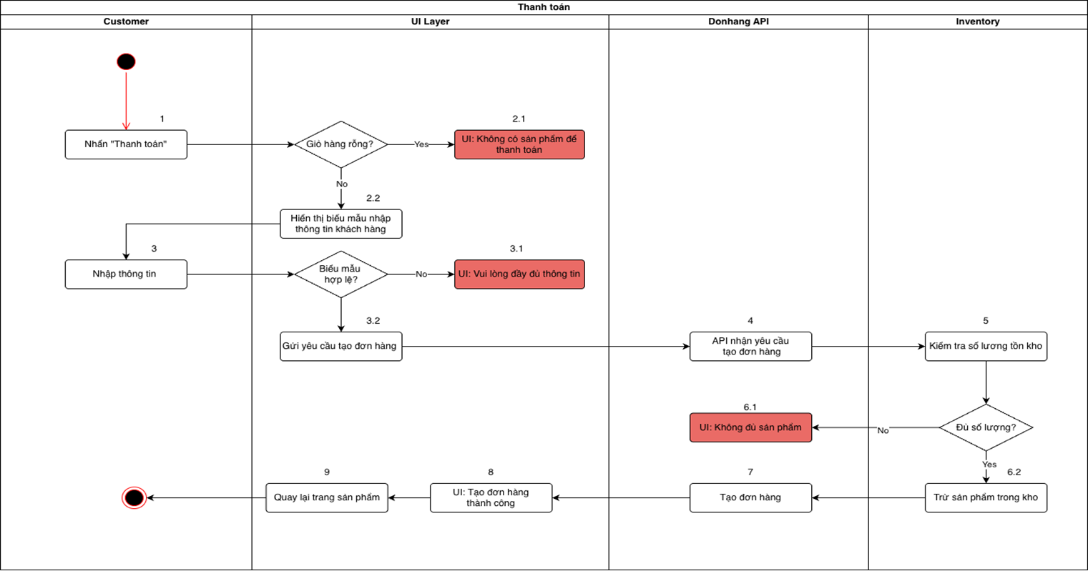

Access control

Login

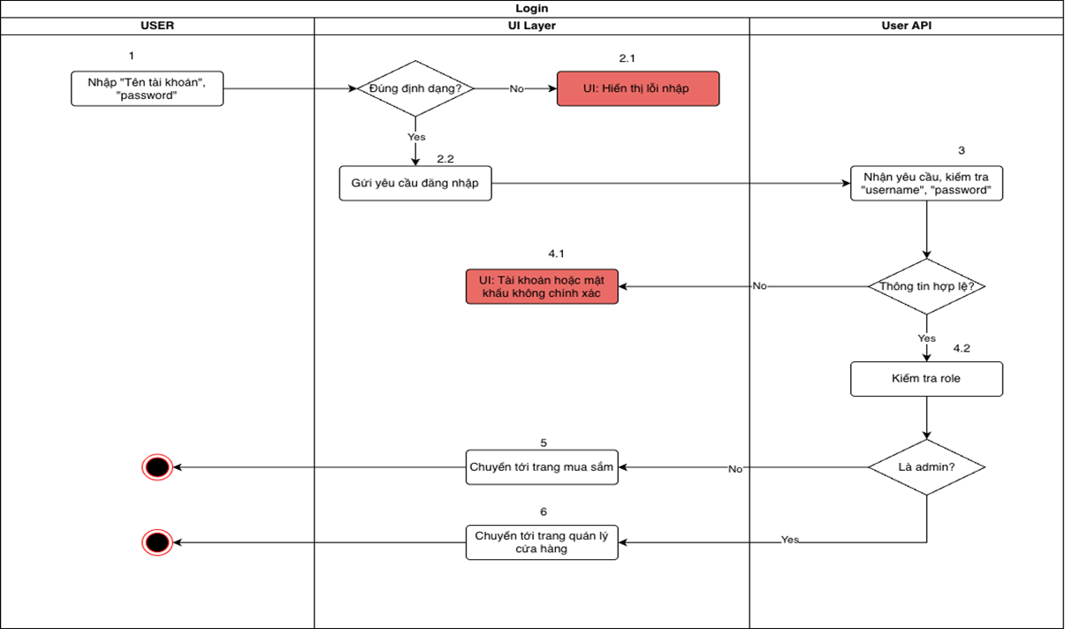

### 

### **2.6.2 Conceptual Model**

### **2.6.3 Object Model**

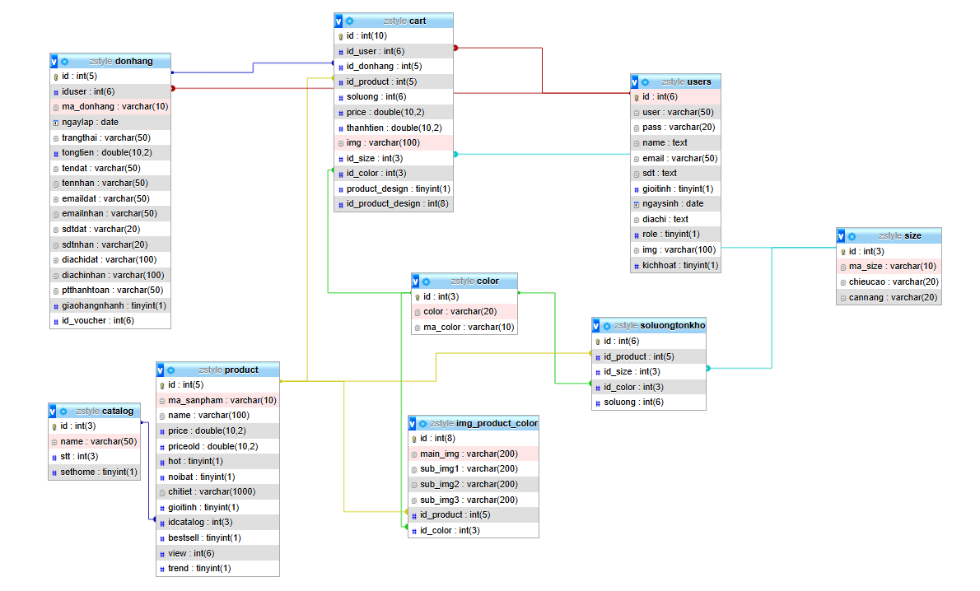

### 

### **2.6.4 Data Model**

| Table name | Table structure |
| --- | --- |
| user |  |
| product |  |
| catalog |  |
| cart |  |
| donhang |  |
| comment |  |
| img_product_color |  |
| color |  |
| size |  |
| quantity of goods |  |
| voucher |  |
| dadung_voucher |  |

### **2.6.5 Business Process**

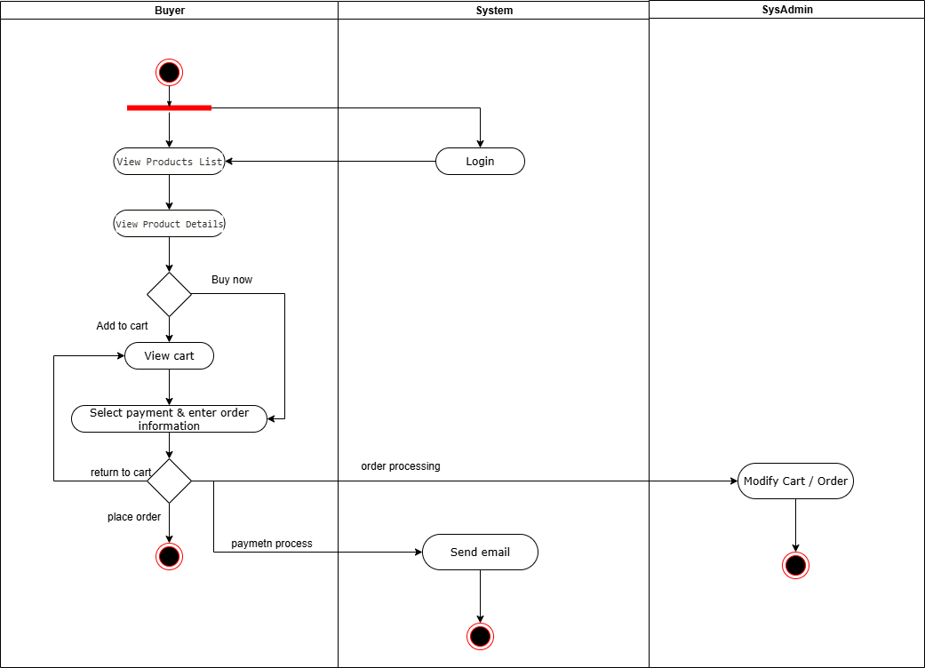

### 

### **2.6.6 Use Case Summary**

| Use case name |  |
| --- | --- |
| Login |  |
| Product |  |
| Order |  |
| Cart |  |

### 

### **2.6.7 ERD**

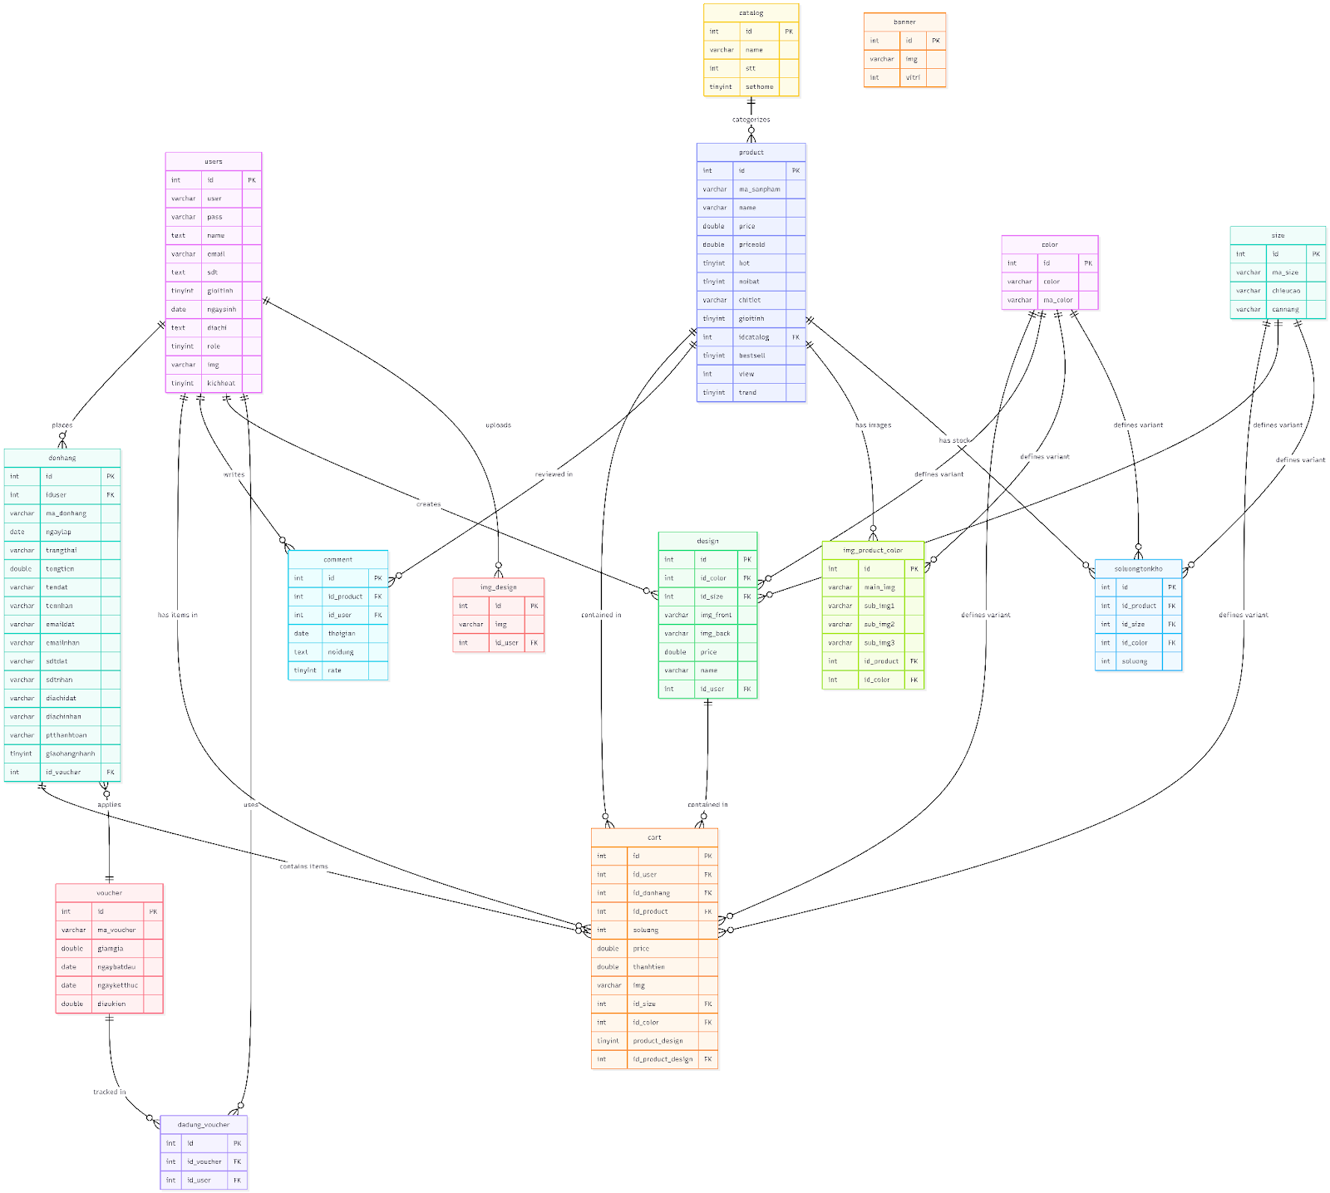

### **2.6.8 UI/UX design**

**Customer Interface**

The customer-centric interface facilitates product discovery, account management, and transaction processing.

HomePage

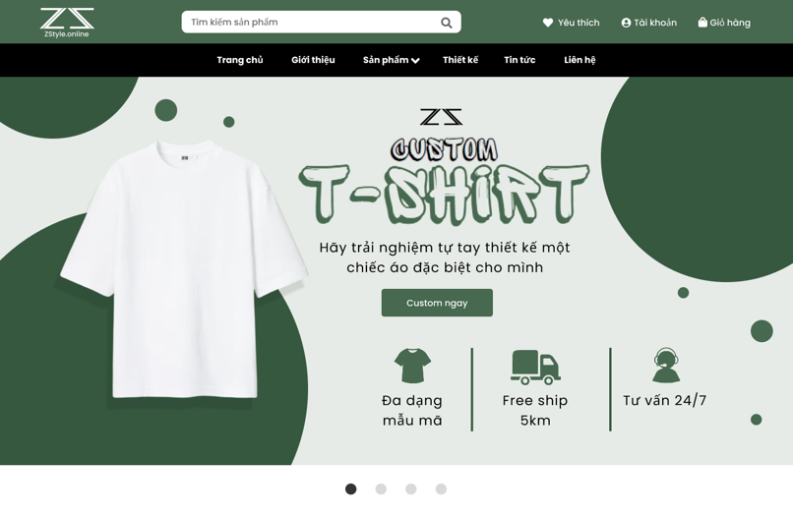

HomePage 2

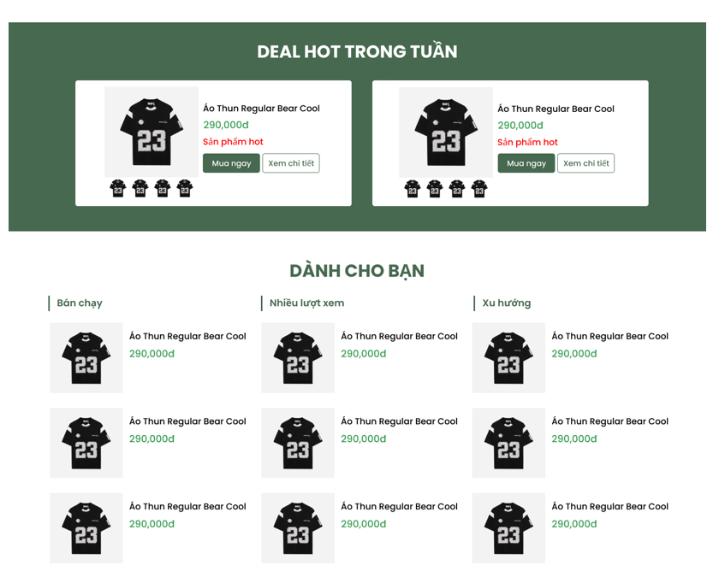

Product List

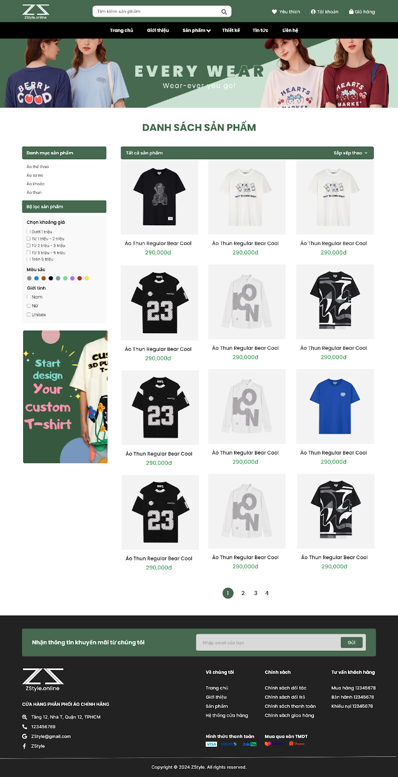

Product detail

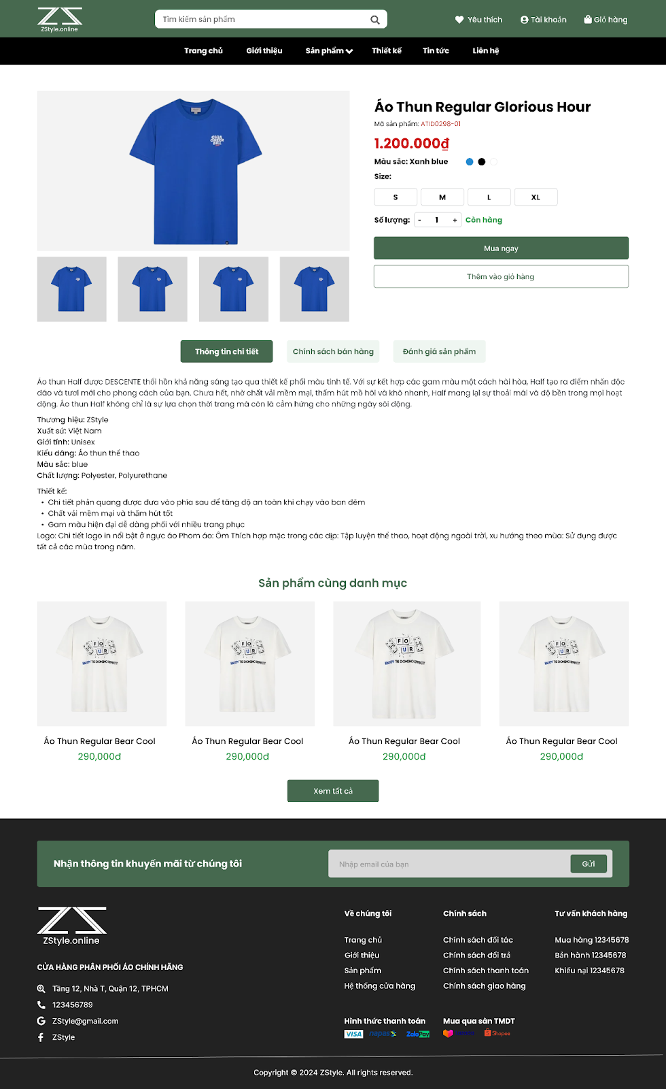

Cart

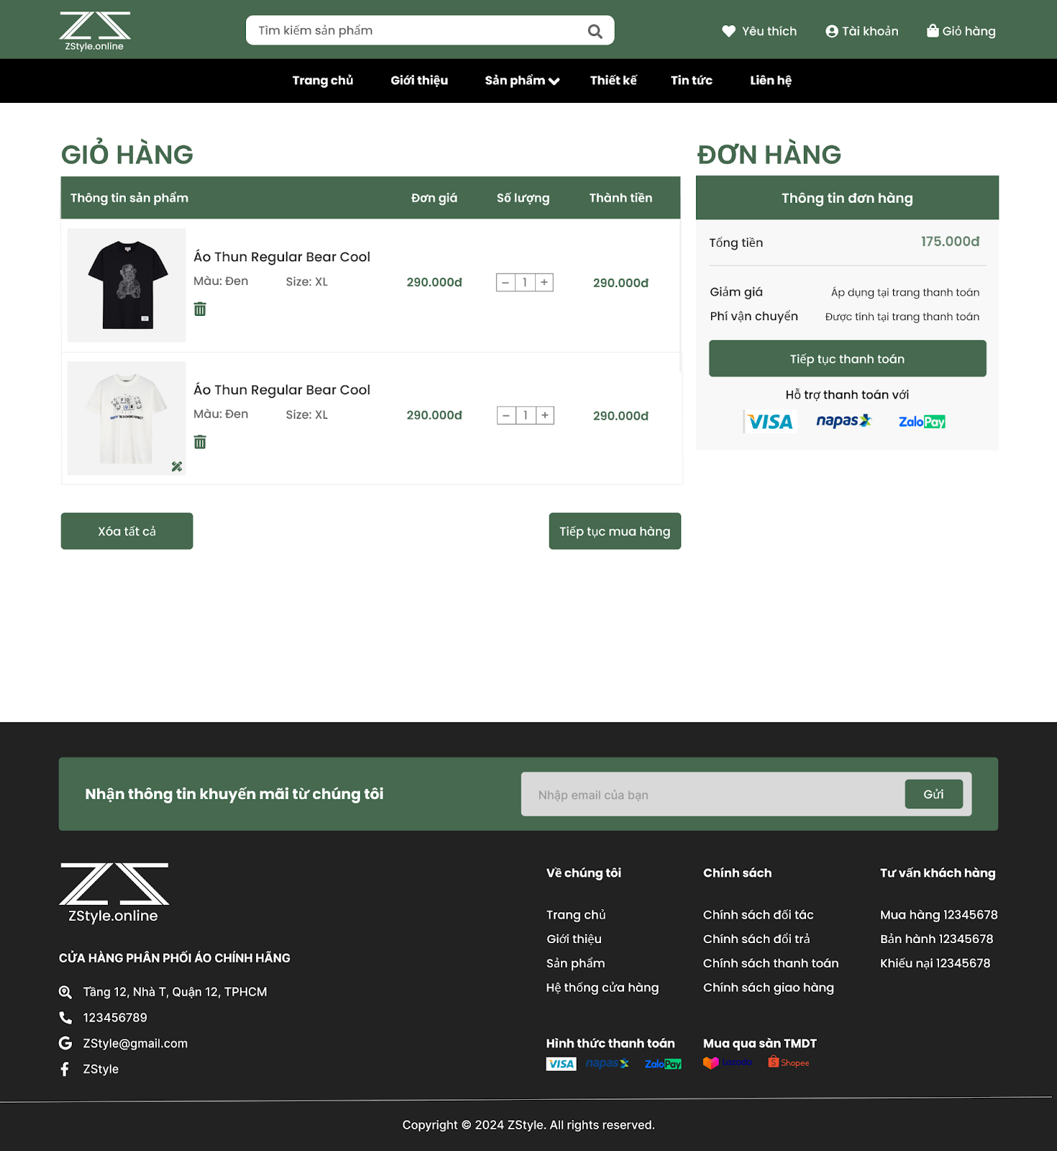

Checkout

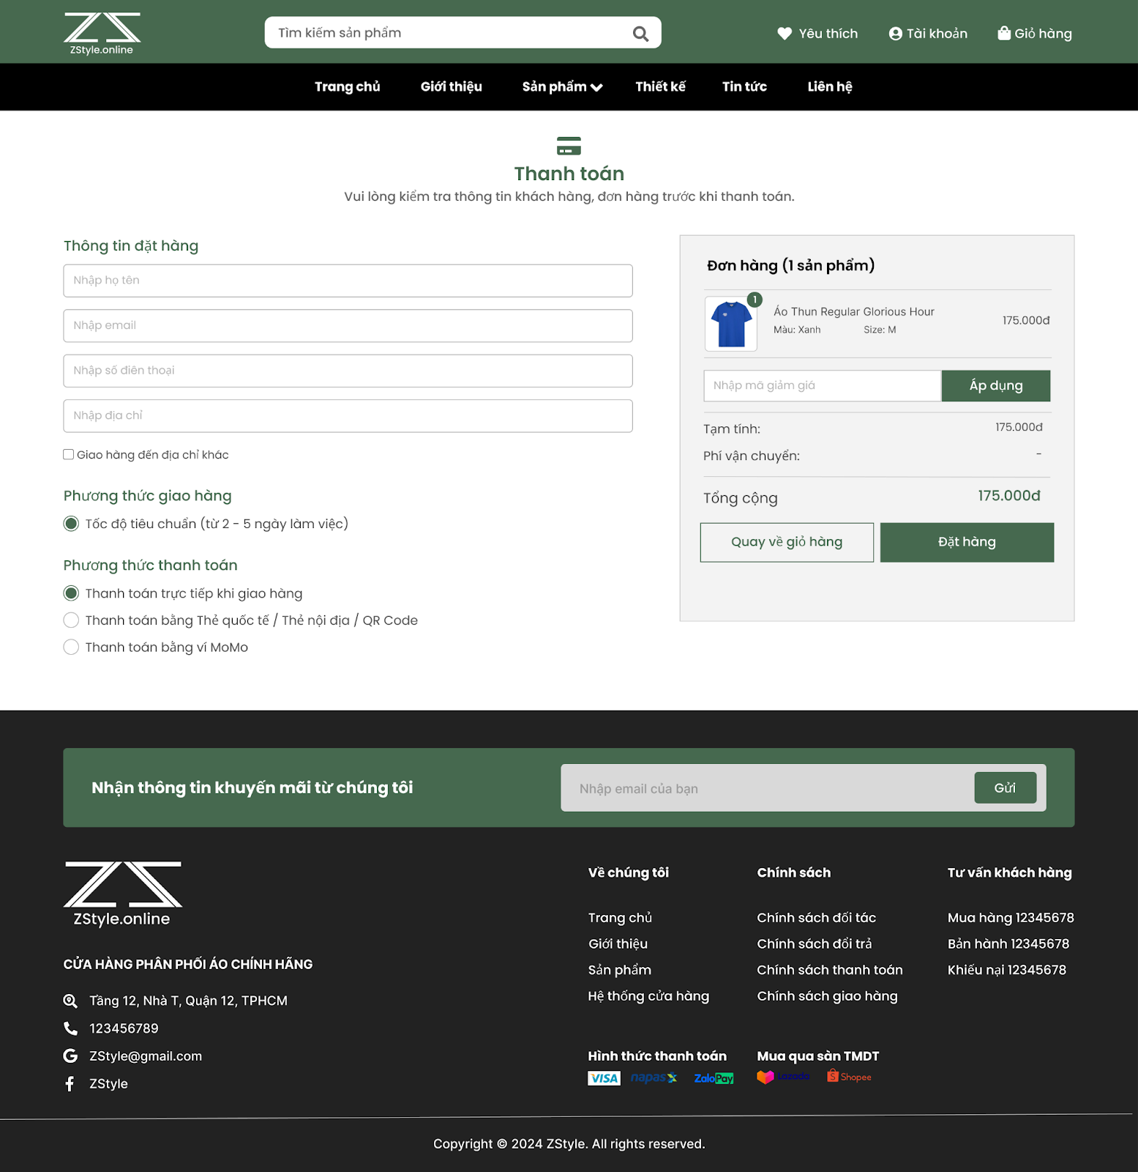

Login

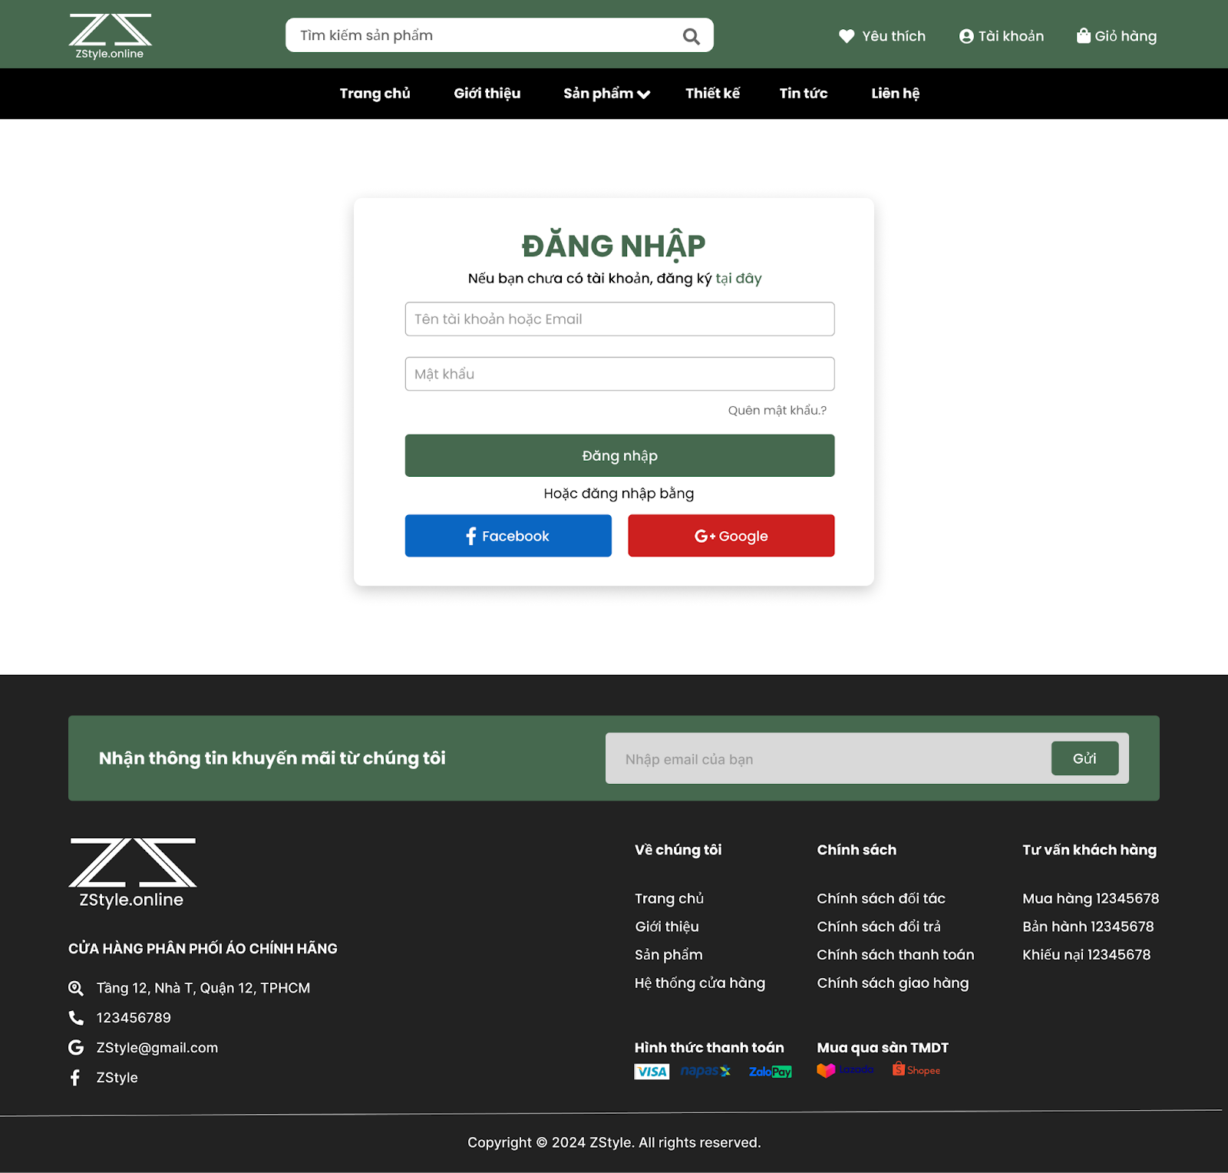

Sign Up

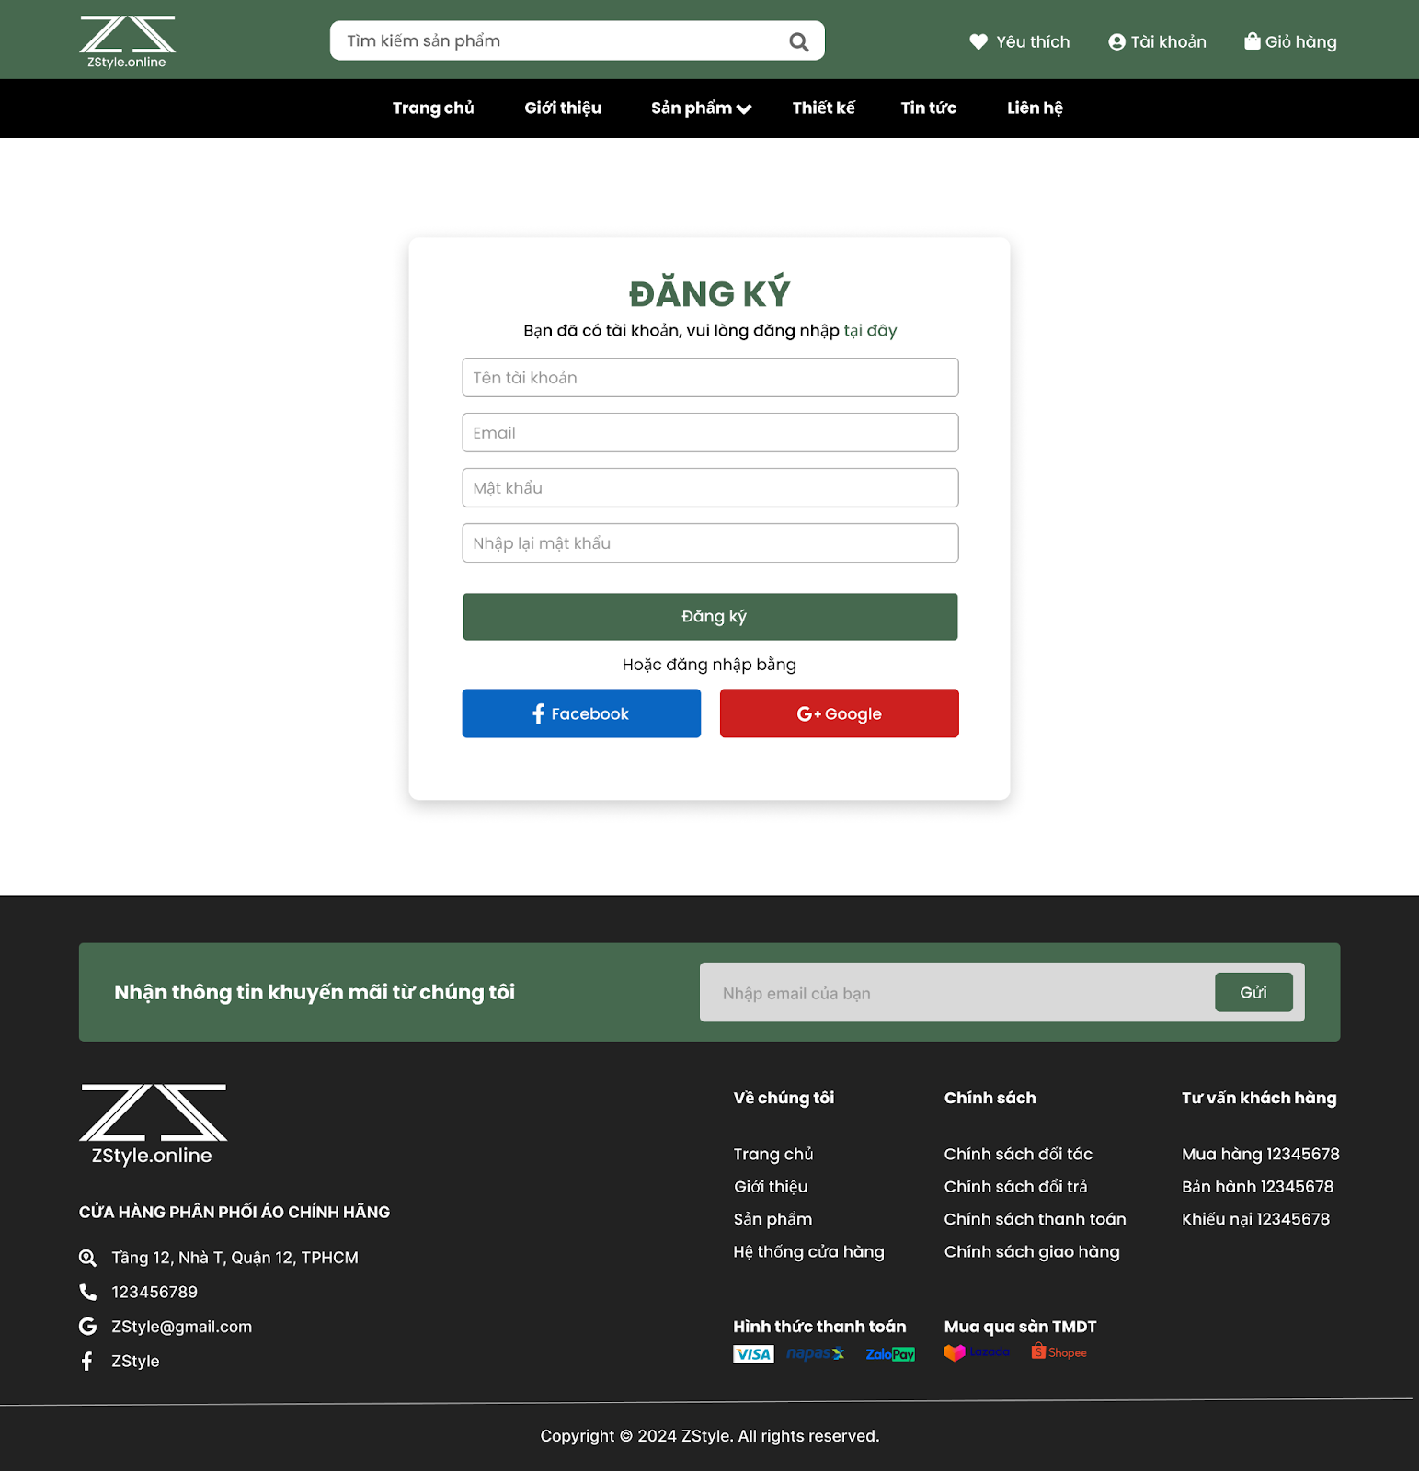

Forgot Password

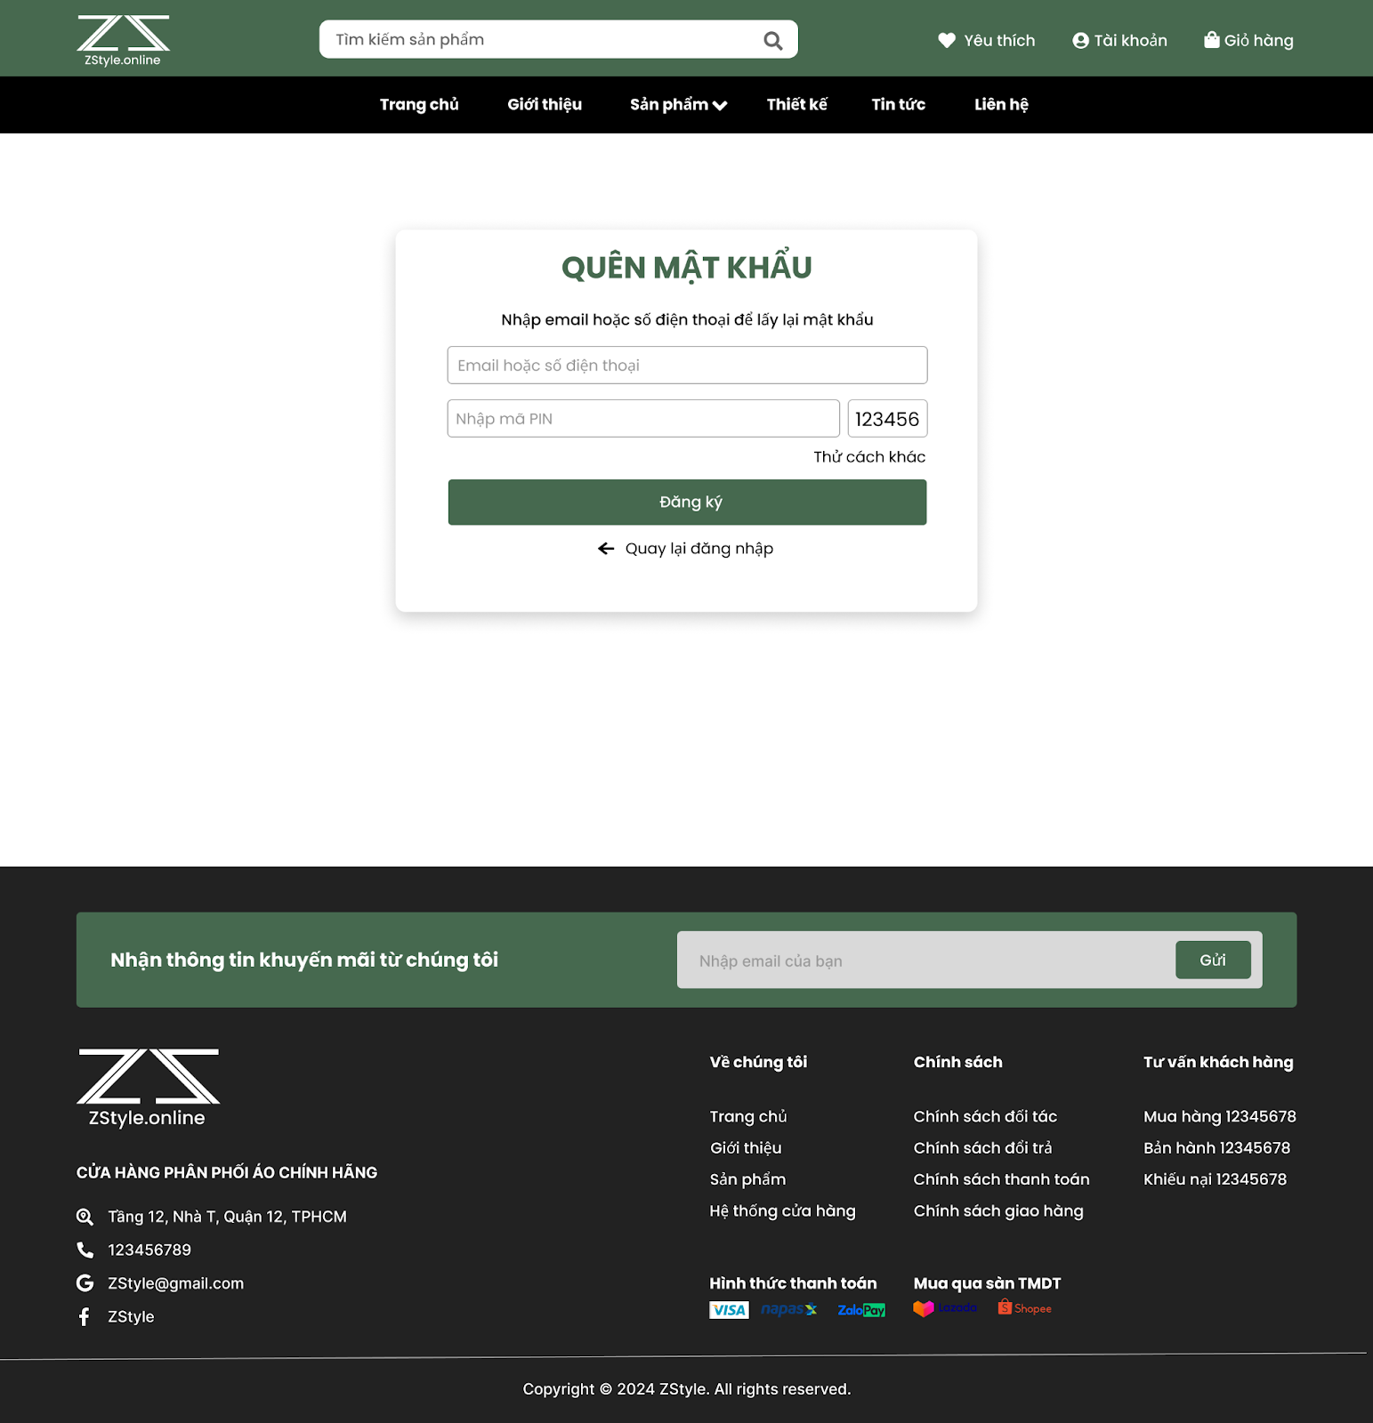

Profile

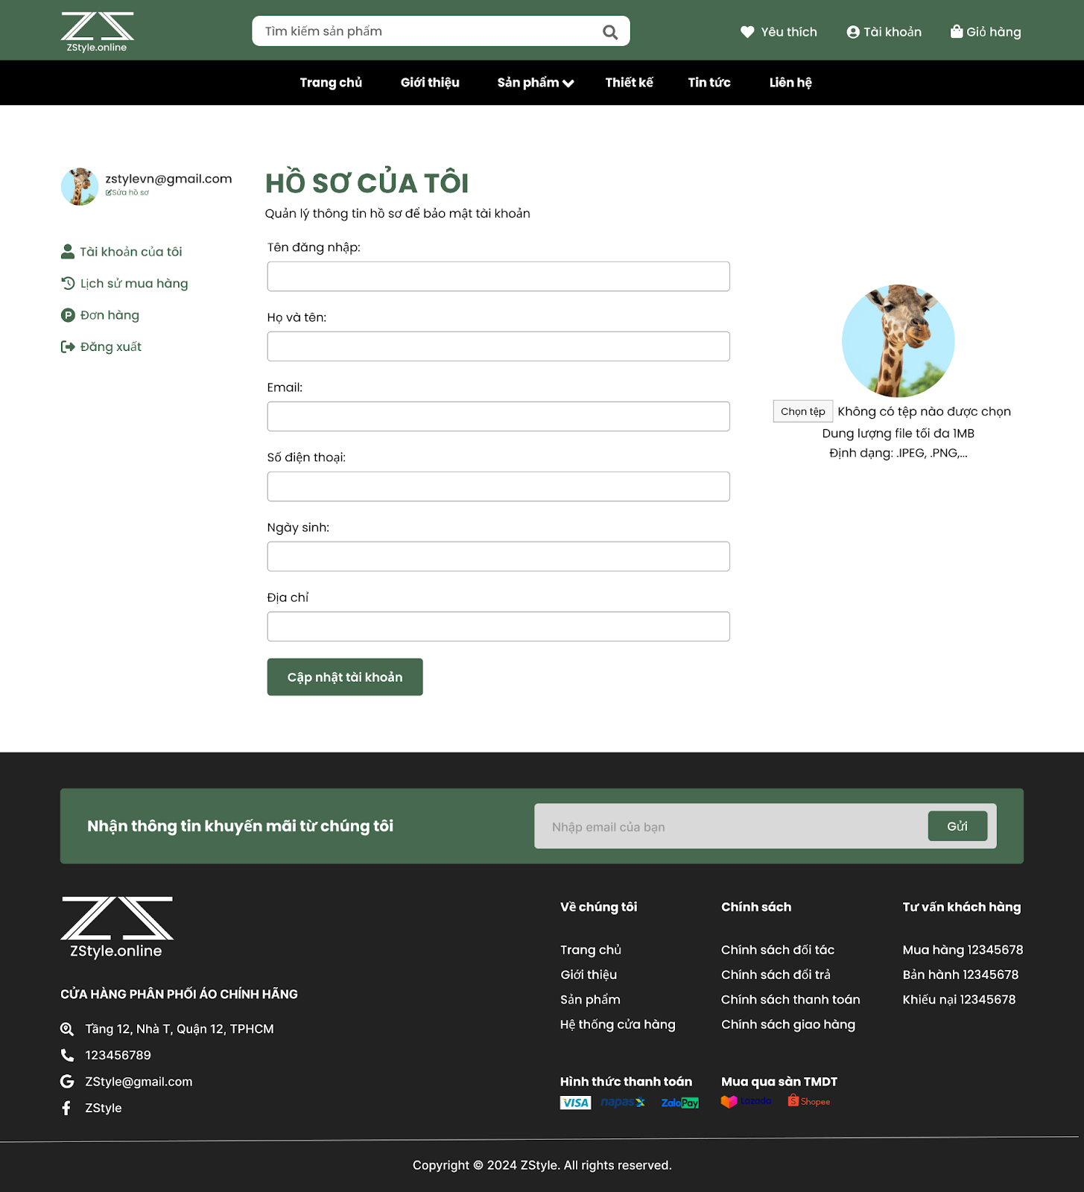

Order History

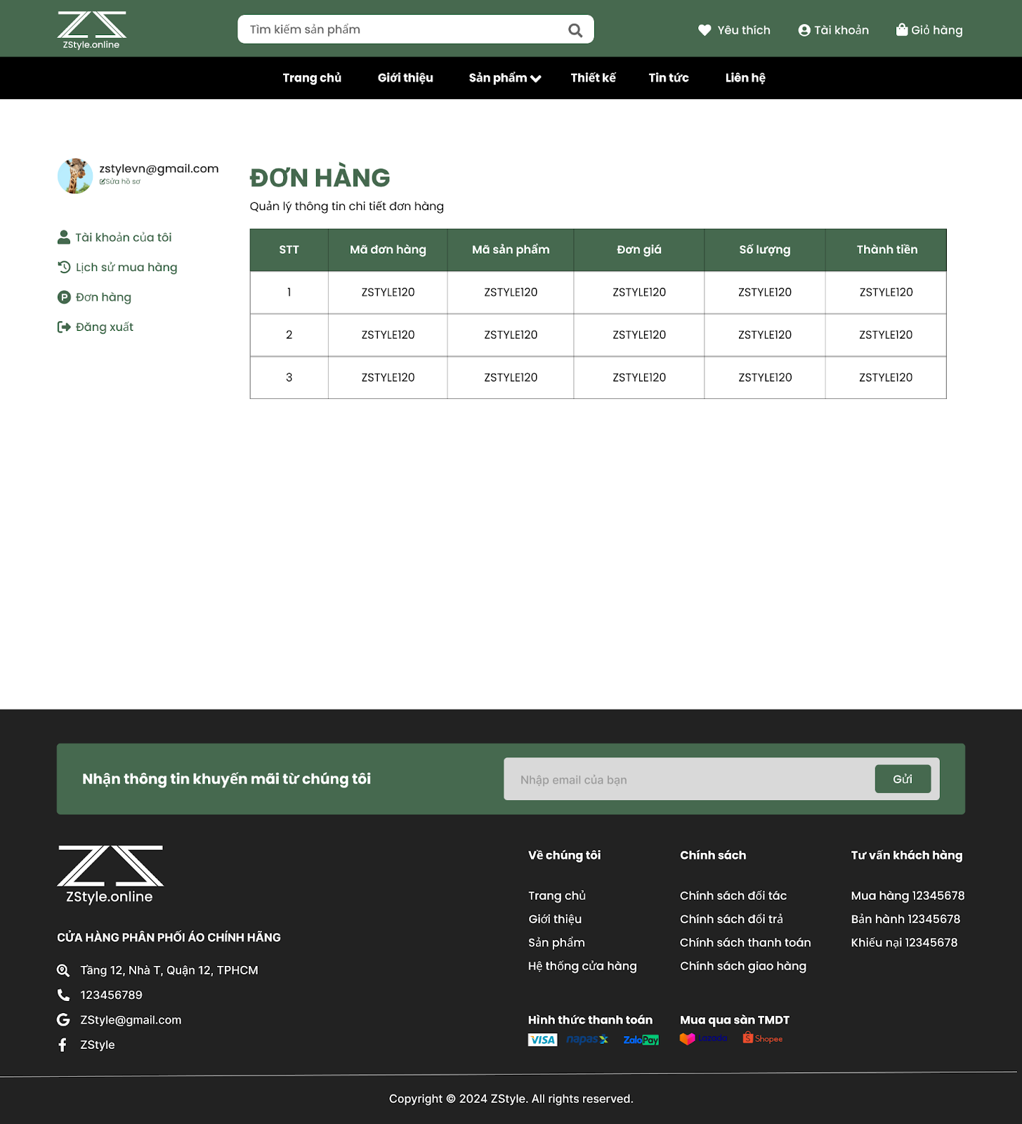

News

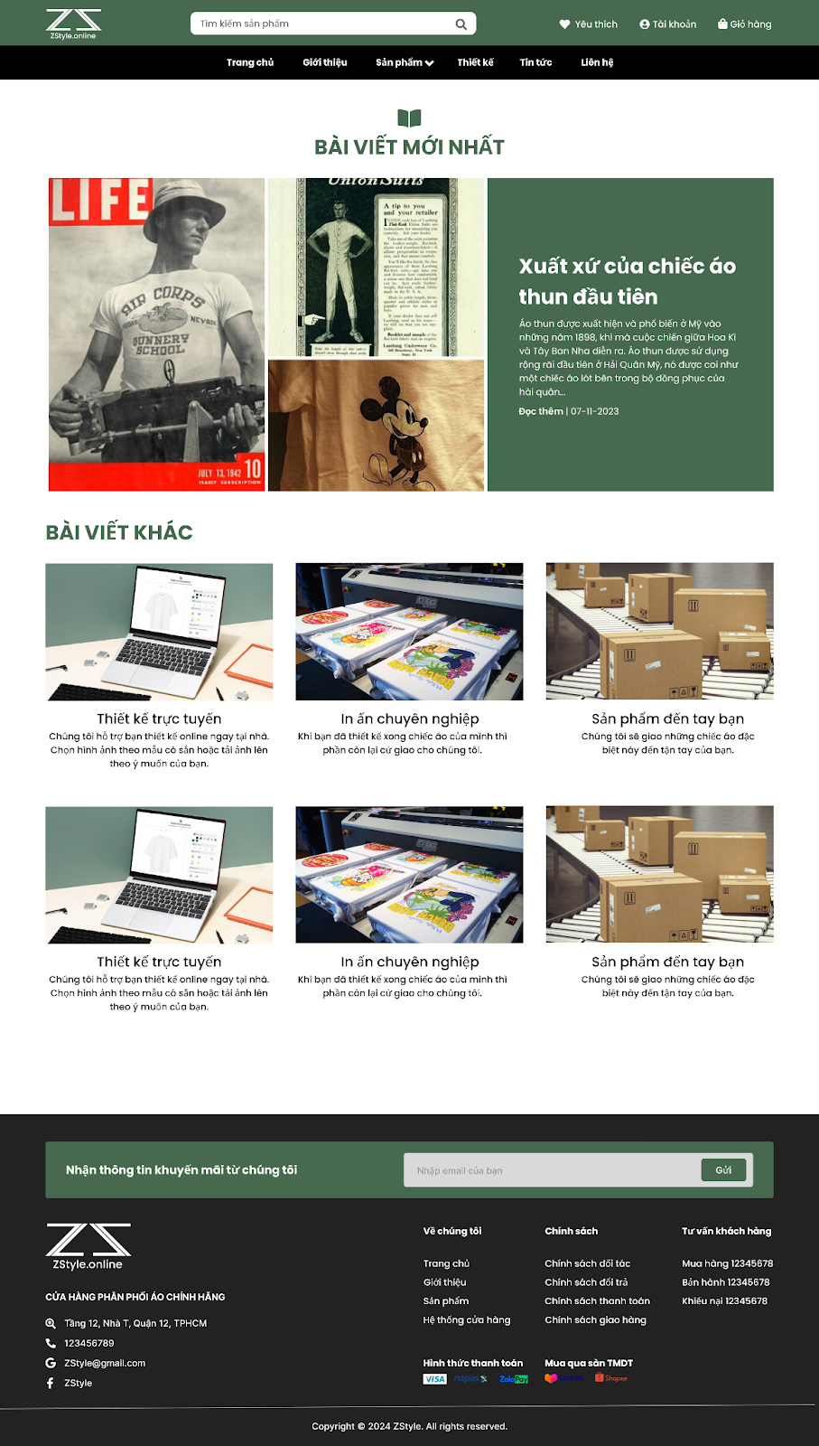

About

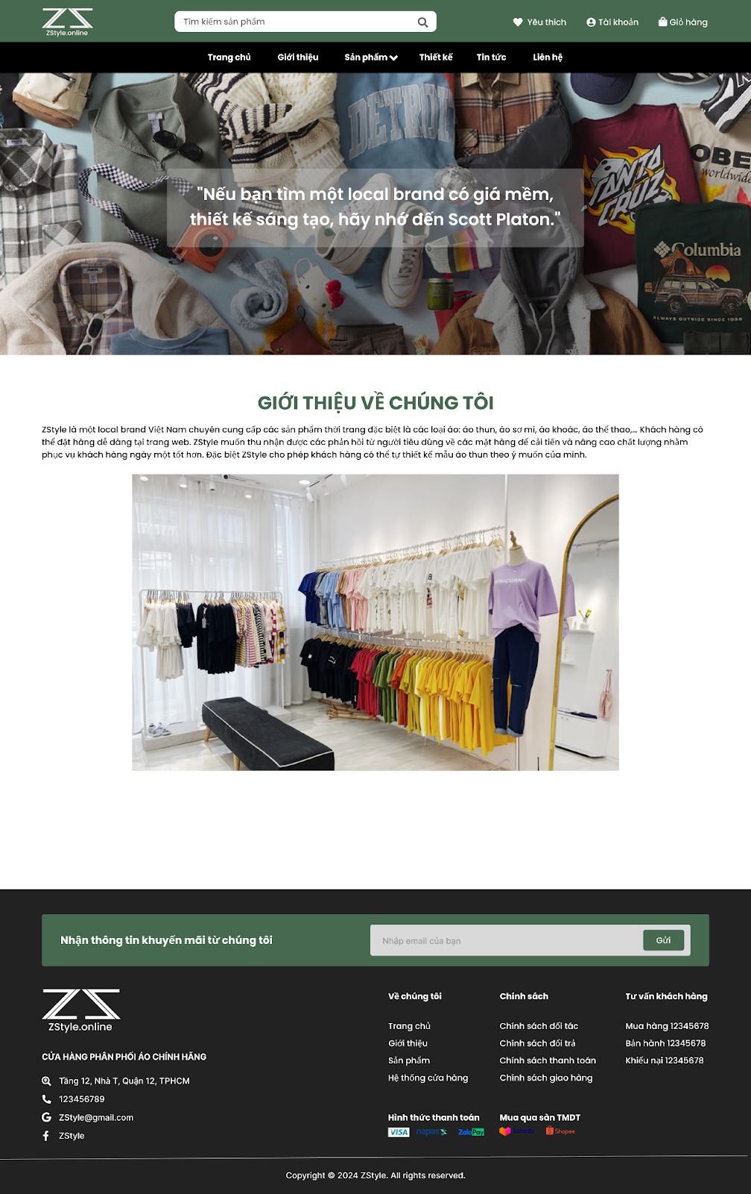

Contact

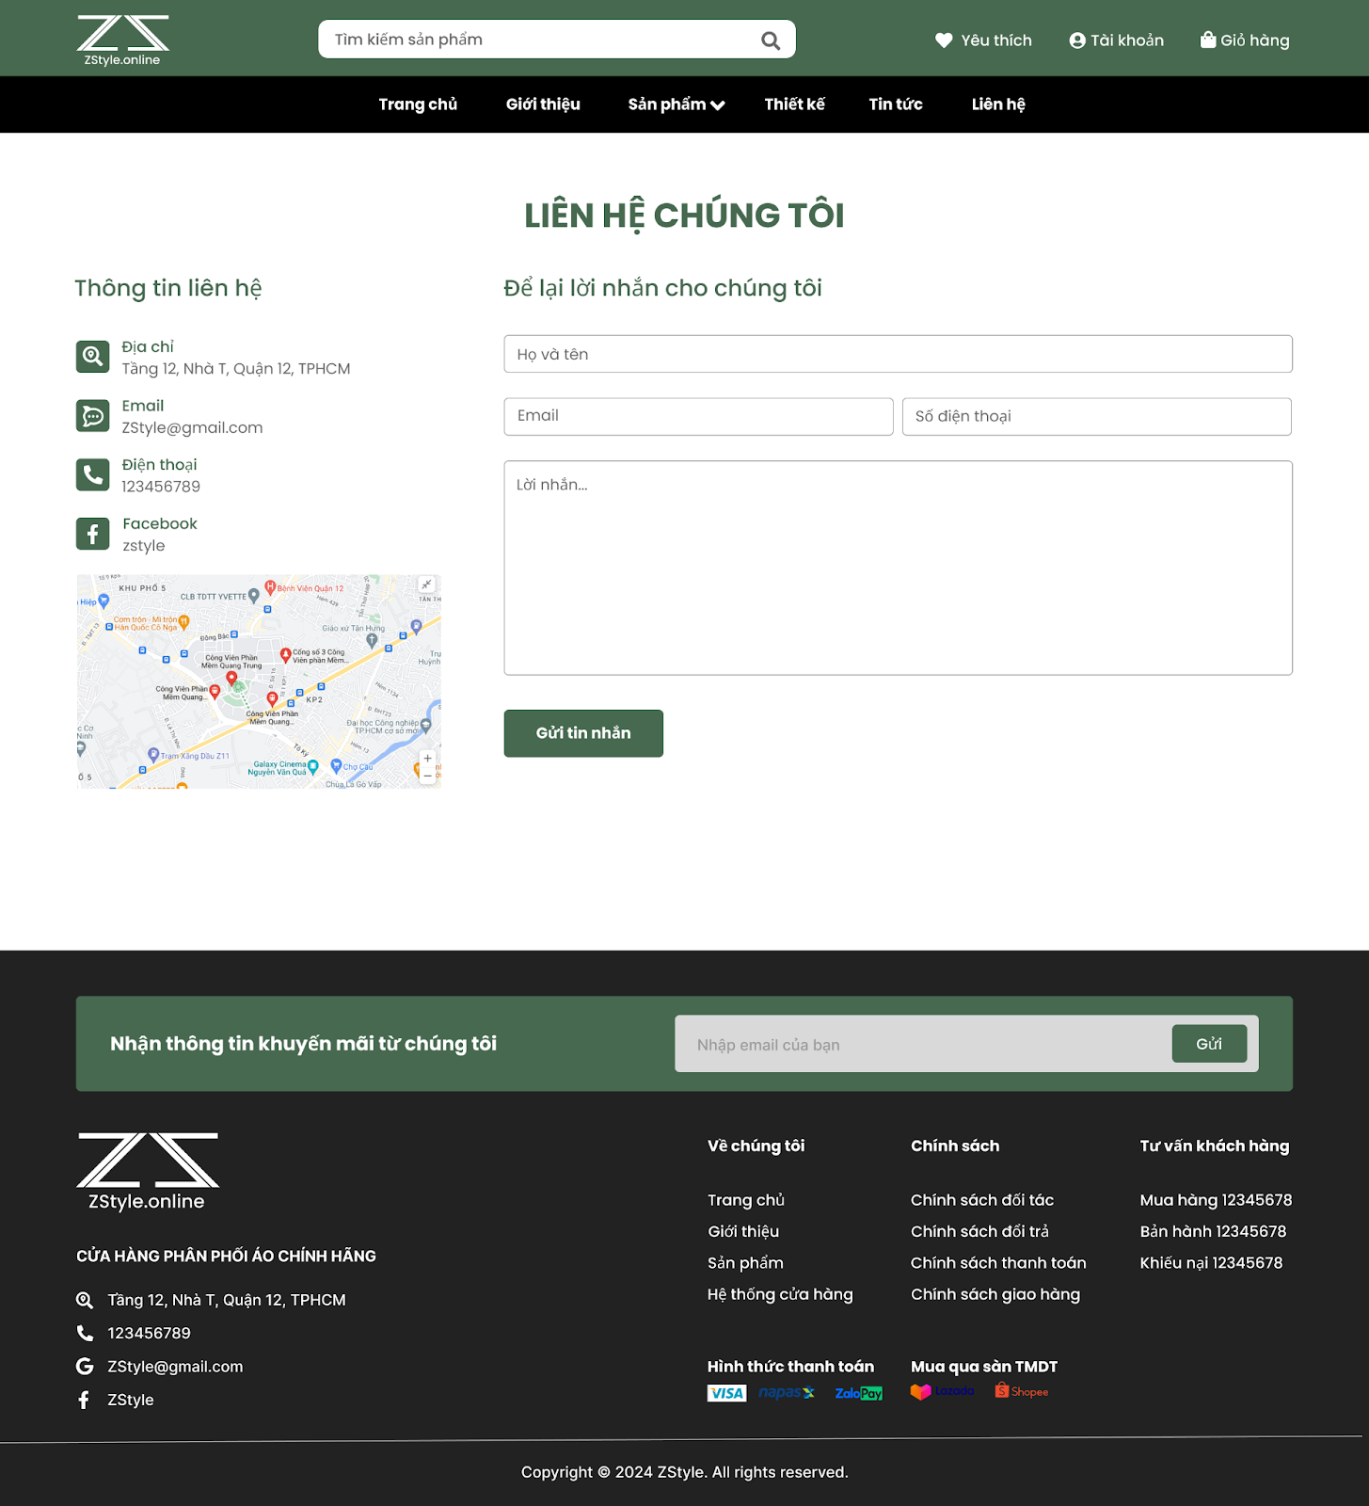

Policy

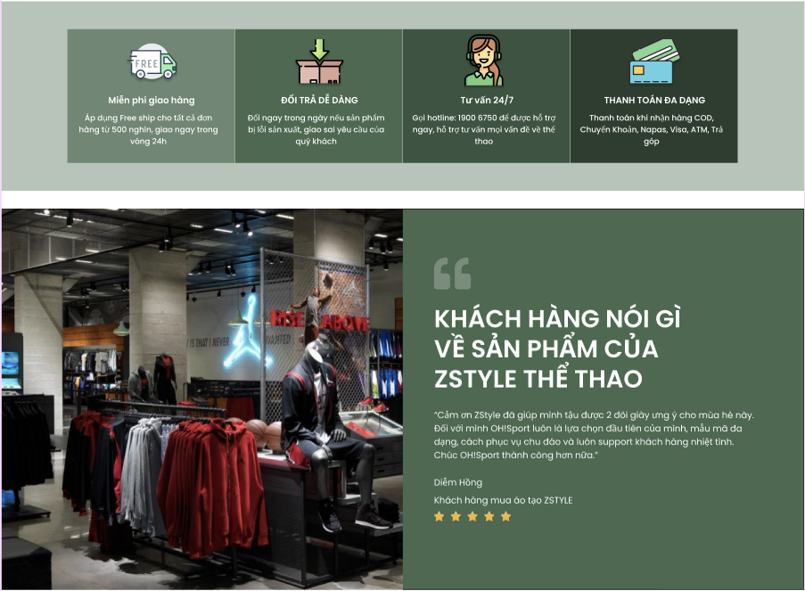

**Admin Interface**

The administration interface provides capabilities for managing system data and business operations.

Admin Dashboard

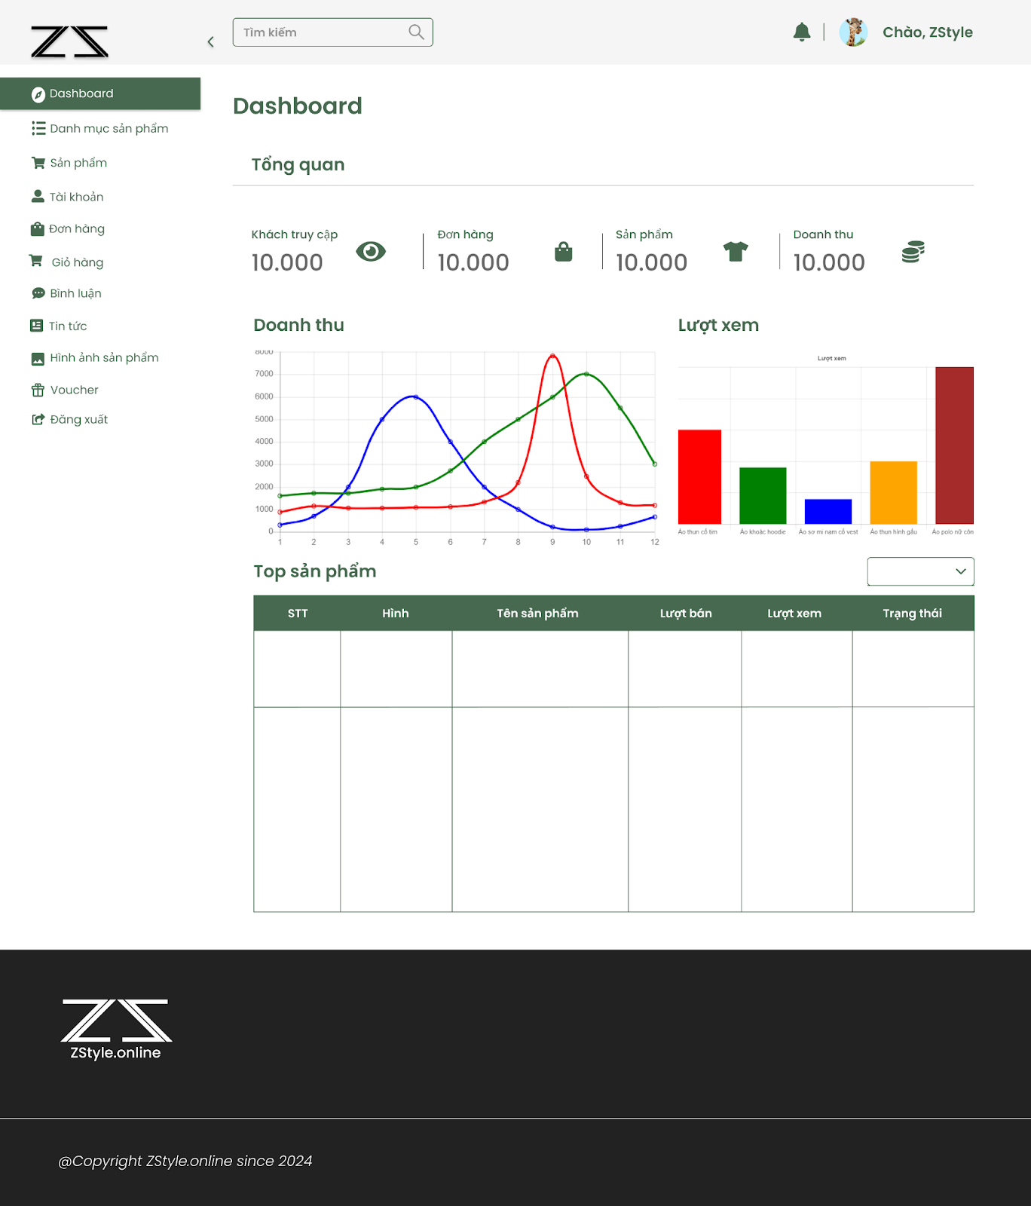

Product Management

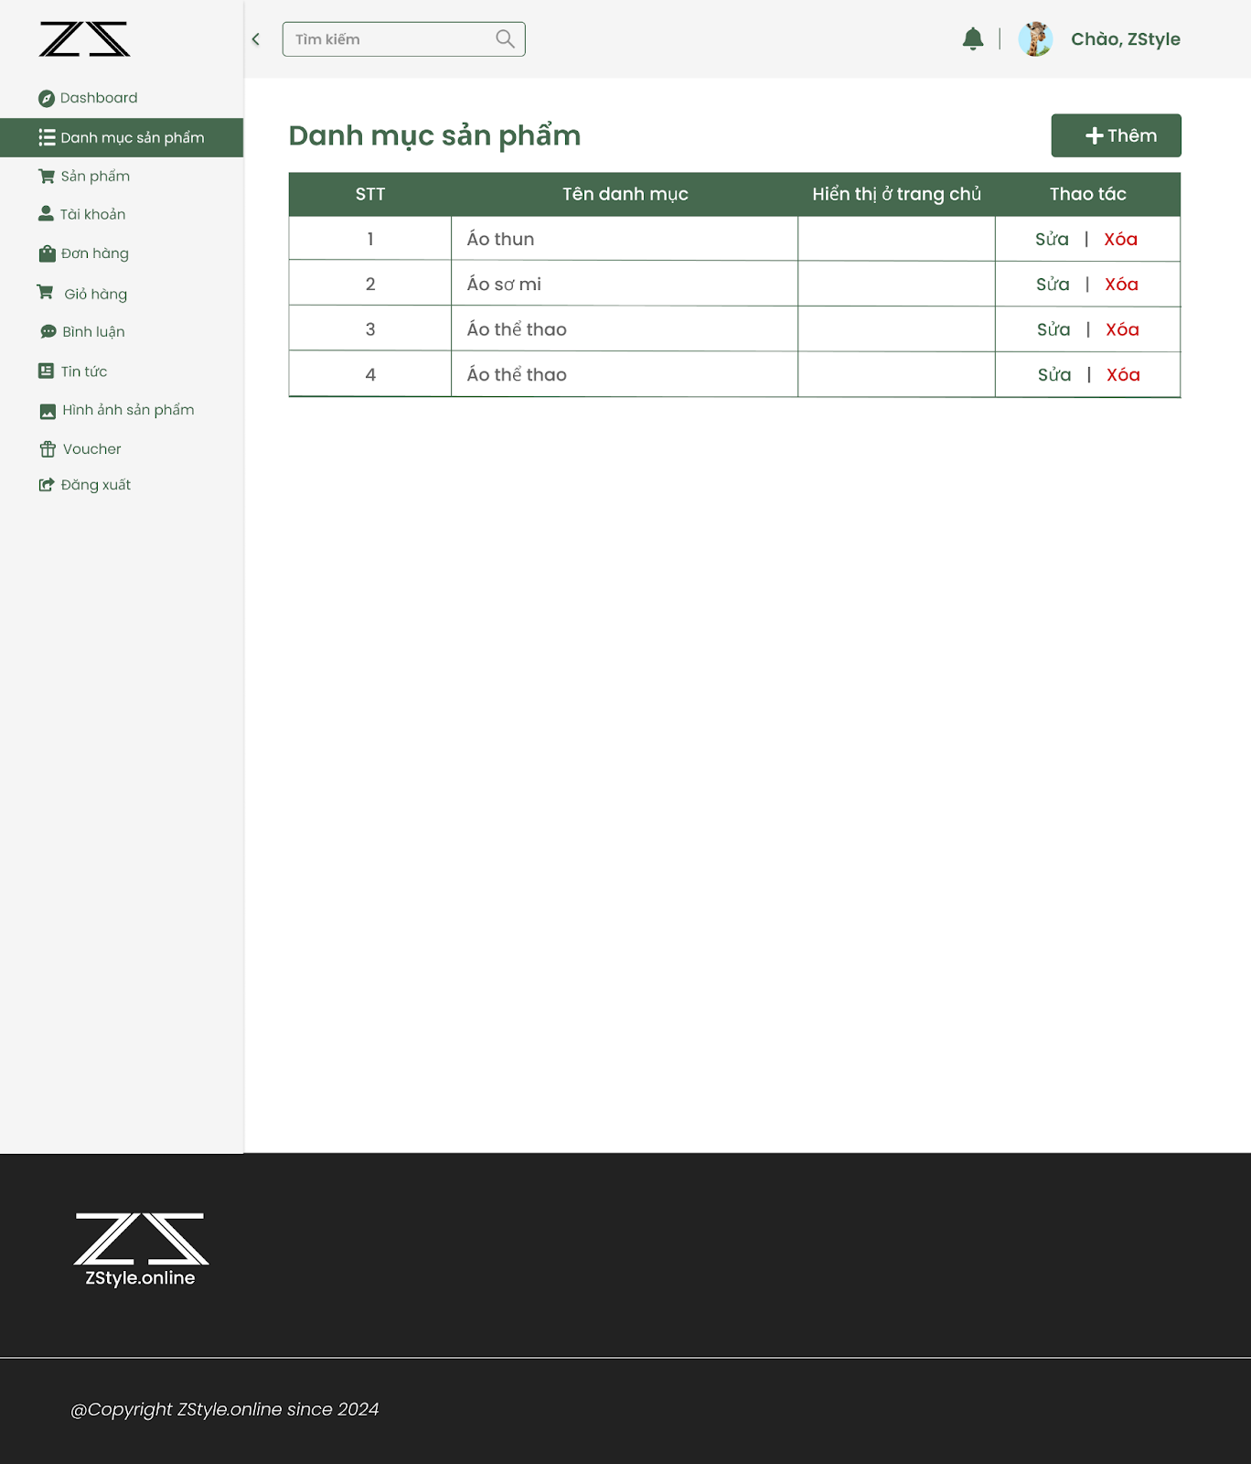

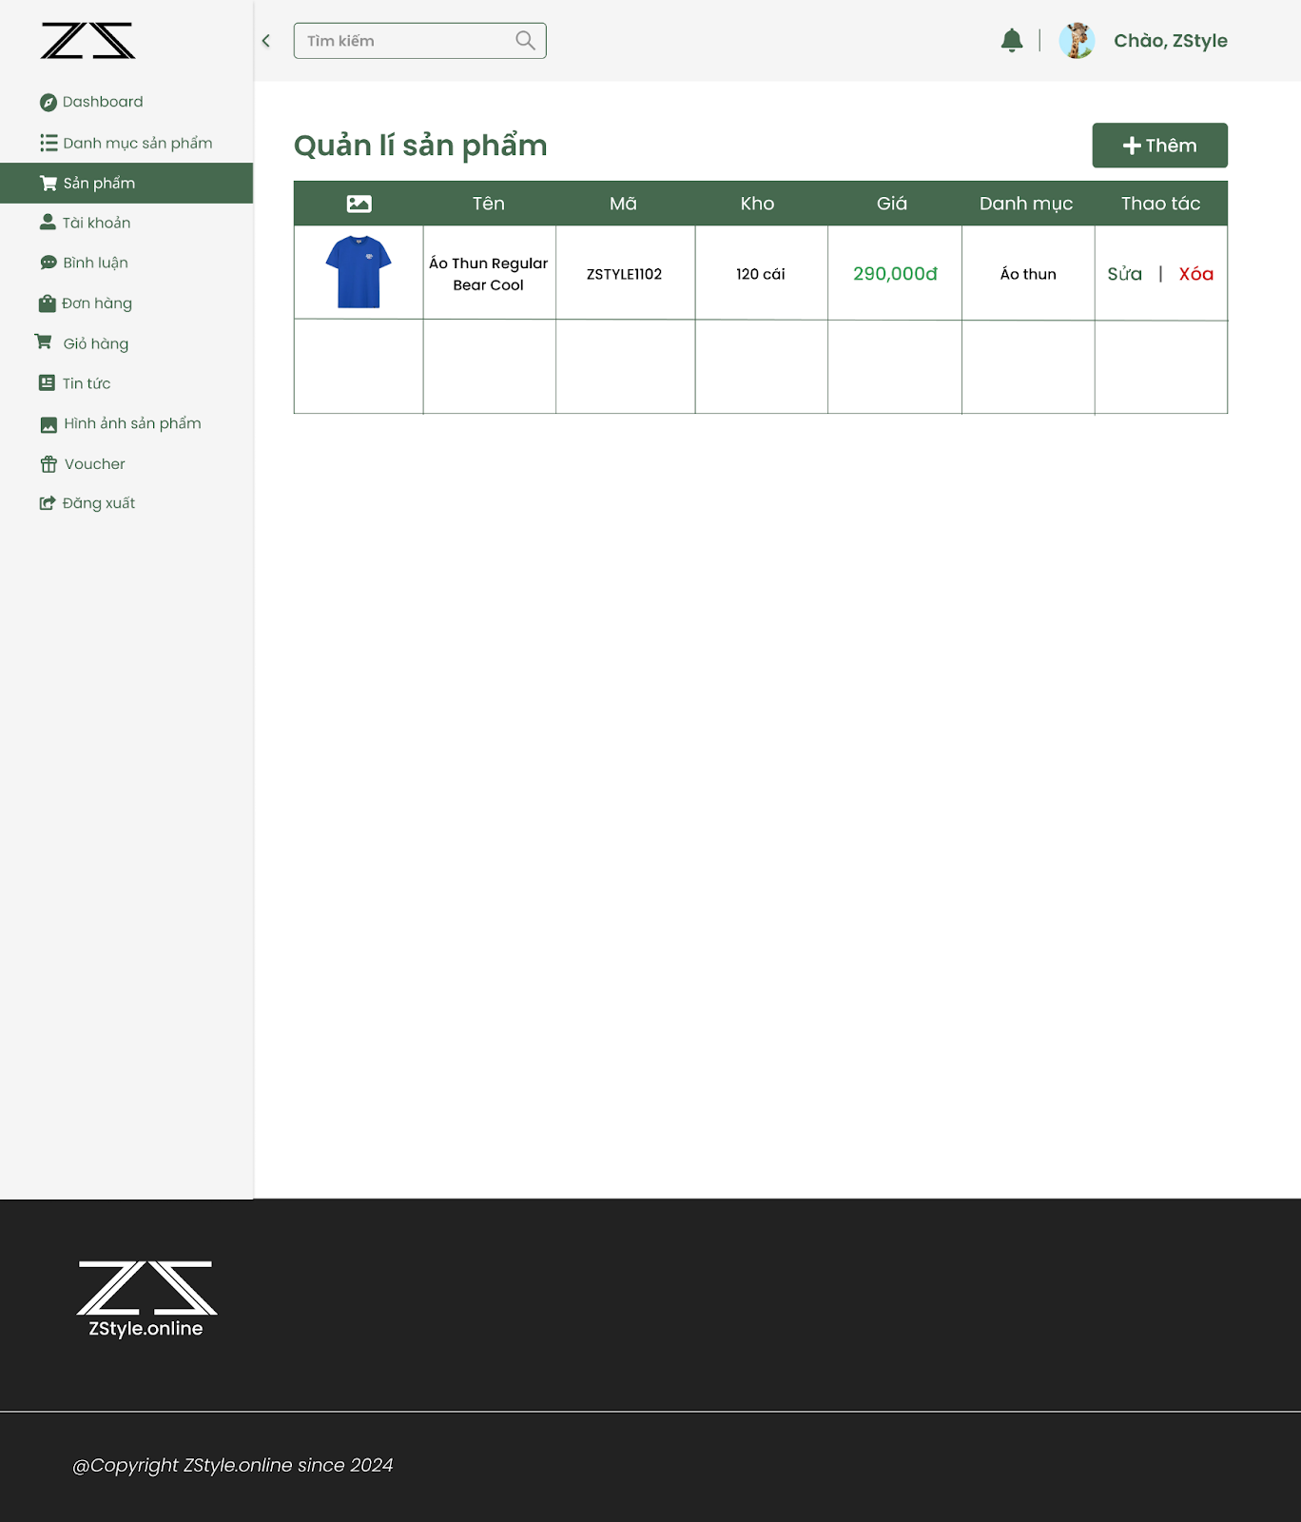

Product Image Management

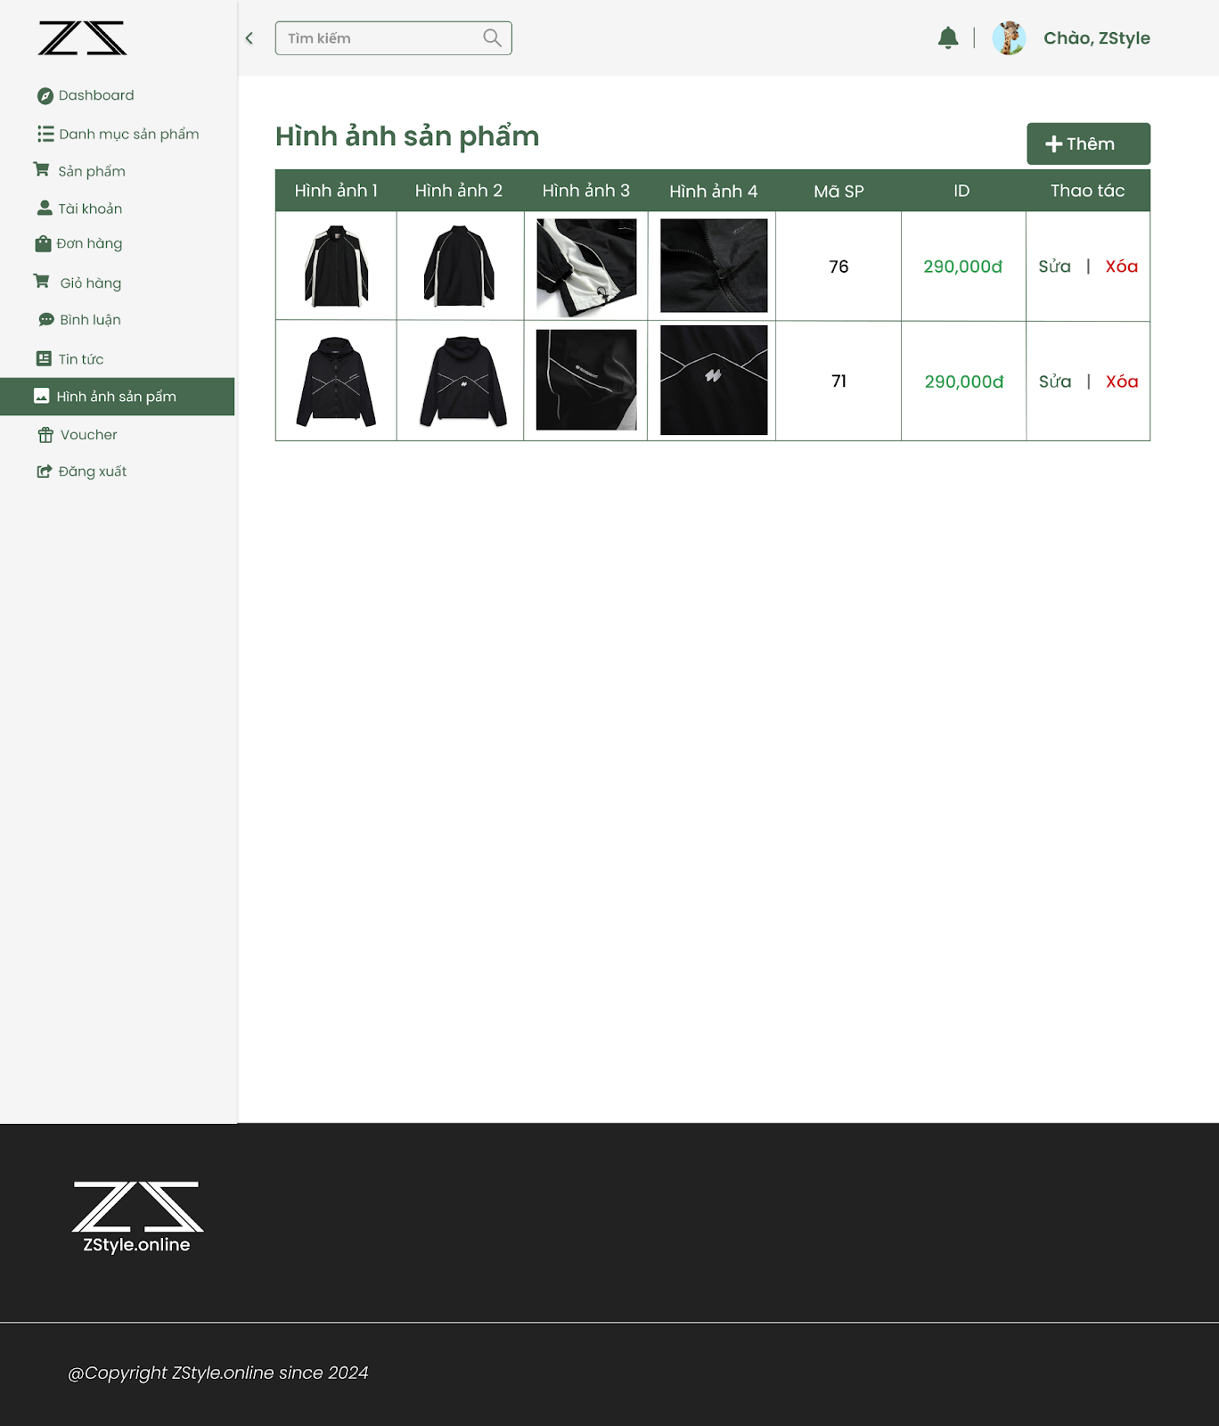

Order Management

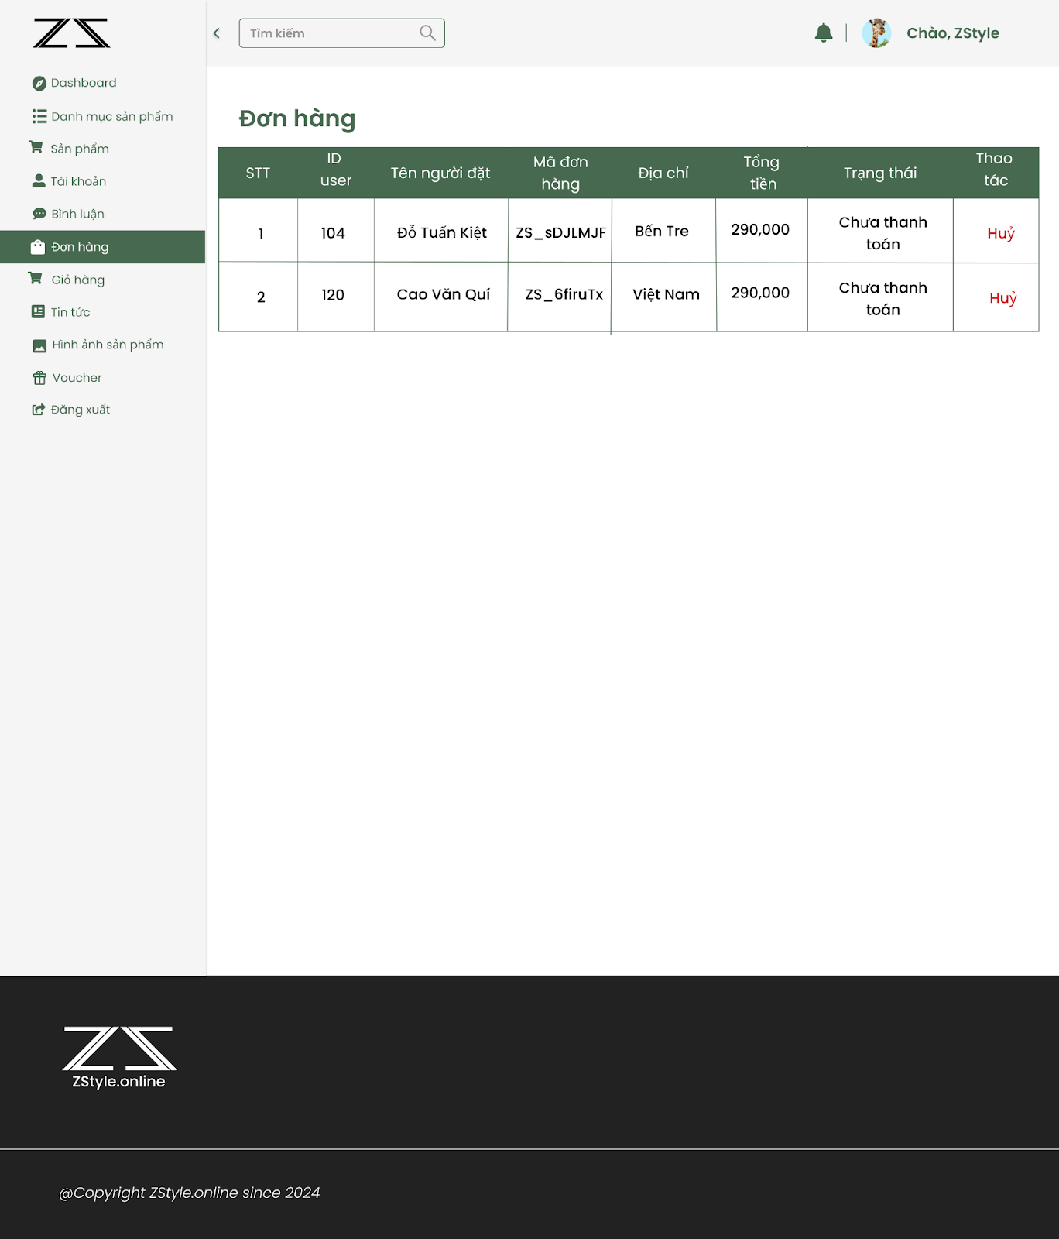

User Management

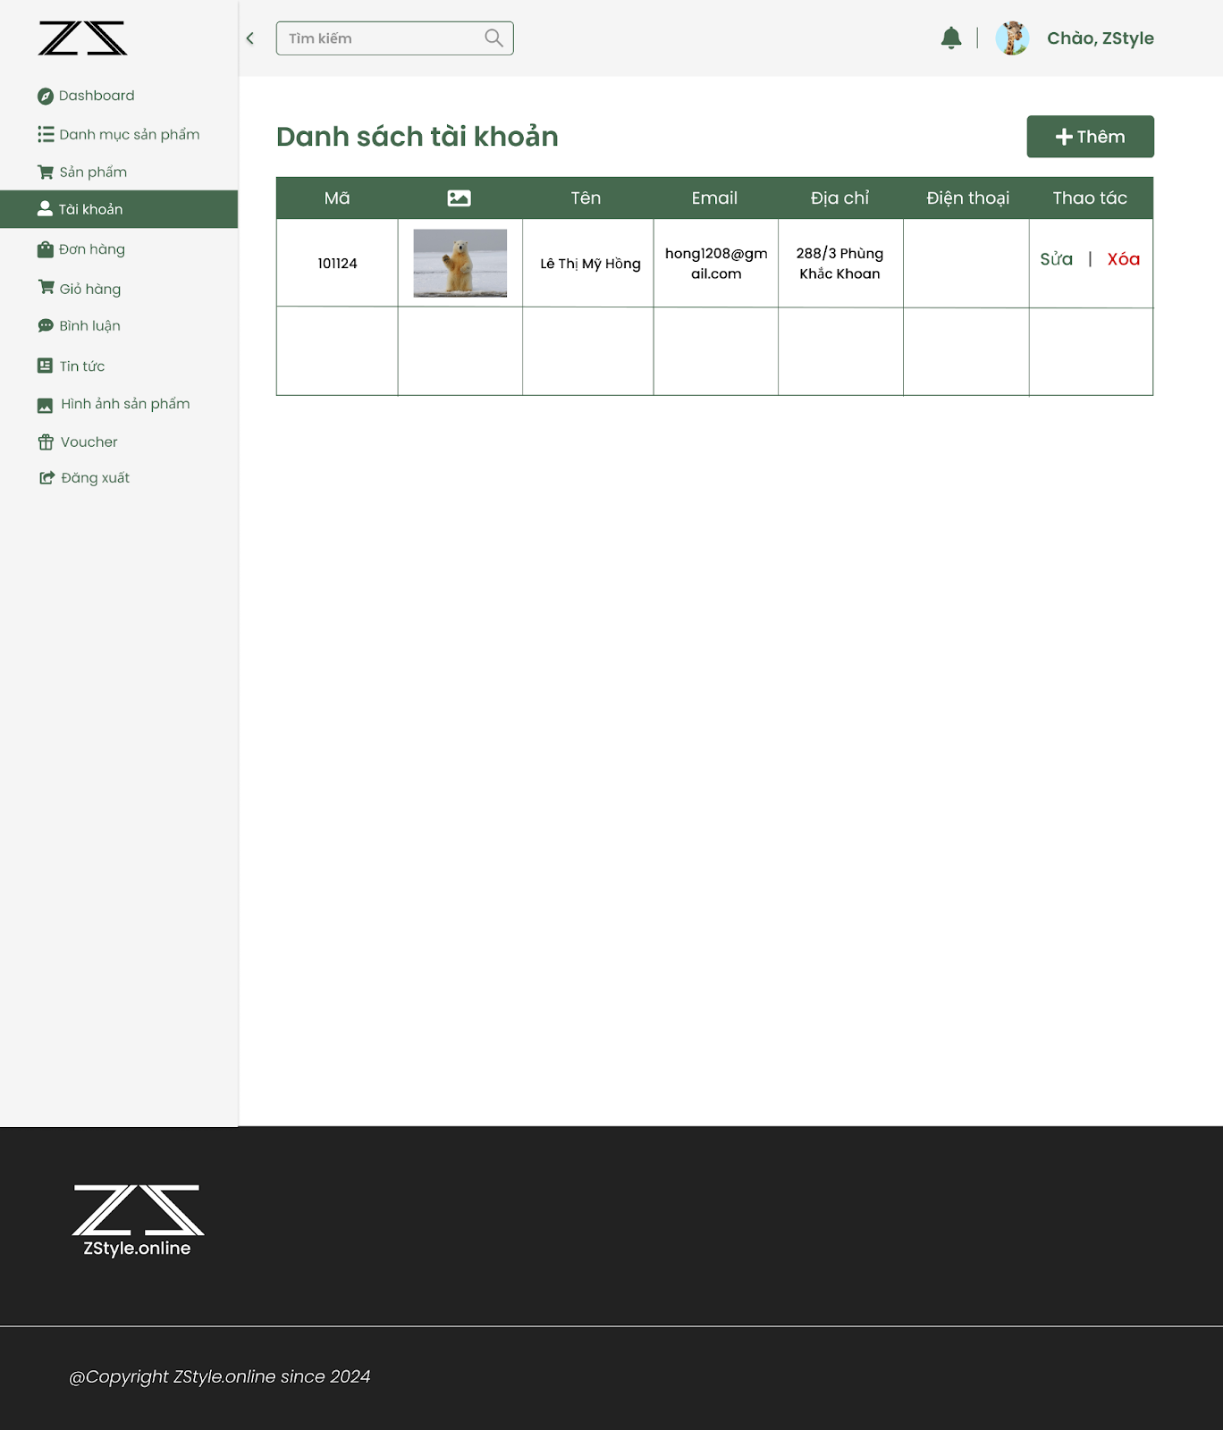

Voucher Management

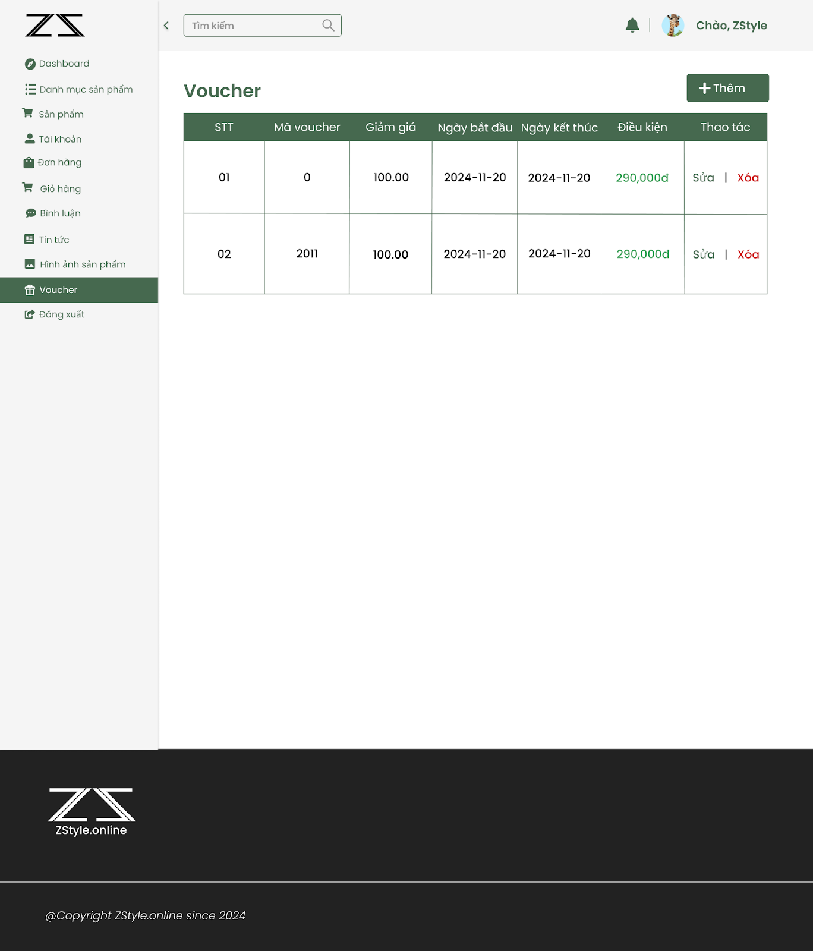

Comment Management

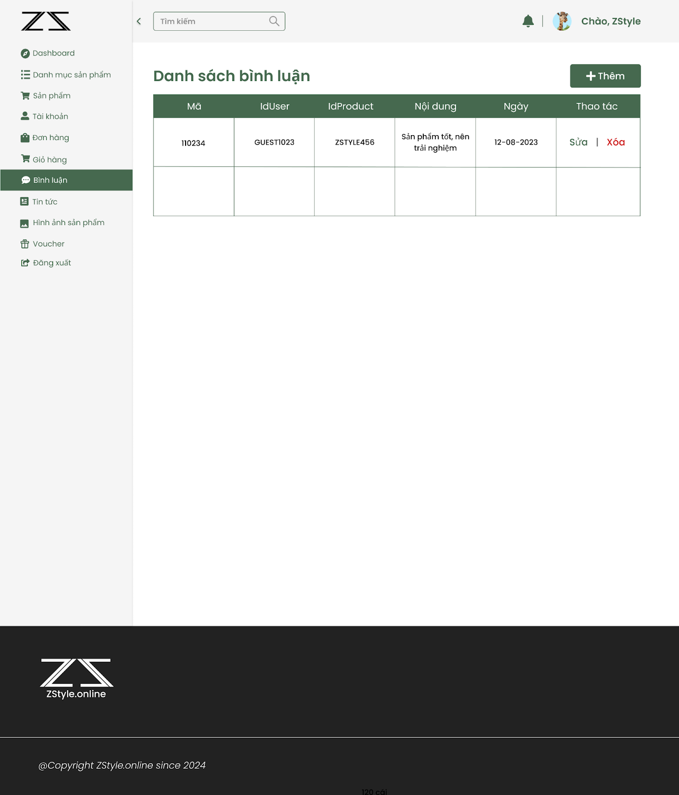

News Management

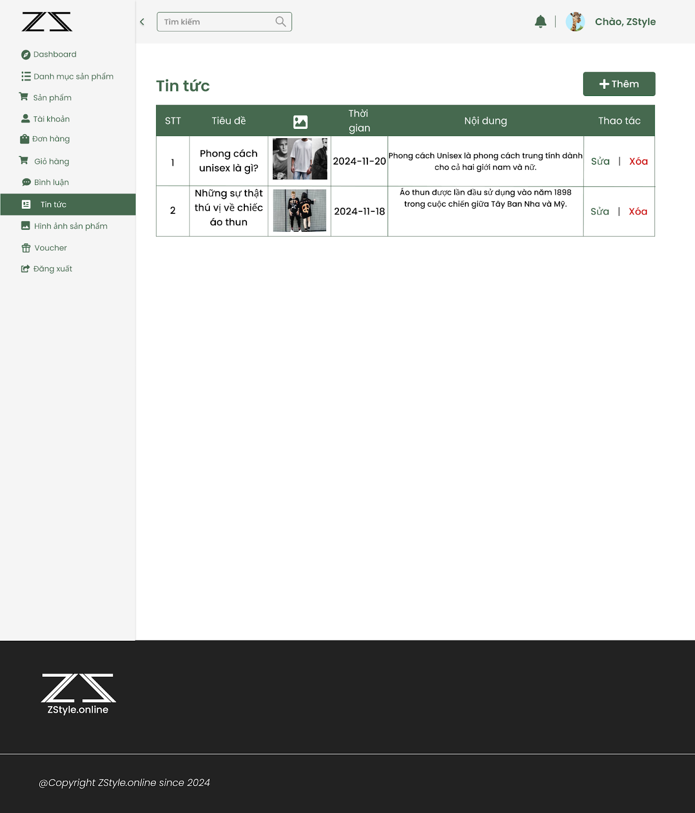

## **2.7 System Architecture Design**

### **2.7.1 System Architecture**

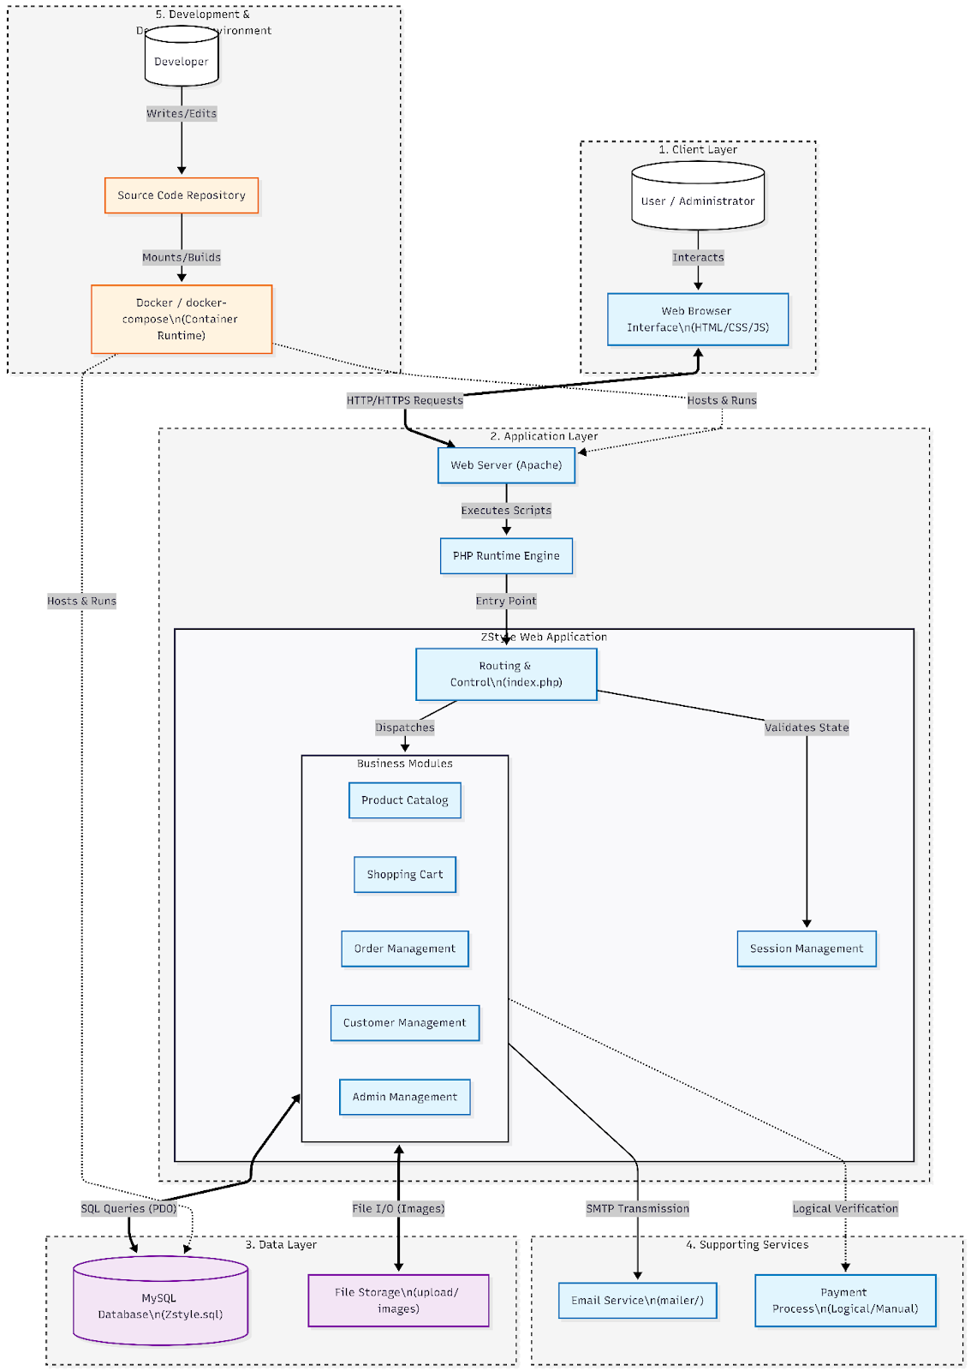

### **2.7.2 Conceptual database schema of functions**

Conceptual database schema of the Product Catalog function

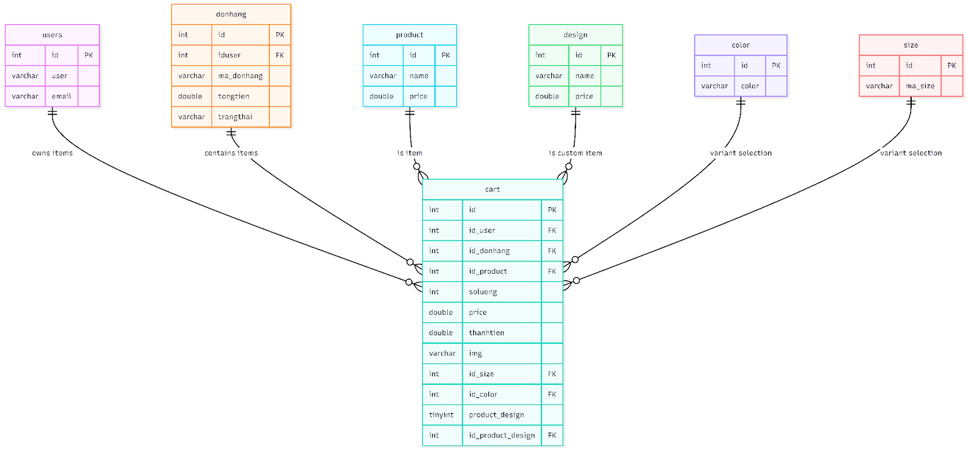

Conceptual database schema of the Shopping Cart function

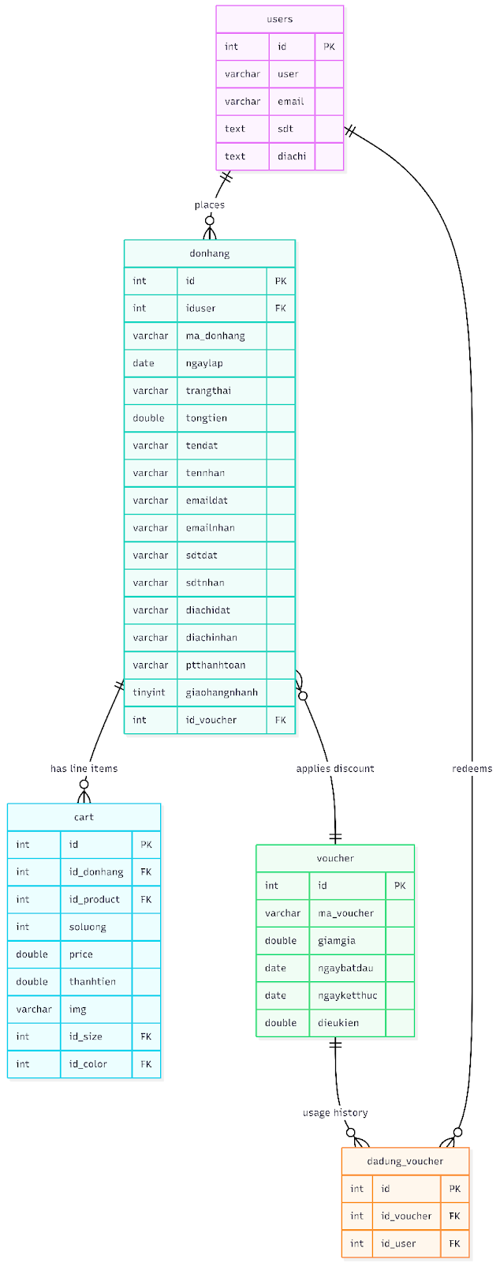

Conceptual database schema of the Order Management function

### 

Conceptual database schema of the Customer Management function

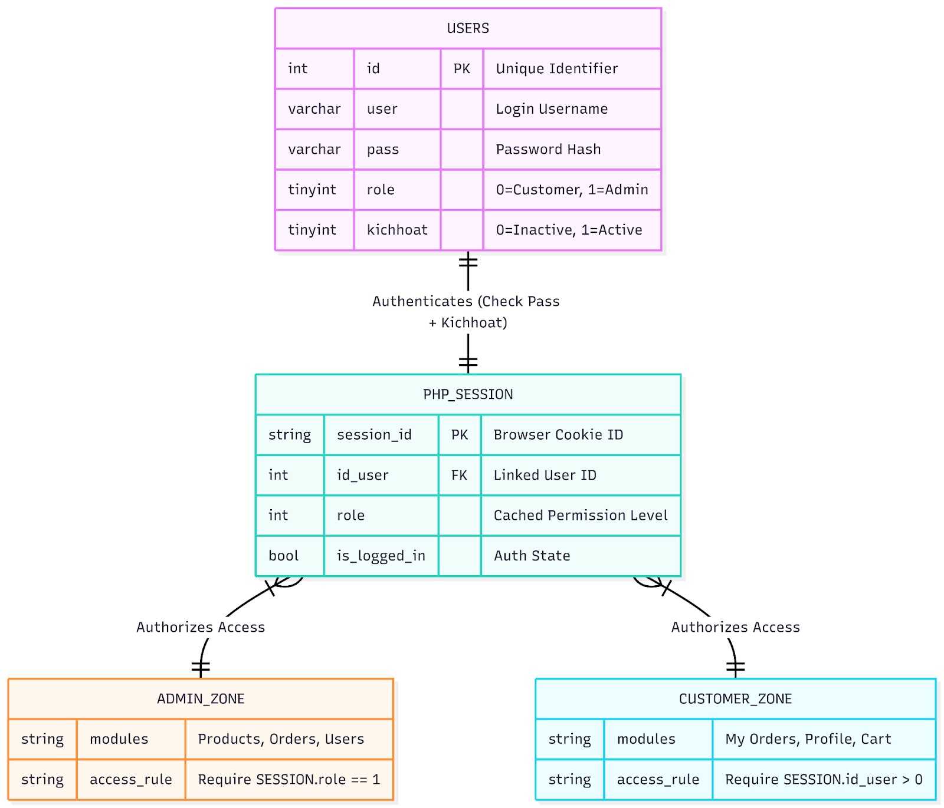

Conceptual database schema of the Access Control function

### 

### **2.7.3 Dictionary data**

| Board | Purpose | Master key | External lock | Main columns (Business operations) |
| --- | --- | --- | --- | --- |
| users | Stores customer and administrator account information, authentication credentials, and profiles. | id | Are not | user, pass, role (0=Guest, 1=Admin), activation, email, phone number, address |
| product | The main product definition table contains pricing, descriptions, and classifications. | id | idcatalog | ma_sanpham (SKU), name, price, priceold, hot, noibat, view, bestsell |
| catalog | Define product categories (e.g., T-shirts, Polo shirts, Jackets) for navigation and grouping. | id | Are not | name, sethome (Display homepage), stt (Sorting order) |
| img_product_color | Product image management is closely tied to specific color variations. | id | id_product, id_color | main_img, sub_img1, sub_img2, sub_img3 |
| quantity of goods | The inventory tracking table links products to specific size/color combinations. | id | id_product, id_size, id_color | quantity (Quantity in stock) |
| color | This is a comprehensive list of available product colors. | id | Are not | color (Color name), ma_color (Hex code) |
| size | This is a comprehensive list of available product sizes with measurement instructions. | id | Are not | ma_size (S, M, L...), chieucao, cannang |
| cart | Multipurpose panel: save temporary cart items AND permanent order details. | id | id_user, id_donhang, id_product, id_size, id_color | quantity, price, total, image, product_design (Custom flag) |
| donhang | The order header contains delivery information, status, and total amount. | id | iduser, id_voucher | ma_donhang (Order Code), trangthai, tongtien, ngaylap, ptthanhtoan |
| voucher | Store discount codes and their validity rules. | id | Are not | ma_voucher (Code), giamgia (Discount Amount), ngaybatdau, ngayketthuc, dieukien (Minimum Spending Condition) |
| dadung_voucher | Track voucher usage history to prevent reuse by the same customer. | id | id_voucher, id_user | No (Linked table) |
| comment | Store customer reviews and product ratings. | id | id_product, id_user | Content, rating (Star rating), time |

### **2.7.4 Business rules**

| ID | Rules | Related Table/Field | Related process/module | The significance of testing |
| --- | --- | --- | --- | --- |
| BR-01 | User login must fail if activation is 0, even if the password is correct. | users.kichhoat, users.pass | Verification (1.1) | Login verification failed even with correct information when the account is inactive. |
| BR-02 | Access to admin pages is strictly restricted to users with role = 1. | users.role | Admin Management (1.5) | Try accessing the admin URL as a client (role=0) and expect a redirect. |
| BR-03 | A completed order must include a "donhang" record and at least one "cart" record associated with it, indicated by "id_donhang". | donhang.id, cart.id_donhang | Order processing (1.4) | Check orphaned donhang records for items that do not have a corresponding cart entry. |
| BR-04 | Customers are restricted to viewing only orders where donhang.iduser matches the user ID in the current session. | donhang.iduser | Customer purchases (3.1) | Verify that User A cannot view User B's order history. |
| BR-05 | A voucher cannot be applied if a record already exists in dadung_voucher for the current user ID and voucher ID. | dadung_voucher, voucher | Payment (2.1.4) | Apply the used voucher code and expect a verification error. |
| BR-06 | A product must be linked to a valid category (idcatalog) to be displayed in the catalog. | product.idcatalog, catalog.id | Product catalog (1.2) | Verifying that a product has an invalid ID catalog does not cause catalog interface errors. |
| BR-07 | Product reviews (comments) must be permanently linked to the user ID (author) and product ID (target product). | comment.id_user, comment.id_product | Shopping experience (2.1.2) | Ensure that reviews remain relevant to the product after the update. |
| BR-08 | Inventory (quantity of goodsThe discount will only be applied upon successful order confirmation, not when adding items to the shopping cart. | `soluongton |  |  |

### **2.7.5 Block Diagram**

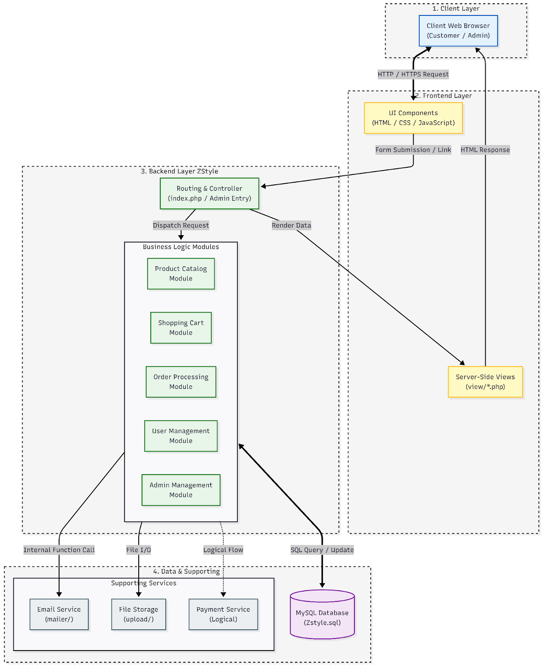

### **2.7.6 CI/CD Diagram**

### 

### **2.7.7 Decomposite view : C4**

C1 — Context Diagram

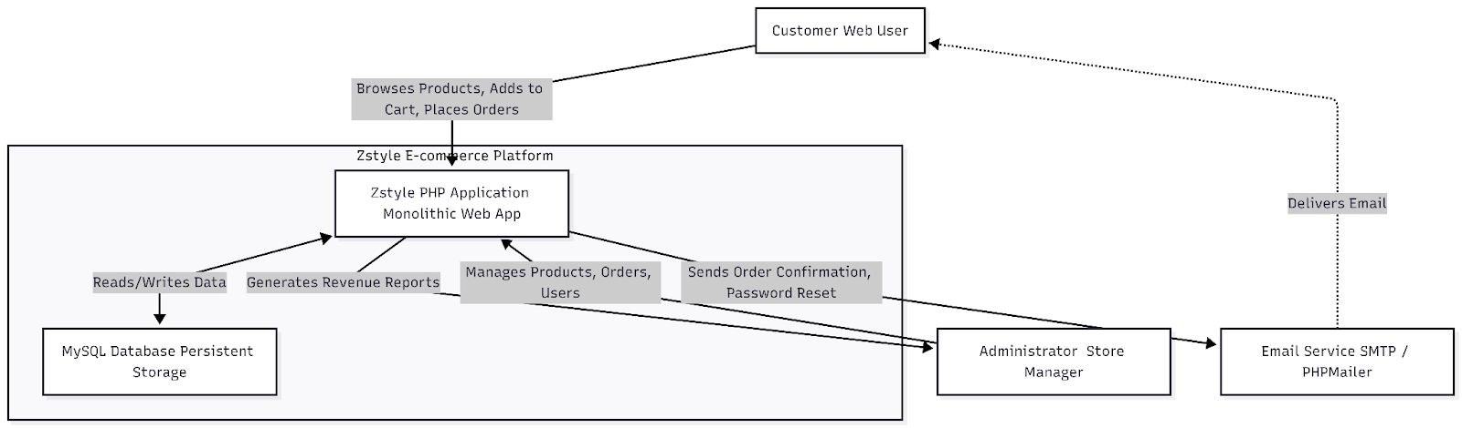

C2 — Container Diagram

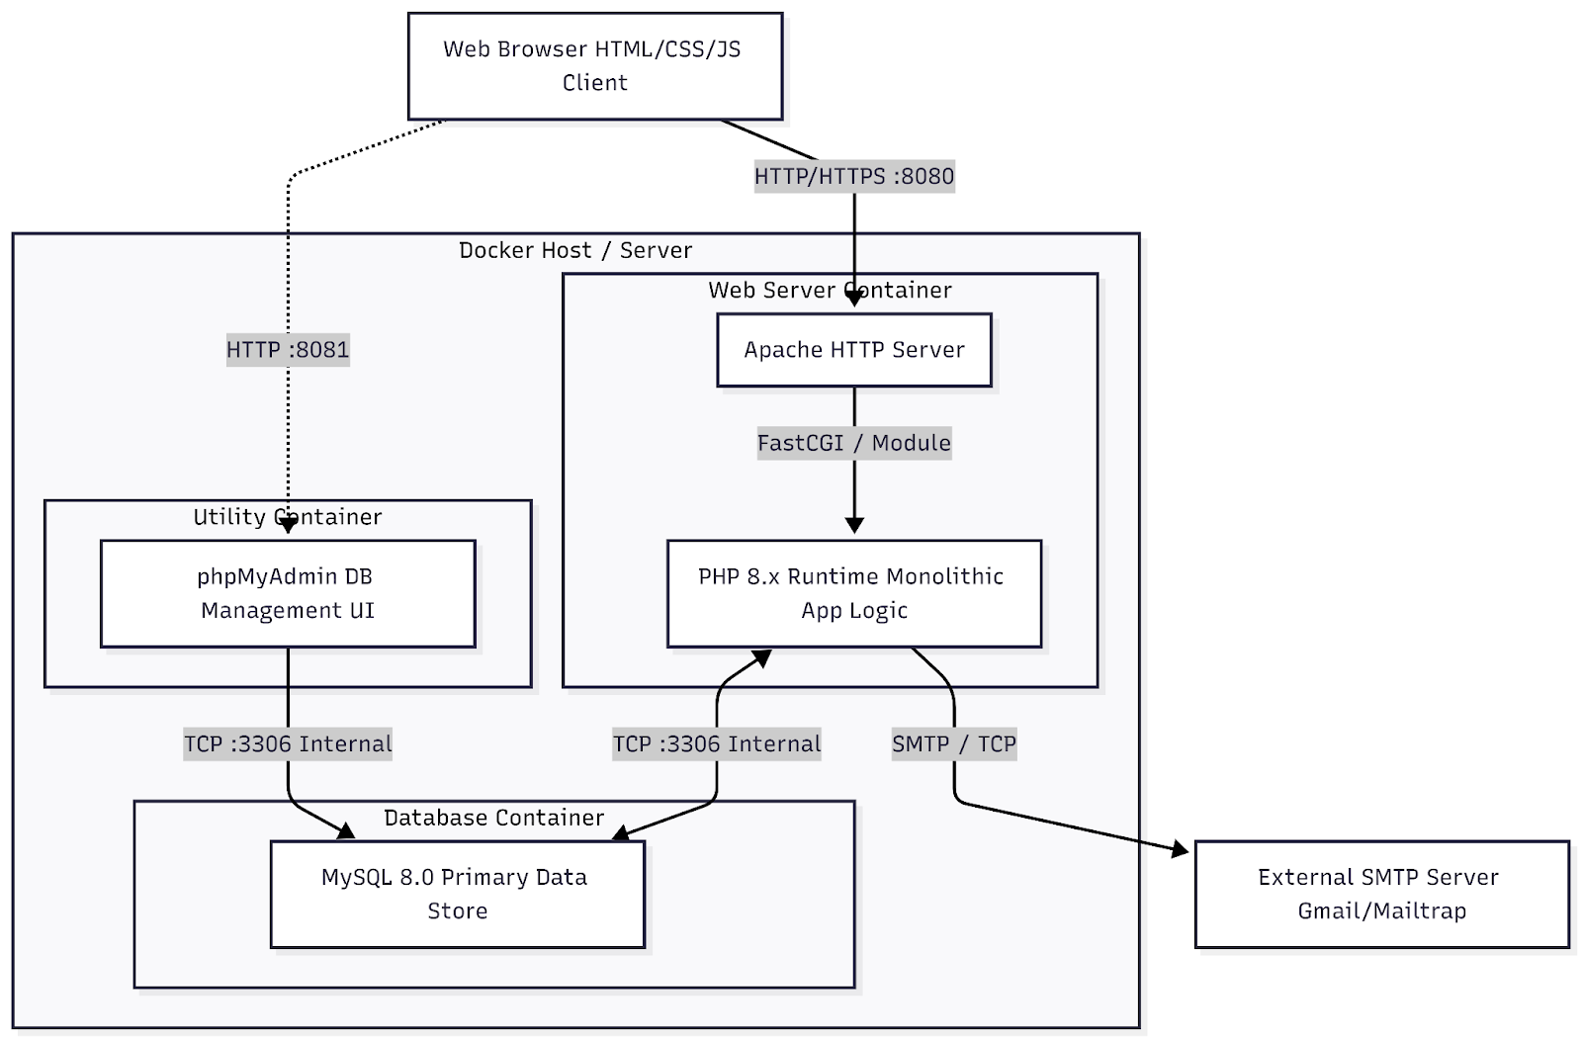

C3 — Component Diagram

High level model

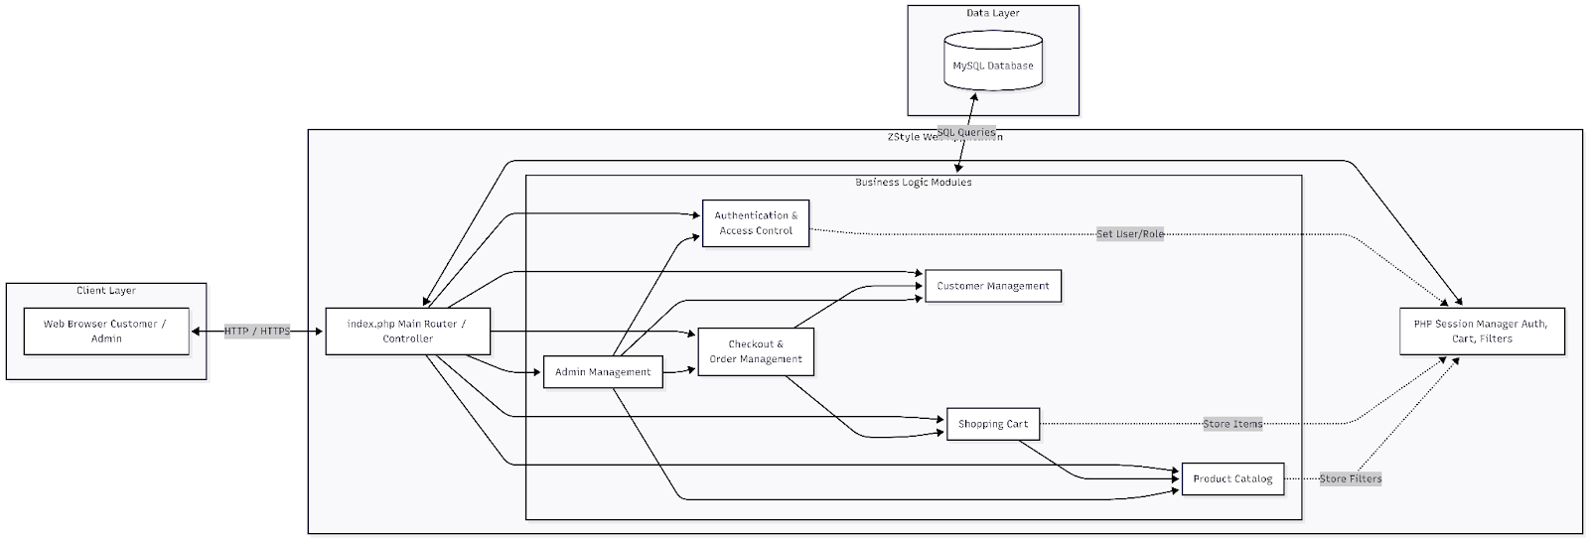

Module model

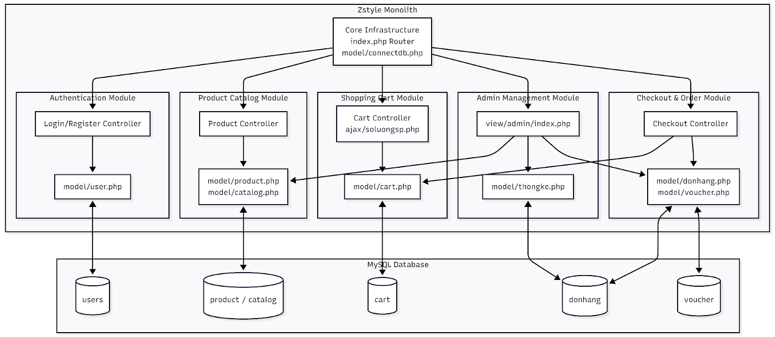

C4 — Code/Implementation Diagram

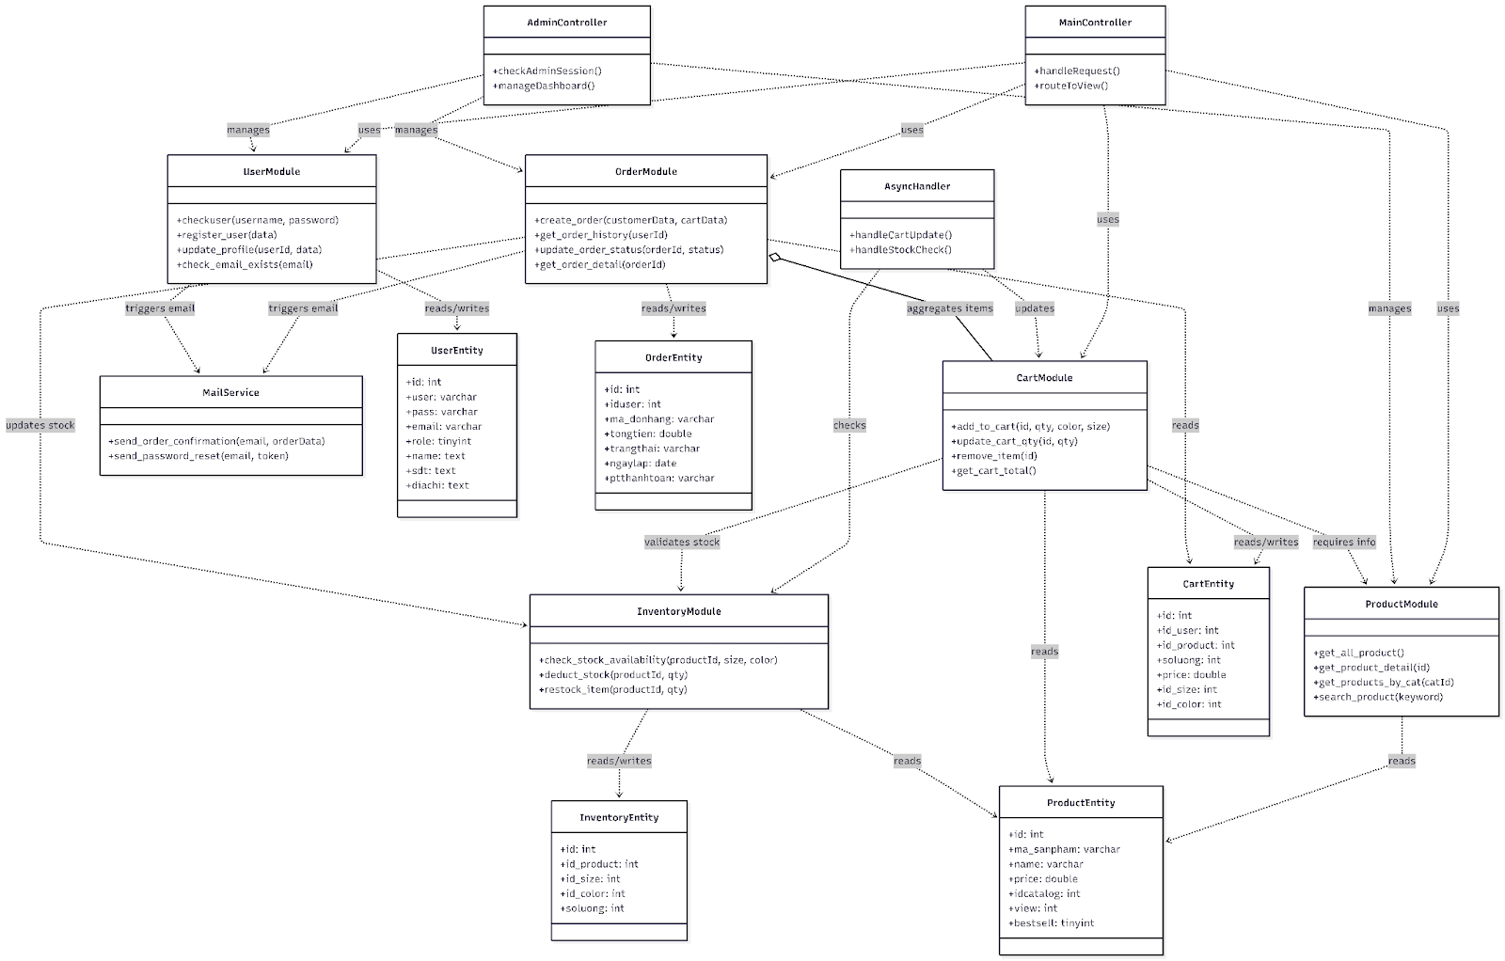

### **2.7.8 Communication view**

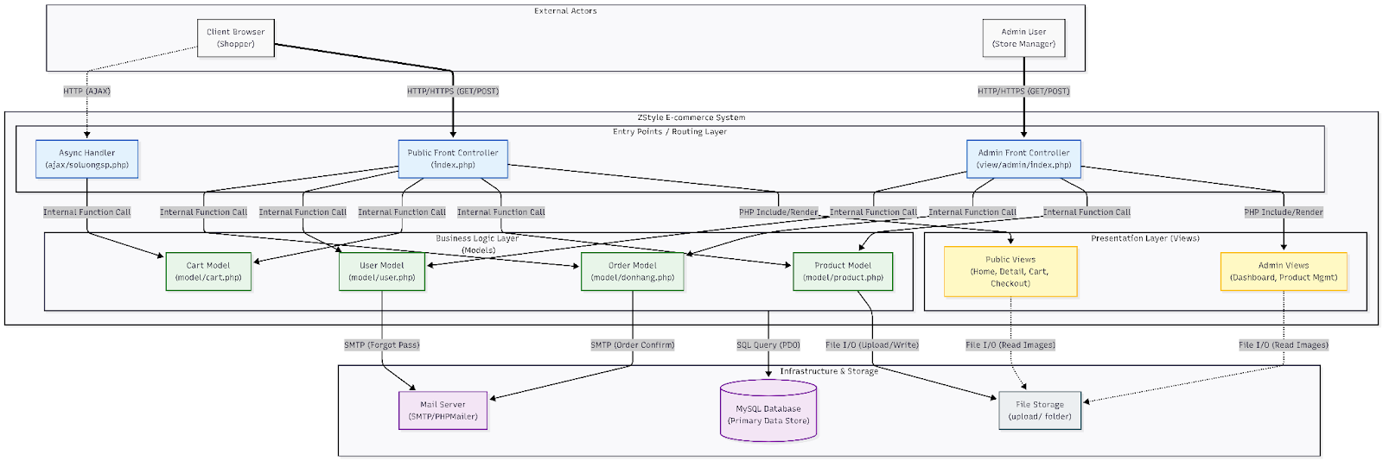

### **2.7.9 Deployment view**

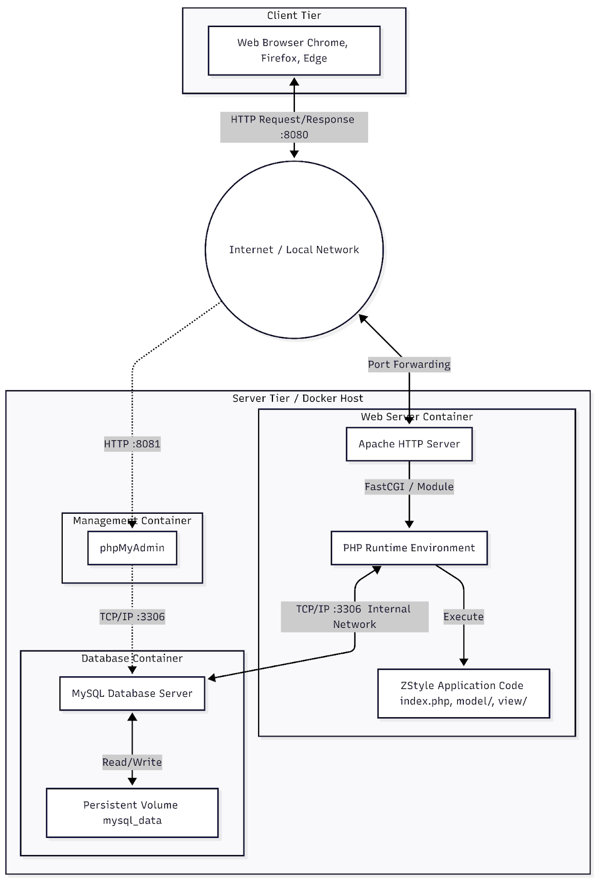

# **Chapter 3: Test Plan**

## **3.1 Testing Objectives**

The objective of the testing activities in this project is to systematically evaluate the software quality of the ZStyle e-commerce website by examining the functions, business processes, and access control mechanisms of the system before deployment.

Based on the detailed analyses inPROJECT_FULL_ANALYSISThe .md file is a test aimed at verifying that the ZStyle system meets the business requirements defined in Chapter 2, and also detecting potential errors that may arise during user and administrator interactions with the system.

Specifically, the main testing objectives of this project include:

* **Verify the correctness of business functions.**Ensure that client-side and administrator-side functions work correctly as required, especially critical functions such as product browsing, shopping cart management, order placement, order management, and access management.
* **Review business processes throughout.**Assess the consistency and completeness of key business processes, from the moment a customer accesses the website until an order is created, processed, and managed by the system.
* **Detecting functional and business errors**Identify errors that could affect user experience or corrupt system data, especially in high-risk processing flows.
* **Evaluating access control and authorization mechanisms**Verify the distinction in permissions between clients and administrators, ensuring that administrative functions are only performed by users with the appropriate privileges.
* **Assess the stability and consistency of the data.**Ensure that user, product, and order data is processed and stored accurately throughout the system's operation.
* **To serve as a basis for evaluating system quality.**The test results are used to evaluate the ZStyle system's compliance with requirements and as a foundation.

for suggesting improvements in the following chapters of the report.

## **3.2. Scope of testing**

The scope of testing for this project is determined based on a detailed analysis of the ZStyle system in the file.PROJECT_FULL_ANALYSIS.md. Testing activities focus on the core functional modules of the system, corresponding to the defined business processes and user roles.

### **3.2.1 Scope of testing client-side modules**

The testing covered modules that customers directly use during the shopping process on the ZStyle website, including:

* Module Authentication (Customer)Test the functionality for account registration, login, logout, and client session management.
* Module Product & Category:Test the functionality for displaying product lists, viewing product details, browsing by category, searching, and filtering products.
* Module Shopping Cart:Test the functionality for adding products to the shopping cart, updating the quantity, removing products, and displaying the total cart value.
* Module Checkout & Order Placement:Test the ordering process, including entering shipping information, confirming orders, and creating orders within the system.
* Module OrderTest the functionality to view a list and details of customer orders.

### **3.2.2 Scope of testing for administrator modules (Admin Modules)**

The administrator-side modules pose a high risk and directly impact ZStyle system data, therefore they are included in the focus of testing.

* Module Admin Authentication & Authorization: Testing administrator login, access control, and administrator user permissions.
* Module ProductTest the functionality for adding, editing, and deleting products, as well as managing product categories.
* Module UserTest user account management, including enabling, disabling, and assigning permissions.
* Module OrderTesting the functionality to view the order list, update order status, and track transaction information.

### **3.2.3 Data Testing Scope (Data & Database Modules)**

The ZStyle system uses a database to store business data, therefore the test scope includes modules related to data:

* User Data Module: Testing the storage and updating of user account data.
* Product & Category Data Module: Testing product data, categories, and relationships between data tables.
* Cart Data Module: Tests cart data in scenarios involving adding, updating, and deleting products.
* Order Data Module: Tests order data and order details, ensuring data integrity and consistency.

### **3.2.4 Scope of testing according to business process (Workflow Modules)**

In addition to functional module testing, the project focuses on testing modules according to business flow, including:

* Workflow Module: Customer Purchase Flow  
   (Product → Cart → Checkout → Order)
* Workflow Module: Order Processing Flow (Admin)  
   (Order Review → Status Update)
* Workflow Module: Access Control Flow  
   (Authentication → Authorization → Function Access)

### **3.2.5 Scope of applicable test types by module**

For the modules mentioned above, the following types of testing are applied:

* Perform functional testing on all modules.  
  Black-box testing for front-end modules.
* Basic white-box testing for critical business process modules.
* User interface testing (UI Testing) for the Frontend and Admin modules.
* Basic authorization and security testing for the Authentication and Admin modules.

### **3.2.6 Scope of Non-Testing**

The following content is outside the scope of testing for this project:

* Integrate physical payment gateways.
* Performance testing and heavy load testing.
* In-depth security testing (penetration testing).
* Deployment and testing in a production environment.

## **3.3 References**

The documents and sources used to develop the test plan in this project include:

* PROJECT_FULL_ANALYSIS.md:This document provides a comprehensive analysis of the ZStyle system, including business logic analysis, workflow, system architecture, risk analysis, and test guidelines.
* Reference materials on software testing and e-commerce website testing.

## **3.4 Background**

The ZStyle website is built as an e-commerce system for selling clothing, supporting two main user groups: customers and administrators. The system provides business functions to facilitate online shopping and business management.

The system analysis revealed that ZStyle has many closely interconnected business processes, particularly those related to shopping carts, ordering, order management, and admin access control. These processes handle critical data and have a high risk of failure.

Therefore, building a test plan for the ZStyle system needs to be based on the system's actual context, focusing on critical business functions and processes, rather than just testing individual functions. This background information forms the basis for determining the test objectives, scope, and strategy.

## **3.5 Constraints**

During the development and implementation of the test plan for the ZStyle e-commerce website system, several constraints were identified based on the practical context of the topic and the scope of the course project. These constraints directly affect the approach, scope, and level of testing implementation.

Firstly, time constraints are a crucial factor. Testing is conducted within the limited timeframe of the course, making it impossible to fully implement all types of testing at the in-depth level seen in a real commercial software project. Therefore, the test plan prioritizes the critical functions and business processes of the system.

Secondly, there are resource constraints. All testing activities in this project were performed by students, without the involvement of a specialized testing team. This resulted in testing being primarily done manually, with automated testing only applied to support and illustrate the approach.

Thirdly, there are constraints related to the deployment environment. The ZStyle system is deployed and tested in a local environment for learning purposes. This environment may differ from the actual deployment environment in terms of hardware configuration, network infrastructure, and concurrent access levels; therefore, the test results may not fully reflect potential issues that could arise in a real-world operating environment.

Fourth, constraints regarding test data. The data used in the testing process is simulated data, created for functional and business testing purposes. Therefore, situations involving large-scale real-world data or sensitive data are not considered within the scope of this project.

Finally, there are constraints regarding technical scope and integration. Functionality integrated with third-party systems, such as online payment gateways or physical shipping services, is not fully implemented and therefore not within the scope of testing. The test plan focuses on internal functionalities and core business processes of the system.

## **3.6 Risk List**

The risk list below identifies the key risks that could affect the quality of the ZStyle system and the effectiveness of testing. The risks were identified based on an analysis of business processes, functional roles, and data sensitivities as presented in the section.PROJECT_FULL_ANALYSIS.md.

**R1. Risk of Customer Purchase Flow distortion**

* Related modules: Product, Cart, Checkout, Order
* Description: The shopping flow from product viewing → shopping cart → order placement may be interrupted, missing processing steps, or processed in the wrong order.
* Potential cause: Modules are tested individually but lack end-to-end testing.
* Level of impact: High – directly affects the customer's ability to fulfill orders.
* Testing approach: Test the entire purchasing workflow.

**R2. Risk of shopping cart data discrepancies**

* Related modules: Cart, Session Management
* Description: Shopping cart data may not be updated accurately when adding, removing, or changing the quantity of products.
* Potential cause: Session handling errors or data synchronization issues between the UI and backend.
* Level of impact: High – resulting in discrepancies in the total order value.
* Testing approach: Testing shopping cart data using a combination of basic black-box and white-box testing.

**R3. Risk of creating and storing inconsistent order data.**

* Related modules: Checkout, Order, Database
* Description: Orders may be created with incomplete information or data may be out of sync between the order table and order details.
* Potential cause: Order processing logic error or data transaction error.
* Impact level: Very high – affects transaction data and order management.
* Testing approach: Data testing and ordering workflow testing.

**R4. Risk of unauthorized access to the administration area.**

* Module liên quan: Admin Authentication, Authorization
* Description: Users without administrative privileges can directly access administrative functions through invalid URLs or sessions.
* Underlying cause: Inadequate control over delegation of authority.
* Impact level: Very high – affecting the entire system and data.
* Testing approach: Conduct permission testing and basic security testing for the Admin module.

**R5. Risk of mismanagement in product and portfolio management.**

* Module liên quan: Product Management, Category Management
* Description: Product or category data may be incorrectly updated, accidentally deleted, or displayed improperly on the customer interface.
* Potential cause: Lack of testing for the connection between the administration module and the user interface.
* Level of impact: High – directly impacts the shopping experience.
* Testing approach: Functional administrative testing combined with client-side interface testing.

**R6. Risk of order status discrepancies**

* Related module: Order Management (Admin)
* Description: The order status is being updated incorrectly or inconsistently between the administrator and the customer.
* Potential cause: Errors in handling status updates or lack of testing in the order management flow.
* Impact level: Medium to high – causes confusion for customers and administrators.
* Test direction: Test the order processing workflow on the Admin side.

**R7. Risk of UI inconsistency**

* Related module: Frontend UI (Customer & Admin)
* Description: The interface displays incorrect system status or does not respond correctly to user behavior.
* Underlying cause: Lack of UI testing across different business scenarios.
* Impact level: Moderate – affects system usability.
* Testing approach: User interface testing (UI Testing) is applied to each module.

**R8. Risks due to limitations of test environment and data.**

* Related module: Entire system
* Description: Local testing environments and simulated data may not fully reflect real-world scenarios.
* Underlying causes: Limitations in time, resources, and implementation environment.
* Level of impact: Low to moderate.
* Testing approach: Clearly identify limitations in the report and prioritize testing critical business flows.

## **3.7 Training Requirements**

To ensure that ZStyle system testing is performed correctly and effectively, the necessary training needs are identified based on the system characteristics, the scope of testing, and the role of the tester in the project.

### **3.7.1 Training on system operations**

Testers need to have a thorough understanding of the ZStyle website's business logic before designing and executing test cases. Specifically:

* Understanding the business model of a clothing e-commerce website, including key business processes such as:
  + Browse and select products
  + Shopping Cart Management
  + Place and track your order.
  + Admin-side product and order management
* Understand the roles and permissions of each user group (Customer and Admin).
* Understanding the relationships between business modules is crucial to avoiding disjointed and inconsistent test case designs.

### **3.7.2 Training on testing methods and techniques**

Because the project involves applying various types of testing, testers need to be equipped with knowledge of the testing methods and techniques used in the project, including:

* Functional Testing.
* Workflow-based testing.  
  Black-box testing and related techniques.
* Basic white-box testing is used for critical processing flows.
* User Interface Testing (UI Testing).
* Testing authorization and access management.

### **3.7.3 Training on testing tools and environments**

The tester needs to be familiar with the environment and tools used in the project, including:

* How to deploy and use a local testing environment (Apache, PHP, MySQL).
* How to operate on the client-side and administrator-side user interfaces.
* How to record test results and errors that arise during the testing process.
* How to read and compare data in a database for data testing purposes.

### **3.7.4 Scope and level of training**

Within the scope of this course project, training is conducted at a self-study and self-preparation level, based on the analysis materials and test plans developed. The training is not as in-depth as in a real-world project, but it is sufficient to ensure that the testers are capable of:

* Understand the system that needs to be tested.
* Apply the chosen testing method correctly.
* Perform and evaluate test results consistently.

### **3.8 Test Requirements**

Professional training needs:

* Understanding the business processes of an e-commerce system, including:
  + The customer's purchasing process (view product → shopping cart → place order).
  + Admin's management process (managing products, orders, and users).
* Understanding the business rules and data constraints that have been analyzed inPROJECT_FULL_ANALYSIS.md, especially boundary cases and exceptions.

Training needs in testing techniques:

* Knowledge of testing techniques applied in this project:
  + Kiểm thử hộp đen (Equivalence Partitioning, Boundary Value Analysis, Decision Table).
  + White-box testing (control flow analysis, logic branch testing).
  + Workflow testing and risk-based testing.
* Understand and correctly apply the concepts of:
  + Test case, test scenario, test execution.
  + Defect, severity, priority.

The need for training in security and data

* Identify and test for common security risks in web systems:
  + SQL Injection.
  + Cross-Site Scripting (XSS).
  + Insecure Direct Object Reference (IDOR).
* Understand data integrity issues between tables such as cart, order, user, and product.

Training needs regarding testing tools and support:

* Skills in using manual testing support tools:
  + Web browser (Chrome, Firefox) with Developer Tools.
  + Tools for logging errors and tracking test cases (Excel, Word).
* Understanding the role of automated testing and test case generation tools (e.g., GenAI), at a directional and reference level, is appropriate for the scope of this project.

Assess the level of training:

* Project analysis document.
* Course materials for the Software Testing module.
* The process of self-study and practice by students.

### **3.8.1 Test Items**

| Module | Business functions (according to MD) | Test object | Testing focus |
| --- | --- | --- | --- |
| Authentication | Register, log in, check activation | Form + Session + DB | Authentication, authorization, security |
| Product Catalog | Browse, search, and filter products. | UI + Query SQL | Data accuracy |
| Cart | Add/edit/delete products | Session + DB | Session-DB synchronization |
| Checkout | Create an order | Workflow + Transaction | Transaction integrity |
| Order | Status monitoring | DB + UI | State consistency |
| Admin Management | CRUD product, user, order | RBAC + DB | Access control |
| Database | cart, donhang, user, product | Data constraints | Avoid orphan/duplicate |
| Security | SQLi, XSS, IDOR | Input + URL + Session | Prevent unauthorized access. |

The test items include all functional and non-functional components of the ZStyle system that need to be tested, specifically:

Customer-facing Functional Requirements

* Authentication & Account Management
  + Register for a customer account.
  + Log in, log out.
  + Update your personal information.
  + Change password and recover password.
  + Manage account status (activated/deactivated).
* Product Catalog & Search
  + Display the list of products.
  + View product details (price, description, color, size, images).
  + Search for products by keyword.
  + Filter and sort products by category, price, and attributes.
* Shopping Cart
  + Add products to your shopping cart.
  + Update the product quantity.
  + Remove the product from your shopping cart.
  + Calculate the total cost in real time.
* Checkout & Order
  + Enter shipping information.
  + Choose a payment method (system logic).
  + Place an order and create an order.
  + View your order history.
  + Cancel orders when permitted.

Admin-facing Functional Requirements

* Admin Authentication & Authorization
  + Log in as administrator.
  + Role-based access control.
* Product & Category Management
  + Add, edit, and delete products.
  + Product catalog management.  
    Manage product images and attributes.
* Order Management
  + View the list of orders.
  + Update order status.
  + Track customer purchase information.
* User Management
  + Manage user accounts.
  + Activate/deactivate account.
  + Control system access.

#### 

Data & Database Requirements

* Data integrity between tables: user, product, cart, order, comment, voucher, etc.
* Store and retrieve data accurately according to each business process.
* Synchronize data between the user interface and the database.
* Data control in case of errors or invalid operations.

Workflow & Business Process Requirements

Business process testing requirements:

* Customer Purchase Workflow:  
  View product → Add to cart → Checkout → Create order → Track order.  
  Admin Order Processing Workflow:  
  Receive order → Update status → Track and manage order.
* Access Control Workflow:  
  User authentication → Authorization → Access to appropriate functions.

### **3.8.2 Acceptance Conditions**

This section defines the test acceptance criteria for evaluating the completion of testing for the ZStyle system – a clothing e-commerce website. A test case or group of test cases is considered passed when it fully meets the criteria described below.

General acceptance criteria

* All test cases within the test scope have been executed.
* The main business functions are operating correctly according to the requirements analyzed.
* There are no unhandled Critical or High level errors.  
  Critical business workflows are executed successfully from start to finish.
* Data within the system is guaranteed to be intact and consistent.

Acceptance Test Criteria by Functional Group

| Functional group | Test conditions | Expected results | Acceptance status |
| --- | --- | --- | --- |
| Authentication | Valid login | User has successfully logged in. | Pass |
| Authentication | Incorrect login information | Access denied system | Pass |
| Product Catalog | View product list | Display the correct data. | Pass |
| Cart | Add/update products | The shopping cart is updated correctly. | Pass |
| Checkout | Create a valid order | The order has been successfully created. | Pass |
| Checkout | Missing required information | Error warning system | Pass |
| Order History | View order history | Display the correct order for the user. | Pass |
| Admin Management | Access without authorization | Access denied. | Pass |
| Data Integrity | Synchronize cart and order | No data loss or duplication. | Pass |
| Security | Unauthorized Access (IDOR) | Blocked | Pass |

Rejection criteria (Fail)

* There are Critical or High errors that directly affect the core business process.
* The purchasing workflow or order management cannot be completed.  
  Data is lost, corrupted, or inconsistent.
* Users or administrators may gain unauthorized access to functionality.

Test completion criteria

* All of the above acceptance criteria have been met.
* The remaining bugs are only at the Medium or Low level and have been documented in the bug report.

## **3.9 Testing Strategy**

### **3.9.1 Overview of testing strategy**

The testing strategy for the ZStyle system – a clothing e-commerce website – is built on the characteristics of a complete e-commerce system, including many closely linked business modules such as: Product Categories, Shopping Cart, Payment, Orders, Customer Management, and System Administration.

The testing strategy focuses on three main objectives:

* Ensure that business functions operate correctly according to the requirements analyzed in the specification document.
* Control data integrity between modules when executing critical workflows.
* Minimizing the risk of errors in key business flows directly impacts user experience and business operations.

### **3.9.2 Total Testing Approach**

ZStyle's testing strategy is built on risk-based testing and workflow-based testing methods, in which:

* Critical and frequently used functions (ordering, payment, order management) are prioritized for thorough testing.  
  Cross-module business flows are tested against complete scenarios, rather than testing individual functions.

The system was tested based on two main groups of objects:

* Customer: uses the public website interface.
* Admin: uses the internal administration interface with specific permissions.

### **3.9.3 Testing Strategy by Test Type**

Black-box testing

* Register / Log in to your account
* Product categories and search
* Shopping cart
* Payment and ordering
* Customer account management

The black box techniques used include:

* Equivalence Partitioning
* Boundary Value Analysis
* Decision Table
* State-based testing

White-box testing

* Login and access control processing flow
* Handling shopping cart sessions
* Create orders and record the data in the database.

#### 

Workflow-based testing

* The complete purchasing process:  
  View product → Add to cart → Checkout → Create order → Send confirmation email
* Admin's order processing procedure:  
  Receive order → Confirm → Process → Complete / Cancel  
  Product and inventory management process
* Account management and permission process

User Interface Testing (UI Testing)

* The interface elements are displayed correctly and are easy to use.
* The error message is clear and contextually appropriate.
* User operations (clicking, typing, page navigation) are working smoothly.
* UI testing is applied to the user interface as well:
* Website for customers
* Admin panel

Automation Testing

* Log in
* Add products to your shopping cart
* Update product quantity
* Basic payment

| Module | Main testing strategy |
| --- | --- |
| Product Catalog | Black-box, UI Testing |
| Shopping Cart | Black-box, Boundary Value, Workflow |
| Checkout & Order | Workflow-based, Data Integrity |
| Customer Account | Black-box, State-based |
| Inventory | Workflow-based, Data Validation |
| Admin Panel | Access Control Testing, Workflow |
| Database | Data Consistency Testing |

## **3.10 Testing Phases**

The testing of the ZStyle system – a clothing e-commerce website – was organized into testing phases to ensure software quality at various levels, from testing individual processing logic to evaluating the entire business process and the system's ability to meet requirements. The division of testing phases was carried out to suit the specific characteristics of the project.

**Unit Testing**

Unit testing focuses on testing individual logical components of a system, primarily on the backend.  
Within the scope of this project, unit testing is applied to key business process functions such as:

* Functions for user authentication and account status verification.
* These functions handle data related to shopping carts and orders.
* Branching conditions and exception handling in source code.

This phase primarily utilizes white-box testing techniques to ensure that critical logic branches are fully executed and tested before integration with other modules.

In the Zstyle project, CI/CD is configured using GitHub Actions with the main goal of automating the execution of unit tests whenever there are code changes. The pipeline is defined in a YAML workflow file, in which the testing environment is set up as follows:

* Operating system: Ubuntu (standard CI environment)
* Language: PHP 8.2
* Testing tool: PHPUnit
* Test scope: only run the Unit Test suite.

The CI/CD configuration is designed to be minimalist, focusing only on testing business logic through Unit Tests, and does not include testing the interface, API, or system integration.

The CI/CD procedure for Unit Testing is performed in the following order:

1. Pipeline activation: The pipeline is automatically activated when a push or pull request is made to the repository.
2. Retrieving source code: The latest source code is retrieved from the repository in preparation for testing.
3. Setting up the environment: Install PHP and the necessary libraries through Composer.
4. Executing Unit Tests: PHPUnit is called to run the Unit Tests defined in the tests/Unit directory. The pipeline will check the test results and determine the success or failure status.
5. Evaluating the results: If all Unit Tests pass, the pipeline ends successfully. Otherwise, the pipeline stops and reports an error.
6. Build the Docker image, and then push the image to the GitHub Container Registry.

This order ensures that every source code change is automatically checked before being accepted for integration.

Integration Testing

Integration testing is performed to check the interaction and data exchange between modules in the ZStyle system.  
The main integration flows tested include:

* The link between the shopping cart module (Cart) and the order placement module (Checkout).
* The link between the ordering module and the order management module.
* The interaction between the user interface and the database.

This phase helps detect errors related to data transmission, state synchronization, and integration issues between system components.

**System Testing**

System testing evaluates the entire ZStyle system as a unified whole, ensuring that the functions and business rules meet the analyzed requirements. This is the core testing phase of the project.

In addition to basic functional testing, System Testing also includes:

* Security testing: examines common risks such as SQL Injection, Cross-Site Scripting (XSS), and Insecure Direct Object Reference (IDOR).
* Data integrity testing: ensures that data across the cart, order, user, and product tables is consistent, preventing data loss or duplicate data creation.
* User interface testing (UI Testing): verifying the correctness and usability of the interface.

Applying risk-based testing at this stage helps prioritize testing areas with a high level of risk.

**Workflow-Based Testing**

Workflow-based testing is performed to test complete business processes in which multiple modules work together.  
The main workflows being tested include:

* The customer's purchasing process (view product → shopping cart → place order).
* Admin's order management and processing procedures.
* Access control and user authorization procedures.

This phase is particularly important because many errors only appear when the system is operating according to the actual business process, and cannot be detected through testing individual functions.

#### 

**Acceptance Testing**

Acceptance Testing is the final testing phase, performed based on the Acceptance Test Criteria defined in section 3.2.2.  
The goal of this phase is to confirm that the ZStyle system fully meets the core functional and business requirements, ready for the completion of testing within the project scope.

A system is considered satisfactory when:

* The main business workflows were successfully executed.
* No critical or high-level errors exist.
* All acceptance criteria have been fully met.

## **3.11 Resources**

This section describes the resources used in the testing process of the ZStyle system – a clothing e-commerce website, including human resources and the methods of managing testing activities within the scope of this course project.

### **3.11.1 Human Resources**

| Role | Primary responsibility |
| --- | --- |
| Test Planner | Develop a test plan, defining the scope, strategy, and schedule for testing. |
| Test Designer | Design test cases and test scenarios based on business requirements and workflows. |
| Test Executor | Execute the test case and record the Pass/Fail result. |
| Defect Reporter | Record, classify, and track errors that occur. |
| Reviewer | Review test cases and test reports, and ensure document consistency. |

Competency requirements

These roles require the following qualities from the person performing them:

* Understanding of e-commerce system business processes.
* Basic knowledge of software testing, especially black-box testing and workflow testing.
* Skills in analyzing, documenting errors, and writing test documentation.

### **3.11.2 Test Management**

Test management in this project was carried out at a level appropriate to the project scale, focusing on controlling the progress, scope, and results of testing.

Test management activities include:

* Test plan management:
  + The test plan was developed based on the requirements analysis document and is detailed in Chapter 3 of this report.
* Test case management:
  + Test cases are designed and stored according to each functional module of the system.
  + Each test case is assigned a unique identifier for easy tracking and comparison.
  + Test case content includes basic information such as test objectives, prerequisites, steps to be taken, and expected results.
* Test schedule management:
  + Testing progress is tracked by marking the execution status of each test case (not executed, pass, fail).
  + Test execution is performed in order of priority, focusing on key business functions and high-risk areas.
  + Test results are compiled periodically to assess the completion level of the testing activity.
* Error handling:
  + Errors discovered during testing are recorded as defects.
  + Each defect is categorized according to its severity and priority for resolution.
  + The defect status is monitored until it is resolved or deemed acceptable within the project scope.
* Report and evaluation:The test results are compiled and presented in the following chapters of the report, serving as the basis for evaluating the quality of the ZStyle system.

## **3.12 Testing Environment**

This section describes the environment used to perform testing activities for the ZStyle system – a clothing e-commerce website. Clearly defining the testing environment helps ensure that test results are evaluated correctly within the context of the project's real-world implementation.

### **3.12.1 Hardware**

The testing was conducted on hardware designed for educational and research purposes, with a configuration that meets the operational requirements of a small to medium-sized e-commerce web system.

Test hardware configuration

* Equipment: Personal computer (Laptop / Desktop)
* Memory (RAM): Minimum 8GB
* Storage: SSD/HDD80GB+
* Network equipment: A stable internet connection is required for accessing and testing the system.

Hardware usage scope

* The hardware used for the operations includes:
  + Deploy the ZStyle system in a local environment.
  + Execute test cases manually in a web browser.
  + Record the test results and any errors that occur.
* No large-scale load testing or performance testing requiring specialized infrastructure will be performed within the scope of this project.

### **3.12.2 Software**

The ZStyle system is deployed and tested in a local software environment, accurately reflecting the architecture and technology used in the project.

* Operating system: Windows
* Web Server: Apache (via XAMPP)  
  Programming language: PHP 8.x
* Database: MySQL
* Frontend: HTML5, CSS3, JavaScript, Bootstrap 5
* Database management tool: phpMyAdmin
* Browsers used for testing: Google Chrome (primary), combined with Firefox for basic interface testing.

### **3.12.3 Test Deployment Environment**

The project's testing infrastructure is implemented using a local development environment model, suitable for the scale and objectives of the project.

* Deployment model: Localhost
* Access mechanism: Through the internal web browser.
* Source code management: Git
* Test data:
  + Using a MySQL database with simulated data.
  + The main data tables include: user, product, catalog, cart, order, comment, voucher,quantity of goods, …

### **3.12.4 Test Data**

Test data used in the test environment is simulated data, created to test the functions and business processes of the system, including:

* Customer and administrator account data.
* Product data, product catalog.
* Shopping cart and order data are in various states.

Test data does not contain actual personal information and is designed to cover the key test scenarios identified within the project scope.

### **3.12.5 Limitations of the testing environment**

Because it was implemented in an educational environment, the testing environment for this project has some limitations:

* It doesn't fully simulate the real-world production environment.
* Do not test under conditions of multiple users accessing simultaneously.
* It does not integrate third-party services such as actual payment gateways.

## **3.13 Test milestones**

| Milestone | Job description | Estimated time | Results achieved |
| --- | --- | --- | --- |
| Milestone 1 – Test Requirements Analysis | - Analyze business requirements and test requirements.  - Identify the modules, workflows, and functionalities that need testing.  - Define the scope and type of testing. | Week 1 | List of test requirements and test scope |
| Milestone 2 – Test Planning & Strategy | - Develop a Test Plan for the ZStyle system  - Define the testing strategy, scope, and phase.  - Identify the environment, resources, and risks. | Week 2 | Complete Test Plan Document |
| Milestone 3 – Test Case Design | - Design test cases for Customer modules  - Design test cases for Admin modules  - Design test cases according to workflow  - Prepare test data | Weeks 3 + 4 | Complete test case set |
| Milestone 4 – Test Execution | - Execute test cases according to modules and workflows.  - Record the Pass/Fail results  - Record and classify errors | Week 5 | Detailed test results and bug list |
| Milestone 5 – Retesting & Recompilation | - Re-testing the fixed functionalities  - Assess the level of compliance with requirements.  - Summary of test results | Week 6 | Test Report & Test Summary |

## **3.14 Test Plan Review Checklist**

The checklist below is used to review and evaluate the completeness, consistency, and compliance of the test plan documentation for the ZStyle system – a fashion e-commerce website.

### **3.14.1 General Information**

| **Attributes** | **Content** |
| --- | --- |
| Project | ZStyle – Fashion E-Commerce Website |
| Document | Chapter 3 Test Plan |
| Reviewer | QA Reviewer |
| Release | N/A |
| Reference template | Test Plan Review Checklist.xlsx |
| Date | N/A |

### **3.14.2 OVERVIEW**

|  | **Criteria** | **Yes / No / N/A** | **Comment** |
| --- | --- | --- | --- |
| A1 | Does the test plan adhere to the defined template/guideline? | Yes |  |
| A2 | The scope and boundaries of the test are clearly defined. | Yes |  |
| A3 | Relevant documents and prerequisites are defined. | Yes |  |
| A4 | The test plan is traceable according to requirements. | Yes |  |
| A5 | Does the Test Plan include version management? | Yes |  |

### **3.14.3 CONTENT**

| **N** | **Criteria** | **Yes / No / N/A** | **Comment** |
| --- | --- | --- | --- |
| B1 | The Test Plan clearly outlines the required content. | Yes |  |
| B2 | Test objectives | Yes |  |
| B3 | Scope of testing | Yes |  |
| B4 | Ctesting strategy | Yes |  |
| B5 | Resources | Yes |  |
| B6 | Test schedule | Yes |  |
| B7 | Testing environment | Yes |  |
| B8 | Product delivered for testing | Yes |  |
| B9 | Test Reporting Mechanism | Yes |  |
| B10 | The roles and responsibilities of the members are defined. | Yes |  |
| B11 | There is a detailed description of the process and methods for testing the system. | Yes |  |
| B12 | The types of tests applied are clearly described. | Yes |  |
| B13 | The necessary tests for each type of test are fully listed. | Yes |  |
| B14 | Integration testing is included. | Yes |  |
| B15 | The level of test coverage is sufficient. | Yes |  |
| B16 | The schedule fits within the project timeline. | Yes |  |
| B17 | The dependencies in the test are identified. | Yes |  |
| B18 | There are defined entry criteria. | Yes |  |
| B19 | There are defined exit criteria. | Yes |  |
| B20 | There is a regression testing strategy. | N/A | Not applicable within the scope of the project. |

### **3.14.4 Overall comments**

| **Content** | **Evaluate** |
| --- | --- |
| Test Plan Completeness Level | Obtain |
| Key criteria | Fully satisfied |
| Items not applicable | Regression Testing |
| Review conclusion | The test plan meets the requirements and is suitable for use in testing activities within the project. |

# 

# **Chapter 4: DESIGN AND TESTING**

## **4.1 Testing Strategy**

### **4.1.1 Applying the Agile/Scrum testing model**

In the ZStyle – a clothing e-commerce website project, testing was organized and implemented according to the Agile/Scrum model, aiming to ensure flexibility, adaptability to change, and improved software quality throughout the development lifecycle.

According to the Agile/Scrum model, the system development process is divided into short cycles (Sprints), where each Sprint focuses on completing one or a group of specific functionalities. Testing is not performed at the end but is integrated in parallel with the development process, helping to detect and fix errors early.

Although the project adopts the Agile/Scrum development process for flexibility, the testing mindset still inherits the rigor of the V-Model, in which: Unit Test corresponds to Component Design, Integration Test corresponds to Architecture Design...

Within the scope of this topic, the application of the Agile/Scrum testing model is demonstrated through the following contents:

* **Early and continuous testing**Immediately after a function or module is completed in a Sprint, corresponding test cases are designed and executed to verify the correctness of that function.
* **User Story Testing**The functionalities of the ZStyle system are described as user stories (e.g., customer views product, adds to cart, places order; admin manages product, processes order). Test cases are built based on each user story, ensuring that testing closely reflects the actual needs of users.
* **Quick response and continuous improvement**The test results after each Sprint are used to provide feedback and make timely adjustments to any unsatisfactory functionalities. This allows the system to be gradually improved through each iteration instead of waiting until the final stage.
* **Coordination between development and testing**In the context of a project, the roles of development and testing are not completely separate. However, applying Agile/Scrum thinking helps implementers become more aware of the importance of testing and evaluating functionality.rightduring the system development process.

Applying the Agile/Scrum testing model to the ZStyle project helps ensure that functionalities are tested in a timely manner, minimizing the risk of accumulated errors and improving system quality within the project's time and resource constraints.

### **4.1.2 Integrating testing into the project development lifecycle**

In the ZStyle – a clothing e-commerce website project, testing was integrated throughout the entire software development lifecycle, rather than being performed only at the final stage. This approach aimed to ensure that errors were detected early, reducing the risk of error accumulation and improving system quality under the project's limited time and resources.

Based on ZStyle's unique characteristics as a monolithic e-commerce system with tightly integrated modules such as Authentication, Product Catalog, Cart, Checkout, and Admin Management, test integration is implemented in stages as follows:

During the requirements analysis phase, the business requirements and user stories of the system are considered simultaneously from a testing perspective. Each function is not only described in terms of business logic but also its testability, test conditions, and boundary cases are defined. This ensures that all requirements can be verified through specific test cases.

During the system design phase, testing is integrated through the analysis of business processes (workflows), data design, and user authorization. Key flows such as "Customer Purchase," "Administrator Product Management," and "Order Processing" are used as the basis for designing test scenarios and test cases at both the system and business levels. Simultaneously, architectural components such as the frontend, backend, and database are clearly defined to support the design of integration testing and white-box testing in subsequent steps.

During the functional development phase, testing is conducted in parallel with the coding process. After each module or function is completed, corresponding test cases are executed to verify the correctness of business logic, data, and access control. Early testing helps detect logical errors, data validation errors, and state handling errors before the system is fully integrated.

During the system integration phase, testing focuses on business flows across multiple modules, such as the flow from adding products to the shopping cart to successful order placement, or the flow of administrators editing data and its impact on the user interface. At this stage, testing not only validates individual functions but also evaluates the coordination between components within the entire ZStyle system.

During the completion and evaluation phase, test results are compiled into test reports, bug reports, and summary reports. Remaining bugs are noted as limitations of the system within the project scope and serve as a basis for future improvement suggestions.

Integrating testing into the entire project development lifecycle ensures that the ZStyle system is continuously and methodically quality-controlled, aligning with the chosen Agile/Scrum development model.

### **4.1.3 Scope and focus of testing**

The scope and focus of testing in the Test Design phase of the ZStyle – Clothing E-commerce Website project were determined based on the importance of the functions, their frequency of use in practice, and the potential risks analyzed in the documentation.PROJECT_FULL_ANALYSIS.md. Clearly defining the scope and focus helps test case design concentrate on the areas that significantly impact system quality.

**Scope of testing**

* Customer-side functional group: Modules directly related to the user's shopping experience, including product browsing, shopping cart management, order placement, and order tracking.
* Admin-side functional group: Modules that support system management such as product management, categories, users, and orders.
* Business and Data Processing Group: Key business processes related to shopping carts, orders, user permissions, and database data storage.

**Testing focus**

* **Focus 1 – Core Business Flows**High priority is given to business flows across multiple modules, especially the customer purchase flow and the administrator order processing flow. Test cases are designed to ensure that data and state are processed correctly at all steps.
* **Focus 2 – Data Integrity and Consistency**The testing focuses on ensuring that shopping cart, order, and user data are stored and updated correctly in the database, avoiding synchronization issues between the interface and backend.
* **Focus 3 – Authorization and Access Control**Because the system has a clear separation between Customer and Admin roles, the test cases are designed to focus on verifying the ability to access functions correctly according to roles, preventing unauthorized access to the admin area.
* **Focus 4 – System behavior in boundary situations**: Testing invalid input scenarios, incorrect operation sequences, or unexpected system states to evaluate the system's error handling and response capabilities.

**Prioritize testing**

* **High priority**Login, shopping cart, order placement, order management, admin permissions.
* **Medium priority**Search and filter products, manage user information, manage categories.
* **Low priority**: Information display functions and auxiliary functions.

### **4.1.4 Choosing a testing method**

The selection of testing methods for the ZStyle – Clothing E-commerce Website project was based on the system architecture, business processes, risk level of each function, and the actual conditions of the project. The chosen testing methods aim to ensure a balance between test coverage and feasibility in implementation.

**Manual Testing**

Manual testing is the primary testing method in the ZStyle project. This method is suitable for business functions with complex processing flows and requires evaluating system behavior from a real user perspective.

Manual testing is applied to:

* The main business flows include purchasing, shopping cart management, and order processing.
* Administrative functions for Admins.
* User interface and user experience (UI/UX) testing.
* Boundary scenarios and exceptional situations.

**Semi-Automation Testing**

In addition to manual testing, automated testing is applied at a support level for certain stable and repeatedly tested functions. The goal of this method is to reduce the effort of repetitive testing and support rapid validation of basic functionalities.

Automated testing is applied to:

* System login function.
* Basic operations on the shopping cart.
* Check the accessibility of the system's main pages.

**Role-based testing**

The ZStyle system has a clear separation between two main roles: Customer and Admin. Therefore, role-based testing was chosen to ensure that the permission mechanism works correctly.

* The ability to access the correct functions according to each role.
* Prevent unauthorized access to administrative functions.
* System behavior when a user is not logged in or has incorrect login credentials.

**Workflow-based testing**

Because ZStyle's modules are closely interconnected, business process testing was chosen as a core testing method.

* The purchasing process spans from product review to order completion.
* Order processing procedure from the Admin side.
* The process for managing system data and status.

Workflow testing helps detect errors arising from the interaction between multiple modules, which would be difficult to detect with single-module testing.

**Combine multiple testing methods.**

Instead of employing a single testing methodology, ZStyle's testing strategy opts for a combination of methods for greater efficiency. Manual testing, automated support testing, role-based testing, and workflow testing are used in conjunction with each other to ensure the system is comprehensively tested in terms of functionality, business processes, and access rights.

### **4.1.5 Applying testing strategies to test case design**

The testing strategies presented in section 4.1 are not only guidelines but are also directly applied to the test case design process for the ZStyle system. This application is demonstrated as follows:

* **Black-box testing**This applies to most business functions on both the Customer and Admin sides. Test cases are designed based on the input, output, and business rules of each module, including valid and invalid cases.
* **Kiểm thử theo workflow (Workflow-based Testing)**Used to design test cases to test complete business processes such as customer purchasing processes and admin order processing processes. These test cases help verify the coordination between multiple modules in the system.
* **Risk-based testing**High-risk areas such as order management, access control, and data integrity are prioritized for test case design, with a higher number and level of detail.
* **White-box testing:**It is selectively applied to certain critical backend processing logic to check the main conditional branches and control flow.

## **4.2 Testing System and Environment**

In Chapter 4, the description of the system and test environment is not intended to simply list the technical components, but rather to clearly define the context of test case design: which systems are being tested, which components are central to the test design, and which environmental conditions directly affect the construction and execution of test cases.

### **4.2.1 Identifying the test object**

During the Test Design phase, the test objects of the ZStyle system are defined at three levels: module level, workflow level, and data level. This separation helps to design structured test cases, avoid duplication, and ensure test coverage.

Module-level test objects:

At the module level, test cases are designed to test the independent functional behavior of each component in the system. Modules identified as test objects include:

* Module Authentication & Authorization
  + Register, log in, log out
  + Role-based access control (Customer / Admin)
  + Manage login status (session)
* Module Product & Category
  + Display product list
  + View product details
  + Search and filter products
  + Data interaction between categories and products
* Module Shopping Cart
  + Add product to cart
  + Update quantity
  + Delete product
  + Calculate the total amount based on the shopping cart status.
* Module Checkout & Order
  + Enter delivery information
  + Create an order
  + Storing and retrieving order data.
* Module Admin Management
  + Product Management
  + User management
  + Order management
  + Update business status

Test objects at the Business Process (Workflow) level:

Because ZStyle is an e-commerce system, the modules do not operate independently but are closely interdependent. Therefore, test design extends beyond the module level to the workflow level.

The workflows identified as test objects include:

* Customer purchasing workflow  
  (Browse products → Add to cart → Checkout → Create order)
* Admin order processing workflow  
  (Receive application → Update status → Complete / Cancel)
* Access control workflow  
  (Authentication → Authorization → Access appropriate functions)

Test objects at the Data and State levels:

In addition to functional behavior, data and system state are also considered important test objects during the Test Design phase.

The data objects being tested include:

* User data (Customer, Admin)
* Product and category data
* Shopping cart data
* Order data and order status

Test cases at this level focus on:

* Data consistency across processing steps.
* System state before and after each business operation
* The ability to handle incorrect or invalid data.

### **4.2.2 Test Environment Details**

During the test design phase, the test environment is described not only in technical terms but also as a test case design constraint.

**Test deployment environment**

* Do not design test cases for distributed or multi-server environments.
* Do not simulate heavy loads or high concurrent access.
* Focus on testing functional and business behavior.

**Software environment for test design**

* Web server: Apache
* Backend language: PHP
* Database: MySQL
* Frontend: HTML, CSS, JavaScript, Bootstrap
* Main browser: Google Chrome

The test cases are designed based on the actual behavior of the system in this environment, avoiding assumptions that are inconsistent with the deployment configuration.

**Test data environment**

* User accounts are in various states.
* The product has all the attributes.
* The order is in multiple processing stages.

Test data is considered part of the test case design, not just random input data.

**Environmental limitations and their impact on test design.**

* Performance and load test cases
* Test case on third-party service integration
* Test case on advanced infrastructure security

This exclusion is clearly documented to ensure consistency between test scope and test case design.

## **4.3 Test Design**

### **4.3.1 Test case design approach**

In ZStyle, test cases are designed around Risk + Workflow + Role + Data:

* **Modular approach**Test cases are designed based on the main modules of the system identified in Chapter 3, including client-side modules (Authentication, Product, Shopping Cart, Checkout, Order) and administrator-side modules (Admin Authentication, Product Management, User Management, Order Management). Each module has a set of test cases designed to test core functionalities and frequently occurring operations in real-world system usage.
* **Workflow-based testing approach**For functionalities with close integration between multiple modules, test cases are designed according to the overall business workflow. Key workflows include:**Customer Purchase Flow (Product → Cart → Checkout → Order)** and **Order Processing Flow phía Admin**It is used as a basis for building test scenarios, aiming to evaluate the consistency and completeness of data as well as system behavior throughout the entire processing process.
* **Role-based testing**Test cases are broken down by user role (Customer and Administrator) to ensure that the functions and access rights of each role are tested correctly according to business requirements and the system's permission mechanism.
* **Black box testing**It is primarily used for user-side interface and business logic modules to verify system behavior based on input data and output results.
* **White-box testing**At a basic level, this is applied to some critical business process functions on the server side (such as user authentication, order creation) to test the main processing branches in the source code.

Modular Test Case Design Guidelines (ZStyle)

| Module | Test design objectives | Data center | Risk points requiring forced testing. |
| --- | --- | --- | --- |
| Authentication | Check registration/login, activation status, session. | user.kichhoat, session | SQLi login, session hijack/timeout, user inactive vẫn login |
| Catalog/Search | Make sure your browse/filter/search/pagination settings are correct. | product, catalog, img_product_color | SQLi/XSS search, special characters, pagination reset filter |
| Cart | Calculate the correct total amount, update the quantity, and check the session status. | $_SESSION['giohang'] | Negative quantity, stock exceeds limit, cart lost upon back/refresh. |
| Checkout/Order | Create order, transfer session to database, send email, clear session. | donhang, cart, voucher, quantity of goods | Double-click creates two orders, orphan cart, email crash disrupts transaction, IDOR order view |
| Admin Management | RBAC, CRUD, upload photos, revenue statistics | multiple tables | Bypass role, CRUD operations destroy historical data, and generate inaccurate statistics. |

### **4.3.2 Traditional Test Case Design Techniques**

Traditional techniques were selected based on the characteristics of the ZStyle e-commerce system and key risk points (Checkout/Cart, access security, data integrity). The techniques applied include:**Equivalence Partitioning (EP), Boundary Value Analysis (BVA), Decision Table, Use case/Workflow testing**

| Test Case Design Techniques | Applicable module | Test object/data | Test objectives | typical test case |
| --- | --- | --- | --- | --- |
| Equivalence Partitioning (EP) | Authentication | Email, password, account activation status | Verify that valid and invalid data classes are handled correctly. | Log in with a valid email / incorrect email format / account not activated |
|  | Catalog / Search | Search keywords | Ensure search results are accurate for each data layer. | Search using valid keywords, empty characters, and special characters. |
|  | Checkout | Delivery information | Detects missing or incorrect required data. | Place an order without a delivery address. |
| Boundary Value Analysis (BVA) | Shopping Cart | Quantity of products | Verify that boundary values ​​are being processed correctly. | Quantity = 0, = 1, = inventory, > inventory |
|  | Voucher / Discount | Discount value | Check the voucher application threshold. | Voucher has expired, voucher exceeds order value. |
|  | Search | Search string length | Check the input data length limit. | An empty, very long search string. |
| Decision Table Testing | Authentication (Customer/Admin) | User exists, password correct/incorrect, activation status | Fully check all branches of validation logic. | User exists + correct password + activation=0 → login denied |
|  | Admin Authorization | Access rights (role) | Prevent unauthorized access to the admin area. | Users typically access the admin URL. |
| Use Case / Scenario-based Testing (basic) | Catalog / Product | Product browsing flow | Ensure that the functions operate correctly according to the business requirements. | Browse categories → view product details |
|  | Shopping Cart | Shopping cart flow | Test basic user operations. | Add product → update quantity → delete |
|  | Order | Order view flow | Check the display and access to order data. | Customers can view the list and details of their orders. |

### **4.3.3 Advanced Test Case Design Techniques**

| Advanced Test Case Design Techniques | Applicable Module / Workflow | Data/State Focus | Test objectives | Example of a typical test scenario |
| --- | --- | --- | --- | --- |
| Workflow-based Testing (End-to-End) | Customer Purchase Flow (Product → Cart → Checkout → Order) | Shopping cart session, order data, inventory | Ensure a seamless purchasing flow and consistent data across modules. | Add product → order successfully placed → shopping cart session cleared |
|  | Order Processing Flow (Admin) | Order status | Verify that order processing is in accordance with administrative procedures. | Admin updated the order status from “Pending” to “Completed” |
| Role-based Testing (RBAC) | Authentication / Admin Management | role, session | Prevent unauthorized access and ensure proper authorization. | Users who frequently access the admin URL are denied access. |
|  | Order / User Data | Order ID, User ID | Prevent users from accessing unauthorized data. | Customers cannot view other customers' orders. |
| Data Integrity Testing | Cart / Checkout / Order | $_SESSION['giohang'], donhang, cart | Ensure that data is not corrupted or orphaned. | Order created successfully → cart and order data synchronized |
|  | Voucher / Inventory | voucher, quantity of goods | Ensure accurate data updates after transactions. | Apply voucher → inventory and total amount are updated correctly. |
| Robustness / Anti-duplication Testing | Checkout / Order | Submit status, session | Detecting duplicate operations or multiple submissions. | Double-clicking the "Place Order" button does not create two orders. |
|  | Cart | Session | Ensure the shopping cart status is stable. | Refresh/Back will not delete your shopping cart. |
| Security-oriented Scenario Testing (basic level) | Authentication / Search | User input | Discovering a fundamental security vulnerability. | SQL Injection at blocked login |
|  | Order / Admin | ID on URL | Prevent unauthorized access by ID. | Changing the order_id in the URL prevents viewing other orders. |

### **4.3.4 Test Case Specification and Test Scenarios**

Test Case Specification

Standard structure of a Test Case

| School | Describe |
| --- | --- |
| Test Case ID | Test case identifiers, assigned according to modules or workflows. |
| Module / Workflow | Related functional module or business workflow |
| Test objectives | The main purpose of test cases |
| Pre-condition | System state before performing the test. |
| Test Data | Input data used in the test |
| Test Steps | Testing procedure steps |
| Expected Result | The system's desired outcome |
| Note | Additional notes (if any) |

Rules for assigning Test Case IDs

| Functional group | Test Case ID prefix |
| --- | --- |
| Authentication (Customer) | CUST_AUTH_XX |
| Product / Catalog / Search | CUST_PROD_XX |
| Shopping Cart | CUST_CART_XX |
| Checkout / Voucher | CUST_CHECK_XX |
| Order (Customer) | CUST_ORDER_XX |
| Admin Authentication / RBAC | ADMIN_AUTH_XX |
| Admin Management | ADMIN_MGMT_XX |
| Workflow End-to-End | WF_PUR_XX |
| Data Integrity | DB_INT_XX |
| Security / Authorization | SEC_XX |

Board Customer Authentication

| Test Case ID | Objective | Preconditions | Test Steps | Test Data | Expected Result | Type |
| --- | --- | --- | --- | --- | --- | --- |
| CUST_AUTH_01 | Registration successful | Guest | 1) Open Register 2) Enter valid information 3) Submit | Valid email; valid password | Create a user record, ensuring no duplicate email/username. | Functional |
| CUST_AUTH_02 | Duplicate email registrations will be blocked. | DB already has email. | Submit register | Duplicate email | Current error: duplicate + cannot insert | Functional |
| CUST_AUTH_03 | Log in with an active account. | user kichhoat=1 | Login | correct username and password | Create a valid session and redirect. | Functional |
| CUST_AUTH_04 | Login to inactive account denied. | user kichhoat=0 | Login | correct username and password | Rejected login, no session created. | Exception |
| SEC_AUTH_01 | SQLi bypass login blocked | N/A | Login | ' OR '1'='1 | Unable to log in; input failed to execute query. | Security |
| CUST_SESS_01 | Logout hủy session | Logging in | Click logout | N/A | Session destroyed, quay về home/login | Functional |
| CUST_SESS_02 | Session timeout/close browser | Logging in | Close your browser → reopen it → access my account | N/A | Valid session no longer exists (must log in again) – risk clearly stated. | Security |

Bảng Customer – Catalog/Search/Filter/Pagination

| Test Case ID | Objective | Preconditions | Test Steps | Test Data | Expected Result | Type |
| --- | --- | --- | --- | --- | --- | --- |
| CUST_CAT_01 | Browse product list | N/A | Go to index.php?pg=product | N/A | Display list + paginate by LIMIT | Functional |
| CUST_CAT_02 | Filter price < 500k | On the product page | Select filter price | <500k | SQL WHERE is correct + displays the correct product. | Functional |
| CUST_CAT_03 | Combine multiple filters | There is multi-attribute data. | Choose price + color | price<500k, color=Red | Correct result AND logic | Functional |
| CUST_SRCH_01 | Search partial match | N/A | Enter keyword | “hood” | Return the product with LIKE %hood% | Functional |
| CUST_SRCH_02 | Search for special characters | N/A | Enter ', % | '%% | No SQL crashes; special handling correct. | Robustness |
| SEC_SRCH_01 | SQLi search bar | N/A | Search | ' OR '1'='1 | No returns for ALL products; no SQL vulnerability exposure. | Security |
| SEC_SRCH_02 | Reflected XSS search | N/A | Search | <script>alert(1)</script> | Do not execute the script; you must escape the output. | Security |
| CUST_PAGE_01 | Pagination giữ filter | Filter is on. | Click page 2 | page=2 | Do not reset the filter; the page is working correctly (risks as stated). | Functional |

Board Customer – Cart (Session-based)

| Test Case ID | Objective | Preconditions | Test Steps | Test Data | Expected Result | Type |
| --- | --- | --- | --- | --- | --- | --- |
| CUST_CART_01 | Add to cart and save to session. | Cart empty | Add from detail | product_id=10 | $_SESSION['giohang'] increments by 1 item | Functional |
| CUST_CART_02 | Update valid quantity | There are items in the cart. | Update qty | qty=2 | Total updated correctly; not exceeding stock. | Functional |
| CUST_CART_03 | Qty = 0 is blocked | There is an item | Update qty | qty=0 | Report error/deny allowed; according to BVA min | Boundary |
| CUST_CART_04 | Negative quantity is blocked. | There is an item | Update qty | qty=-5 | Do not create a negative total (risk stated). | Security/Boundary |
| CUST_CART_05 | Qty > stock blocked | Stocks can be known in advance. | Add/update qty | stock+1 | “Insufficient stock” theo BVA max | Boundary |
| CUST_CART_06 | Cart is not lost when navigating | There is an item | Back/forward giữa pages | N/A | Sessions are still available; no "lost cart" | Workflow |

#### 

Checkout/Order Board

| Test Case ID | Objective | Preconditions | Test Steps | Test Data | Expected Result | Type |
| --- | --- | --- | --- | --- | --- | --- |
| WF_PUR_01 | End-to-end COD ordering | Log in, the cart has items. | Checkout → select COD → Order | COD | 1) Create order 2) Insert cart using order_id 3) Clear session 4) Send email | Workflow/System |
| CUST_CK_01 | Validate address/phone/email | Cart not empty | Enter information → Order | email/phone | The captured data is correct; the format is not incorrect. | Functional |
| CUST_CK_02 | Payment method simulated | Cart not empty | Choose MoMo/Card | “MoMo” | Only record the string (do not call the API). | Functional |
| CUST_CK_03 | Double-click order does not create two orders. | Cast has items | Click Order twice quickly | N/A | Only one order can be created; no duplicates (risk stated). | Robustness |
| DB_INT_01 | Synchronize order-cart | Order created | Query DB checks linkage | N/A | cart.id_donhang exists and matches the order. | Data Integrity |
| FAIL_CK_01 | Email failures do not cause transaction crashes. | Simulated Mail Fail | Checkout order | email invalid | The system handles mail errors; no order data will be lost (risk clearly stated). | Resilience |
| SEC_ORD_01 | IDOR views other people's blocked applications. | Login User A | Change URL order ID | id=UserB order | It should show "Access denied"; the file should list the current error that needs testing. | Security |
| DT_CK_01..05 | Decision table checkout | According to the conditions | Implement the 5 rules | empty cart/login/address/payment | Act in accordance with the rule table. | Decision Table |

Board Admin – Authentication/Authorization + Direct URL protection

| Test Case ID | Objective | Preconditions | Test Steps | Test Data | Expected Result | Type |
| --- | --- | --- | --- | --- | --- | --- |
| ADMIN_AUTH_01 | Admin logged in correctly | user role=1 | Login | admin/123 | Redirect admin panel, session role=1 | Functional |
| ADMIN_RBAC_01 | Non-administs are banned from admin access. | role=0 | Access /view/admin/index.php | N/A | Redirect home/deny (rule DT admin) | Security |
| ADMIN_RBAC_02 | Not logged in to admin. | no session | Paste URL admin | N/A | Redirect login/home | Security |
| SEC_ADMIN_01 | SQLi admin login | N/A | Login | ' OR '1'='1 | Login failed; sanitize | Security |

#### 

Bảng Admin – Dashboard/Statistics accuracy (so DB)

| Test Case ID | Objective | Preconditions | Test Steps | Test Data | Expected Result | Type |
| --- | --- | --- | --- | --- | --- | --- |
| ADMIN_DASH_01 | Dashboard load OK | admin login | Access the admin index. | N/A | Render dashboard + sidebar | Functional |
| ADMIN_DASH_02 | Revenue matching DB | There is an order. | Comparing UI with SUM queries | N/A | Revenue UI = SUM(donhang) | Data Integrity |

Board Admin – CRUD Products/Categories/Users/Orders (kèm edge/security)

| Test Case ID | Objective | Preconditions | Test Steps | Test Data | Expected Result | Type |
| --- | --- | --- | --- | --- | --- | --- |
| ADMIN_PROD_01 | Product added successfully. | admin login | Add product → Save | name/price/image | Insert product + upload image OK | Functional |
| ADMIN_PROD_02 | Update product reflects storefront | The product exists. | Edit price → Save → mở storefront | New price | Storefront displays the new price. | Integration |
| ADMIN_PROD_03 | Deleting a product doesn't ruin history. | The product is already in the order. | Delete | N/A | Do not damage order history; handle FK/soft-delete (risk). | Data Integrity |
| SEC_PROD_01 | Stored XSS product desc | admin login | Add product desc chứa script | <script>… | The script does not run on the frontend. | Security |
| ADMIN_USER_01 | Create user/admin | admin login | Add user | role=0/1 | Insert user with the correct role. | Functional |
| ADMIN_USER_02 | Deactivate user → no login | user active | Set kichhoat=0 | 0 | User blocked from logging in (as requested) | Functional |
| ADMIN_USER_03 | Self-demotion prevention | admin login | Edit own role=0 | role=0 | Risk lock-out system | Edge Case |
| ADMIN_WORD_01 | Update status Pending→Delivered | have an order | Update status | Delivered | Status update is correct and displayed correctly. | Functional |
| ADMIN_WORD_02 | Delete order cleanup cart | order có line items | Delete order | N/A | Do not leave the orphan cart (defect mentioned). | Data Integrity |

#### 

Bảng White-box coverage

| Path ID | Condition | Test Data | Expected |
| --- | --- | --- | --- |
| WB_AUTH_P1 | The user does not exist. | user=nouser | “Not Found” |
| WB_AUTH_P2 | User exists, incorrect password | user=… pass=wrong | “Wrong Pass” |
| WB_AUTH_P3 | User exists, correct password, inactive | kichhoat=0 | “Inactive” |
| WB_AUTH_P4 | User exists, correct password, active | kichhoat=1 | return user + session |

Bảng CUST-PRODUCT-DETAIL

| Test Case ID | Objective | Preconditions | Test Steps | Test Data | Expected Result | Type |
| --- | --- | --- | --- | --- | --- | --- |
| CUST_PD_01 | View details of eligible products | Product exists | Click product | valid product_id | Display the correct name, price, image, and description. | Functional |
| CUST_PD_02 | The product does not exist. | N/A | Accessing the wrong product URL. | product_id=99999 | Notification does not exist / safe redirect | Exception |
| CUST_PD_03 | Display the correct inventory level. | Product is in stock. | View the schematic. | stock=5 | Display available quantity | Data |
| CUST_PD_04 | Do not add to cart if out of stock. | Product stock=0 | Click Add to cart | qty=1 | Blocked, display a message. | Boundary |
| SEC_PD_01 | XSS in product descriptions | Product desc contains script | Open details | <script>alert(1)</script> | The script was not executed. | Security |

CUST-VOUCHER Table

| Test Case ID | Objective | Preconditions | Test Steps | Test Data | Expected Result | Type |
| --- | --- | --- | --- | --- | --- | --- |
| CUST_VOU_01 | Apply valid voucher | Cart > my | Enter voucher | CODE10 | The right discount | Functional |
| CUST_VOU_02 | Voucher has expired. | Voucher expired | Apply | CODEOLD | Rejected, expired | Functional |
| CUST_VOU_03 | The voucher is not eligible. | Cart < my | Apply | CODE20 | Not applicable | Boundary |
| CUST_VOU_04 | Voucher sai | N/A | Apply | ABCXYZ | The voucher does not exist. | Exception |
| CUST_VOU_05 | Do not use two vouchers. | Voucher applied | Apply a different voucher | CODE15 | Blocked | Business Rule |

Bảng CUST-ORDER-HISTORY

| Test Case ID | Objective | Preconditions | Test Steps | Test Data | Expected Result | Type |
| --- | --- | --- | --- | --- | --- | --- |
| CUST_ORDH_01 | View order history | Login | Go to Order History | N/A | Display the correct list. | Functional |
| CUST_ORDH_02 | View your order details | There is an order. | Click order | user_id | Show details | Functional |
| SEC_ORDH_01 | IDOR views other people's orders | Login user A | Change URL order_id | order_id user B | Access blocked | Security |
| CUST_ORDH_03 | User has no order yet | New user login | Go to Order History | N/A | Display "No orders placed" | UX |

ADMIN-CATEGORY Table

| Test Case ID | Objective | Preconditions | Test Steps | Test Data | Expected Result | Type |
| --- | --- | --- | --- | --- | --- | --- |
| ADMIN_CAT_01 | Add category | Admin login | Add category | name=Shirt | Insert successful | Functional |
| ADMIN_CAT_02 | Duplicate category names | The category exists. | Add | name=Shirt | Blocked | Business Rule |
| ADMIN_CAT_03 | Edit category | The category exists. | Edit | name=Jacket | Update successful | Functional |
| ADMIN_CAT_04 | Delete the category containing the product. | There is a product | Delete | N/A | Blocked / Warning | Data Integrity |
| SEC_CAT_01 | XSS category name | Admin login | Add | <script> | Do not execute | Security |

ADMIN-UPLOAD-IMAGE table

| Test Case ID | Objective | Preconditions | Test Steps | Test Data | Expected Result | Type |
| --- | --- | --- | --- | --- | --- | --- |
| ADMIN_IMG_01 | Upload valid photos | Admin login | Upload | jpg/png | Upload successful | Functional |
| ADMIN_IMG_02 | Uploaded in the wrong format. | Admin login | Upload | exe | Rejected | Security |
| ADMIN_IMG_03 | Upload large image | Admin login | Upload | > size limit | Blocked | Boundary |
| ADMIN_IMG_04 | Frontend image path | Product has image | View storefront | N/A | The image is displayed correctly. | Integration |

ADMIN-REPORT table

| Test Case ID | Objective | Preconditions | Test Steps | Test Data | Expected Result | Type |
| --- | --- | --- | --- | --- | --- | --- |
| ADMIN_REP_01 | Order statistics | There is an order. | View dashboard | N/A | Correct count | Data |
| ADMIN_REP_02 | Revenue statistics | There are many orders. | View revenue | N/A | Sum = Sum DB | Data Integrity |
| ADMIN_REP_03 | Canceled orders are not counted towards revenue. | There is an order cancellation. | View revenue | N/A | No addition | Business Rule |

DB-INTEGRITY table

| Test Case ID | Objective | Preconditions | Test Steps | Test Data | Expected Result | Type |
| --- | --- | --- | --- | --- | --- | --- |
| DB_INT_01 | Deleting a user will not result in the loss of orders. | User code order | Delete user | user_id | The order still exists. | Integrity |
| DB_INT_02 | Deleting a product does not break the order. | Product sold | Delete product | product_id | Order history is error-free. | Integrity |
| DB_INT_03 | Card with valid order attached | Checkout completed | Query DB | N/A | valid cart.id_donhang | Integrity |
| DB_INT_04 | No orphanage | Order fail | Simulate fail | N/A | There are no orphaned carts. | Integrity |

Security Table

| Test Case ID | Objective | Preconditions | Test Steps | Test Data | Expected Result |
| --- | --- | --- | --- | --- | --- |
| SEC_SQL_01 | SQLi login | N/A | Login | ' OR 1=1 -- | Blocked |
| SEC_SQL_02 | SQLi search | N/A | Search | ' OR 'a'='a | No leaks |
| SEC_XSS_01 | Stored XSS product | Admin add product | View storefront | <script> | Not running |
| SEC_IDOR_01 | IDOR order | Login | Change order_id | different user order | Access denied |
| SEC_SESS_01 | Session fixation | Login | Reuse session id | N/A | Session regenerated |

TC-UNIT-AUTHENTICATION Table

| ID | Function name | Script | Input | Expected | Actual | Status |
| --- | --- | --- | --- | --- | --- | --- |
| UT_AUTH_01 | validateEmail | Valid email | example@gmail.com | Returns true | As expected. | Pass |
| UT_AUTH_02 | validateEmail | Email is in the wrong format. | invalid-email | Returns false | As expected. | Pass |
| UT_AUTH_03 | validatePasswordLength | The password is long enough. | password123 | Valid (≥8 characters) | As expected. | Pass |
| UT_AUTH_04 | validatePasswordLength | The password is too short. | short | Invalid | As expected. | Pass |
| UT_AUTH_05 | isValidPhoneNumber | Valid phone number | 0123456789 | Returns true | As expected. | Pass |
| UT_AUTH_06 | isValidPhoneNumber | Invalid phone number | abcdefghij | Returns false | As expected. | Pass |
| UT_AUTH_07 | sanitizeInput | Prevent XSS input | <script>alert(1)</script> | Script escaped | As expected. | Pass |
| UT_AUTH_08 | hashPassword | Hash password | mySecurePassword123 | Hash ≠ plaintext | As expected. | Pass |
| UT_AUTH_09 | verifyPassword | Verify the password is correct. | password + hash | Returns true | As expected. | Pass |
| UT_AUTH_10 | creatpass | Generate random passwords | none | Password is 8 characters long. | As expected. | Pass |
| UT_AUTH_11 | creatusername | Birthday Cookies | Test User | Starts with user_, length 11 | As expected. | Pass |

TC-UNIT-CART table

| ID | Function name | Script | Input | Expected | Actual | Status |
| --- | --- | --- | --- | --- | --- | --- |
| UT_CART_01 | calculateItemTotal | Calculate the total price of one product. | qty=3, price=100000 | Total amount = 300,000 | As expected. | Pass |
| UT_CART_02 | calculateSubtotal | Calculate the total price of multiple products. | sp1(2×100k), sp2(1×150k), sp3(3×50k) | Subtotal = 500000 | As expected. | Pass |
| UT_CART_03 | calculateShippingFee | Not yet eligible for free shipping. | subtotal=500000 | Shipping fee = 30000 | As expected. | Pass |
| UT_CART_04 | calculateShippingFee | Meets free shipping requirements. | subtotal=1500000 | Shipping fee = 0 | As expected. | Pass |
| UT_CART_05 | calculateVoucherDiscount | Apply the 10% voucher. | subtotal=500000 | Discount = 50000 | As expected. | Pass |
| UT_CART_06 | calculateFinalTotal | Calculate the final total | subtotal=500000, ship=30000, discount=50000 | Total = 480,000 | As expected. | Pass |
| UT_CART_07 | calculateSubtotal | Shopping cart is empty. | cart=[] | Total amount = 0 | As expected. | Pass |
| UT_CART_08 | validateMaxQuantity | Quantity exceeds limit | max=99, qty=150 | Qty is set to 99 | As expected. | Pass |

TC-UNIT-PRODUCT Table

| ID | Function name | Script | Input | Expected | Actual | Status |
| --- | --- | --- | --- | --- | --- | --- |
| UT_PROD_01 | formatPrice | Price format | price=399000 | Showing 399,000 | As expected. | Pass |
| UT_PROD_02 | calculateDiscount | 20% discount | price=500000 | Price after discount = 400,000 | As expected. | Pass |
| UT_PROD_03 | sanitizeProductName | Trim product name | "Cool T-shirt" | "Cool T-shirts" | As expected. | Pass |
| UT_PROD_04 | generateSlug | Create product slug | "Cool T-shirts" | Slug contains no space. | As expected. | Pass |
| UT_PROD_05 | validateImageExtension | Check image extensions | product.png | Valid extension | As expected. | Pass |
| UT_PROD_06 | validateStockQuantity | Order ≤ Stock | stock=10, order=5 | Valid | As expected. | Pass |
| UT_PROD_07 | preventNegativeStock | Prevent negative inventory | stock=-5 | Stock is set to 0 | As expected. | Pass |
| ID | Function name | Script | Input | Expected | Actual | Status |
| UT_PROD_01 | formatPrice | Price format | price=399000 | Showing 399,000 | As expected. | Pass |
| UT_PROD_02 | calculateDiscount | 20% discount | price=500000 | Price after discount = 400,000 | As expected. | Pass |
| UT_PROD_03 | sanitizeProductName | Trim product name | "Cool T-shirt" | "Cool T-shirts" | As expected. | Pass |

TC-UNIT-ORDER Table

| ID | Function name | Script | Input | Expected | Actual | Status |
| --- | --- | --- | --- | --- | --- | --- |
| OUT_ORDER_01 | getSubtotal | Calculate the total price from multiple products. | Product A (100×2), Product B (50×1) | Subtotal = 250 | As expected. | Pass |
| OUT_ORDER_02 | getSubtotal | Calculate the total amount when the order is empty. | items = [] | Subtotal = 0 | As expected. | Pass |
| OUT_ORDER_03 | goatTotal | Calculate the total amount when the order is empty. | items = [] | Total = 0 | As expected. | Pass |
| OUT_ORDER_04 | setShippingFee | Apply shipping fees. | price=100, qty=1, ship=30 | Total = 130 | As expected. | Pass |
| OUT_ORDER_05 | setShippingFee | Free shipping when the threshold is reached. | price=600, ship=30 | ShippingFee = 0, Total = 600 | As expected. | Pass |
| OUT_ORDER_06 | setDiscount | Apply a fixed discount voucher. | price=200, discount=50 | Total = 150 | As expected. | Pass |
| OUT_ORDER_07 | goatTotal | Calculate the final total | subtotal=200, ship=20, discount=10 | Total = 210 | As expected. | Pass |
| OUT_ORDER_08 | setStatus | Set the status to valid | status = pending | Status = pending | As expected. | Pass |
| OUT_ORDER_09 | setStatus | Set the status to valid | status = paid | Status = paid | As expected. | Pass |
| OUT_ORDER_10 | setStatus | Set the status to valid | status = canceled | Status = canceled | As expected. | Pass |
| OUT_ORDER_11 | setStatus | Reject invalid status | status = invalid_status | Do not change status | As expected. | Pass |
| OUT_ORDER_12 | goatTotal | Prevent the total amount from becoming negative when the discount exceeds the subtotal. | price=100, discount=200 | Total = 0 | As expected. | Pass |

TC-INTERGRATION Table

| Test Case ID | Test objectives | Steps to follow | Test data | Expected Result | Actual results |
| --- | --- | --- | --- | --- | --- |
| INT-AUTH-CART-01 | Check that your shopping cart is synchronized when you log in (Session ↔ Database) | 1. The user adds products to the shopping cart without logging in (Guest Session).<br>2. Log in with the account that already has a shopping cart in the database.<br>3. Check the shopping cart status after logging in. | - Guest Cart: Product A (Qty: 1)<br>- DB Cart: Product B (Qty: 2)<br>- User: test user | - The shopping cart in the Session must be merged with the shopping cart in the Database.<br>- Total shopping cart displayed: Product A (1) + Product B (2).<br>- Data in the tablecartRecently updated. |  |
| INT-AUTH-CART-02 | Check if deleting the shopping cart session when logging out (Session ↔ Auth) | 1. Log in and add products to your shopping cart.<br>2. Click the "Log out" button.<br>3. Check the variable.$_SESSION['cart']and then go back to the shopping cart page. | - User: test user<br>- Cart: Product A (Qty: 1) | - Session userCancelled.<br>- SessioncartCancelled or reset to empty.<br>- The previous user's products are no longer displayed when returning to the shopping cart page. |  |
| INT-CART-ORDER-01 | Convert data from Shopping Cart to Orders (Cart ↔ Order) | 1. Add products to your shopping cart.<br>2. Proceed to checkout and click "Place Order".<br>3. Check the table.donhang and cart_detail. | - Cart: Product A (Qty: 2, Price: 100)<br>- Total: 200 | - A new record is created in the table.donhang with total=200.- Corresponding records are created in the order details table.<br>- Shopping cart in Session and Database (table)cartThe user's account details have been completely erased. |  |
| INT-CART-ORDER-02 | Troubleshooting when checkout with an empty shopping cart (Cart ↔ Order) | 1. Log in, ensure the shopping cart is empty.<br>2. Attempt to access the order processing URL (index.php?act=confirm_order).<br>3. Check if the order has been created. | - Cart: Empty<br>- URL: Direct Access | - The system refused to create the order.<br>- No records were added to the table.donhang- Redirect to the homepage or display an error message. |  |
| INT-ORDER-INV-01 | Deduct inventory when an order is successfully placed (Order ↔ Inventory) | 1. Check the current inventory of product A.<br>2. Order product A with quantity X.<br>3. Check the table again.quantity of goods. | - Product A Stock: 10<br>- Order Qty: 2 | - Order created successfully.<br>- Inventory in DB reduced to 8 (10 - 2).<br>- Transaction committed successfully. |  |
| INT-ORDER-INV-02 | Order rollback when inventory is insufficient (Order ↔ Inventory) | 1. Check the inventory of product A (e.g., only 1 left).<br>2. Try to order a quantity larger than the current inventory (e.g., 2).<br>3. Check the table.donhang and quantity of goods. | - Product A Stock: 1<br>- Order Qty: 2 | - The system displays an error message: "Out of stock".<br>- No orders were created in the table.donhang- Inventory remains at 1 (Rollback transaction). |  |
| INT-ORDER-SESS-01 | Prevent double-submission of orders (Order ↔ Session) | 1. Fill in the checkout information.<br>2. Quickly press the "Place Order" button twice in a row (or refresh the processing page).<br>3. Check the number of orders created in the database. | - User: test user<br>- Action: Double Click | - Only ONE order was created in the database.<br>- The shopping cart session was deleted immediately after the first processing attempt, causing the second attempt to be rejected. |  |
| INT-ORDER-SESS-02 | Session lost during checkout (Order ↔ Session) | 1. Add items to your cart and go to the Checkout page.<br>2. Clear your session cookie (simulate a timeout).<br>3. Click the "Confirm Payment" button. | - Cart: Valid<br>- Session: Deleted mid-process | - The system requires you to log in again.<br>- The order was NOT created.<br>- No data was overwritten or created as garbage in the database. |  |
| INT-AUTH-HIST-01 | Display order history for the correct user (Auth ↔ Order History) | 1. Log in with User A and create order #101.<br>2. Log out and log in with User B.<br>3. Access the "Order History" page. | - User A Order: #101<br>- User B Order: None | - User B does NOT see order #101.<br>- SQL query must have conditionsWHERE user_id = [User B ID]. |  |
| INT-CART-DB-01 | Data consistency when updating quantities (Cart ↔ Database) | 1. Add product A to the cart (Qty: 1).<br>2. Open two browser tabs in the same session.<br>3. Tab 1: Update Qty to 5.<br>4. Tab 2: Update Qty to 3.<br>5. Refresh and check the database. | - Product A<br>- Concurrent Updates | - The final value in the database must match the last update (Last Write Wins) or key processing.<br>- The total amount displayed must match the amount stored in the database. |  |

Bảng NF-01. Performance & Response Time

| Test Case ID | Module | Objective | Test Steps | Expected Result |
| --- | --- | --- | --- | --- |
| NF_PERF_01 | Product List | Check the product list loading time. | Access the product list page. | Page load in < 3 seconds |
| NF_PERF_02 | Product Detail | Check the product details loading time. | Click on 1 product | Page load in < 2 seconds |
| NF_PERF_03 | Cart | Check the response when updating the quantity. | Update qty trong cart | Instant response |
| NF_PERF_04 | Checkout | Check order creation time | Submit checkout | Order created in < 3 seconds |
| NF_PERF_05 | Admin Dashboard | Check the load dashboard. | Admin login → dashboard | Load < 3s |

#### 

Table NF-02. Usability & UX

| Test Case ID | Module | Objective | Test Steps | Expected Result |
| --- | --- | --- | --- | --- |
| NF_UX_01 | Authentication | The error message is easy to understand. | Incorrect password entered | Display messages clearly. |
| NF_UX_02 | Cart | Display the total amount clearly. | Add/remove products | The total amount is updated in an easy-to-understand manner. |
| NF_UX_03 | Checkout | Validate the form. | Submit incomplete data | Display errors in the field. |
| NF_UX_04 | Order History | Easy to track status | View order history | Clear state |
| NF_UX_05 | Admin CRUD | Confirm dangerous action | Delete product | There is a confirmation dialog. |

Bảng NF-03. Compatibility & Browser

| Test Case ID | Module | Objective | Test Steps | Expected Result |
| --- | --- | --- | --- | --- |
| NF_COMP_01 | Frontend | Chrome interface | Access using Chrome | Display correctly |
| NF_COMP_02 | Frontend | Interface on Firefox | Access using Firefox | Display correctly |
| NF_COMP_03 | Frontend | Basic Responsive | Resize screen | Layout is not broken |
| NF_COMP_04 | Admin UI | Admin interface | Access admin | Show full |
| NF_COMP_05 | Form Input | Vietnamese Unicode | Enter Vietnamese | Display/save correctly |

Bảng NF-04. Reliability & Robustness

| Test Case ID | Module | Objective | Test Steps | Expected Result |
| --- | --- | --- | --- | --- |
| NF_REL_01 | Checkout | Refresh and submit | Refresh when submitting | Do not create duplicates. |
| NF_REL_02 | Cart | Back/Forward browser | Back/forward | Cart is not lost. |
| NF_REL_03 | Session | Session timeout | Waiting for timeout | Please log in again. |
| NF_REL_04 | Admin | Open multiple tabs | Update song song | No breakdown |
| NF_REL_05 | Database | Abnormal data error | Incorrect data entered | Do not crash the system. |

Normalization Table for Mapping Module → Test Case

| Module | Test Case Groups |
| --- | --- |
| Authentication | CUST_AUTH_, ADMIN_AUTH_, SEC_AUTH_, WB_AUTH_ |
| Product & Catalog | CUST_PROD_, ADMIN_PROD_, ADMIN_CAT_, SEC_PROD_ |
| Cart | CUST_CART_, DB_INT_, NF_REL_* |
| Checkout & Voucher | WF_PUR_, CUST_CHECK_, NF_PERF_* |
| Order | CUST_ORDER_, ADMIN_ORD_, SEC_ORD_* |
| Admin System | ADMIN_, NF_COMP_ |
| Database | DB_INT_* |
| System Quality | NF_, SEC_ |

### 

### **4.3.5. Traceability Matrix**

To ensure that the test cases are designed to closely adhere to the critical business processes and risks analyzed in the document.PROJECT_FULL_ANALYSIS.md, the topic is building a link between business workflows, risks, and test cases.

* Ensure that all critical workflow errors are tested.  
  Ensure that all high-level risks have control test cases.
* Avoid missing or duplicating test cases during the design process.

| Workflow | Risk ID | Risk description | Test Case ID Control |
| --- | --- | --- | --- |
| Customer Purchase Flow | R1 | Purchase flow mismatch | WF_PUR_01, CUST_CART_01 |
|  | R3 | Inconsistent order data | DB_INT_01, WF_PUR_02 |
|  | R8 | Lost shopping cart session | CUST_CART_03 |
| Checkout / Order | R2 | Duplicate order due to multiple submissions. | WF_PUR_03 |
|  | R3 | Orphan cart after placing the order | DB_INT_02 |
| Order Processing (Admin) | R6 | Incorrect order status | ADMIN_WORD_01 |
|  | R4 | Unauthorized access to orders | SEC_ORD_01 |
| Access Control Flow | R4 | Bypass permissions | ADMIN_AUTH_02, SEC_AUTH_01 |

Bảng 4.3.5.2 – Risk Coverage Summary

| Risk ID | Risk description | Level of risk | Test Case Coverage |
| --- | --- | --- | --- |
| R-01 | Logical checkout error | High | CUS-CHECK-02, CUS-CHECK-03 |
| R-02 | Shopping cart data lost | High | CUS-WF-01, CUS-CART-04 |
| R-03 | Incorrect order status | Medium | ADM-ORD-02 |
| R-04 | Unauthorized access by Admin | High | ADM-AUTH-02, SEC-AUTH-01 |
| R-05 | RBAC permission error | High | ADM-AUTH-03, SEC-AUTH-02 |
| R-06 | Data integrity loss | Medium | DB-INT-01 |
| R-07 | IDOR accesses orders | High | SEC-IDOR-01 |
| R-08 | Create duplicate orders | High | CUS-WF-03 |

# **Chapter 5: Test Report, Bug Report, Test Summary**

## **5.1 Test Execution Summary**

### **5.1.1 Test Execution Overview**

The testing activities in this project are conducted based on the test cases designed and specified in Chapter 4, especially those grouped by functional module, business workflow, and critical risk.

The testing was performed in a local environment, using simulated data, consistent with the deployment scope of the ZStyle system. External integration functions (e.g., payment gateways) were tested at the behavioral simulation level, without actual integration.

### **5.1.2 Scope of Test Execution**

The test cases executed cover the following key functional groups:

* Authentication & Authorization Group: Executes test cases related to login, account activation status, and access control between regular users and administrators (e.g., CUS-AUTH-*, ADM-AUTH-*, SEC-*).
* Catalog/Shopping Cart Group: Execute test cases to verify product browsing, searching, adding products to the shopping cart, updating quantities, and handling cart status within a session (e.g., CUS-PROD-*, CUS-CART-*).
* Checkout/Order Group: Execute test cases related to order creation, data transfer from session to database, cart status verification after order placement, and handling anomalies during the ordering process (e.g., CUS-CHECK-*, CUS-WF-*, DB-INT-*).
* Admin Management Team: Execute test cases to verify administrative operations, update order status, assign RBAC permissions, and control access to administrative functions (e.g., ADM-ORD-*, ADM-MGMT-*).

### **5.1.3 Test case execution methods**

Each test case was executed according to the test scenario and test data described in section 4.3.4.

**The implementation process includes:**

* Set up the initial conditions (pre-condition)
* Perform testing according to the test steps.
* Record the actual results of the system.
* Compare with the expected result.

**The execution results of each test case are recorded according to the following states:**

* Pass: The system is working as expected.
* Fail: The system did not produce the expected results.
* Blocked: Test case could not be executed due to environment or data dependencies.

### **5.1.4 Linking with risk management**

During execution, test cases related to workflow, security, and data integrity are prioritized, as they directly relate to the high-level risks identified.PROJECT_FULL_ANALYSIS.md.

* Assess the level of risk control of the system.
* Summarize the test results and bug reports in the following sections of Chapter 5.

### **5.1.5 Test Environment**

* OS: Windows 10
* Browser: Chrome, Opera GX
* Backend: PHP
* Database: MySQL
* Test method: Manual testing

## **5.2 Test Result Summary**

### **5.2.1 Overall Test Results**

The table below summarizes the test execution results for the entire ZStyle system:

| **Test Category** | **Total** | **Passed** | **Failed** |
| --- | --- | --- | --- |
| Customer Functional Tests | 45 | 41 | 4 |
| Admin Functional Tests | 32 | 29 | 3 |
| Workflow (End-to-End) Tests | 12 | 10 | 2 |
| Security Tests | 14 | 11 | 3 |
| Data Integrity Tests | 8 | 7 | 1 |
| Non-functional Tests | 20 | 18 | 2 |
| **Total** | **131** | **116** | **15** |

### **5.2.2 Result Analysis**

* The majority of test cases received a "Pass" rating, indicating that the system adequately meets the main functional and business requirements.
* The failed test cases mainly focus on:
  + Boundary scenarios in data processing.
  + Security issues related to access control.
  + Several unusual situations occurred in the business workflow.
* No critical errors were detected that would render the system inoperable under normal usage scenarios.

## **5.3 Test Report**

### **5.3.1 Test Coverage Evaluation**

The testing activities achieved the following levels of coverage:

* Covers 100% of the main business modules of the ZStyle system.
* Covers critical business workflows from both customer and administrator perspectives.
* Cover the key risks identified during the requirements analysis phase.
* Testing includes functional, security, data, and non-functional aspects.

### **5.3.2 Quality Assessment**

Based on the test results, the ZStyle system is rated as:

* Stable performance in primary use cases.
* It effectively meets the core business requirements of a clothing e-commerce website.
* There are some areas for improvement regarding exception handling and security.

### **5.3.3 Deviations and Limitations**

Due to the limitations of the project scope:

* No high-load performance testing was performed.
* Integration with actual payment services was not tested.
* Some advanced security vulnerabilities are only tested at a basic level.
* The ZStyle system is built on a monolithic model, where user requests are processed directly by the backend and the results are rendered as HTML returned to the browser. The system does not provide REST APIs or independent internal APIs for the client. Therefore, this project does not perform separate API testing; equivalent processing flows are covered through functional testing and end-to-end workflow testing.

These limitations have been noted to avoid misunderstandings regarding the scope of system quality assessment.

## **5.4 Bug / Defect Report**

### **5.4.1 Defect Summary**

| Severity | Number of Defects |
| --- | --- |
| Critical | 1 |
| High | 2 |
| Medium | 7 |
| Low | 5 |

### **5.4.2 Representative Defects**

| Defect ID | Related Test Case | Description | Severity | Status |
| --- | --- | --- | --- | --- |
| DEF-01 | SEC_ORD_01 | IDOR risk when accessing order details | Critical | Open |
| DEF-02 | CUST_CART_04 | Allows entering negative quantities in the shopping cart. | High | Fixed |
| DEF-03 | WF_PUR_03 | It is possible to create duplicate entries when submitting quickly. | High | Fixed |
| DEF-04 | ADMIN_PROD_05 | Missing confirmation when deleting a product. | Medium | Open |
| DEF-05 | CUST_AUTH_07 | The login error message is unclear. | Low | Open |

### **5.4.3 Defect Impact Analysis**

* Critical/High vulnerabilities that directly impact security and business operations have been prioritized for resolution.
* Medium/Low bugs primarily affect the user experience and can be improved in future versions.

## **5.5 Test Conclusion and Recommendation**

### **5.5.1 Test Conclusion**

Based on the test results, the ZStyle system – a clothing e-commerce website – largely meets the functional and business requirements. The core functions operate stably and can be used within the scope of the project.

### **5.5.2 Recommendations**

* Improve access control mechanisms to completely eliminate the risk of IDOR.
* Add stricter data validation in the shopping cart and checkout modules.
* Expand security testing and performance testing into subsequent development phases.

### **5.5.3 Overall Assessment**

Inspection activitiesThe tests in this project were conducted methodically, adhering to software testing principles and conforming to the IEEE Test Report standard. The test results accurately reflect the system quality within the scope of the project and meet the evaluation requirements of the Software Testing course.

# **Chapter 6: CONCLUSION**

### **6.1. Summary of achievements**

Through the research, development, and testing process for the project "Building and Testing the ZStyle E-commerce Website," the team has achieved the initial objectives, including:

* In terms of system development: We have successfully built the ZStyle website with all the core business functions of an e-commerce site, such as: category management, product display, shopping cart, order process (Checkout), and an administration system (Admin Dashboard) for administrators.
* In terms of software testing:
  + A detailed test plan has been developed, applying risk-based testing strategies and workflow-based testing.
  + Design and execute test cases that cover critical functional flows from both the customer and administrator sides.
  + Manual testing, combined with some automated supporting testing, ensures system stability before commissioning.
  + Detects and resolves critical/high-level vulnerabilities related to fundamental business and security aspects, ensuring the system meets core functional requirements.

### **6.2. Limitations of the topic**

Despite the achievements, due to limitations in time, resources, and the scope of a course project, the topic still has some limitations:

* Deployment Environment: The current system has only been deployed and tested in a local environment (Localhost), and has not yet been run in a real-world production environment with a public domain and server.
* Non-functional testing scope: The project has not yet performed performance testing or load testing with a large number of simultaneous users.
* Payment integration: The new payment functions are currently only at the process simulation stage and are not yet integrated with actual online payment gateways (such as MoMo, VNPay, Visa/Mastercard).
* In-depth security testing: Although basic security flaws (such as IDOR and permissions) have been checked, the system has not undergone in-depth security testing (Penetration Testing) to detect more complex vulnerabilities.

### **6.3. Lessons Learned**

Through the process of completing the project, the team has learned valuable lessons:

* Master the software development and testing process according to the Agile/Scrum model, and know how to integrate testing activities in parallel with the development process.
* Gain a deeper understanding of e-commerce practices and the potential risks involved in the online purchasing process.
* Improve your test case design skills, defect management skills, and your use of testing support tools.

### **6.4. Development direction**

To improve and enhance the quality of the ZStyle system in the future, the team proposes the following development directions:

* Thoroughly address outstanding issues: Focus on resolving access control (IDOR) errors and strengthening data validation mechanisms in the shopping cart and checkout modules.
* Expand the scope of testing: Conduct performance testing, advanced security testing, and mobile device testing to ensure the best user experience.
* Integrate real-world services: Connect with real-world payment gateways and shipping providers to streamline your e-commerce process.
* Technology upgrades: Improve system architecture, consider switching to a Microservices model, or develop a mobile app for ZStyle if the business scales up.

# 

# 